xionb

Annex I to DP/2021/31
Detailed annual review of the financial situation, 2020

Summary

The report on the annual review of the financial situation presents a comprehensive review and analysis, from a financial perspective, of UNDP activities at the global and aggregate levels. The overview assesses the performance of the organization against the various sources for programming: UNDP regular resources, other resources, and provides the financial position at the end of 2020 with comparatives to the previous year.

To streamline documentation shared with the Executive Board in line with the Executive Board Decision 2019/18, the annual review of the financial situation is integrated with DP/2021/31 (since 2020, for fiscal year ended in 2019) and the financial information is detailed in this annex I.

Contents
I. Introduction 2
II. Overview 2
III. Financial highlights for 2020 5
A. Summary of UNDP financial situation 5
B. Revenue 5
C. Expenses 10
IV. Financial position 16
A. Assets 16
B. Liabilities 17
C. Accumulated Surplus 18
V. Others 21
VI. United Nations reform and support to United Nations organizations 22
A. UNDP administrative agent function 22
B. Support to United Nations organizations 22
C. United Nations development coordination activities 22
D. United Nations-mandated security costs 23
VII. ‘Greening’ UNDP 23
VIII. Appendices (available on the UNDP Executive Board web page) 24

- Introduction
- This Annex provides an overview of the financial position of UNDP – including the United Nations Volunteers (UNV) and the United Nations Office for South-South Cooperation (UNOSSC) at the end of 2020.
- Appendices I-VI are available on the Executive Board web page. Tables 1-10, in Appendix VII, provide further details of the activities undertaken by UNDP.
- In accordance with Executive Board decision 2013/28, this report includes a comparative overview of actual 2020 utilization compared to the resource planning figures in the UNDP Integrated resources plan, 2018-2021 (DP/2017/39), and the corresponding appendix II. It includes appendices III.A and III.B in the format of the UNDP integrated resources plan. Appendix III.C provides the resources allocated to posts, by location. Appendix IV provides annual contributions (regular resources) from top 10 donors, and an update on general management services cost-recovery waivers is described in Appendix V. The detailed agenda of Appendices can be found in Section VIII.
- Overview
- Financial stability remained a top corporate priority in 2020 for UNDP. In mid-March 2020, the COVID-19 pandemic became a global challenge and impacted the global economy in an unprecedented manner. UNDP continued to focus on the effective implementation of its programmatic activities, quickly adjusting to these unprecedented circumstances, supported by a robust response from partners/donors in addressing the pandemic during this period.
- Total revenue, including voluntary contributions in 2020 was $6.6 billion, an increase of $1.8 billion (or 37 per cent) from $4.8 billion in 2019. This includes voluntary contributions of $6.3 billion, an increase of $1.8 billion (or 40 per cent) from $4.5 billion) in 2019. This increase was driven by multi-year agreement with several key donors.
- Total expenses in 2020, that includes programme delivery, was $5.1 billion, an increase of $127 million (3 per cent) from $4.9 billion in 2019. Of $5.1 billion, despite the pandemic, programme expense (i.e., delivery) was $4.4 billion, an increase of $66 million (or 2 per cent) from 2019, which is UNDP’s second-highest delivery rate in six years.
- Total revenue, less total expenses resulted in a surplus of $1.6 billion for 2020, compared to a deficit of $94.5 million in 2019. This surplus increased the accumulated resource balance which will be utilized to support future years’ programme delivery. The 2020 institutional budget was fully balanced (four years in a row) with a small surplus of $57.6 million, of which $34.1 million is flexible.
- Compared to the previous year, the proportion of regular resources allocated to development programmes increased to 69 per cent from 66 per cent, while the proportion of regular resources used for institutional budget activities decreased from 34 per cent to 31 per cent. The latter was below the planned allocation of regular resources to institutional activities of 33 per cent in the Executive Board-approved integrated budget. In 2020, 91 cents of every dollar spent went to programmes and services to achieve development results, unchanged from 2019.
- Total accumulated resource balances were $11.0 billion (2019: $9.4 billion), of which, non-core programme resources balances were $10.3 billion, an increase of 19 per cent over 2019 ($8.7 billion). The $11.0 billion includes $4.9 billion of receivables, investments of $0.9 billion for the After-Service Health Insurance (ASHI) liability, leaving accumulated resources of $5.2 billion available for programme delivery, which will be utilized to support future years’ programme delivery.
- Total cash and investments, including the After-Service Health Insurance (ASHI) portfolio increased by $981 million to $8.0 billion (2019: $7.1 billion) as at 31 December 2020.
- The liability for ASHI is valued at $1.2 billion ($1.0 billion in 2019), an increase of 12 per cent, while ASHI investments increased by 18 per cent to $918 million. This resulted in a funding position of 78 per cent (2019: 74 per cent), based on a 15-year ASHI funding strategy. The growth in the ASHI liability is mostly attributable to the year-over-year decrease in interest rates (discount rate) which increased the liability as per the actuarial assessment.
- UNDP changed its asset capitalization threshold for property, plant, and equipment from $1,500 to $5,000 per unit. This change delivers efficiencies in the administration of these assets. This accounting change affected 18,066 assets and resulted in a decrease in the overall net book value of property, plant, and equipment from $150 million to $129 million.
- Foreign Exchange gains contributed $23 million (2019: $1 million) to core resources, partly attributable to higher volatility. Volatility has continued to decline from its peak during the early stages of the pandemic, and the large gain recorded in 2020 is not anticipated going forward.
- Figure I (a) -I (c) illustrates the trend of total revenue and total expenses.
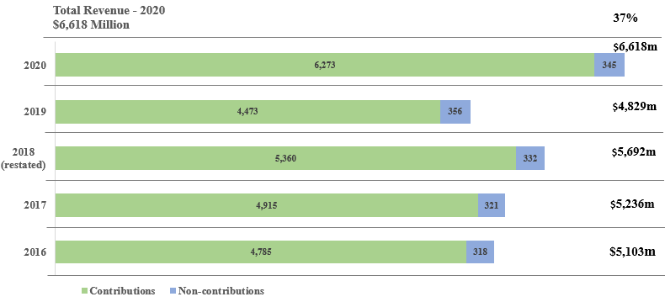
Figure I (a). UNDP total revenue trend

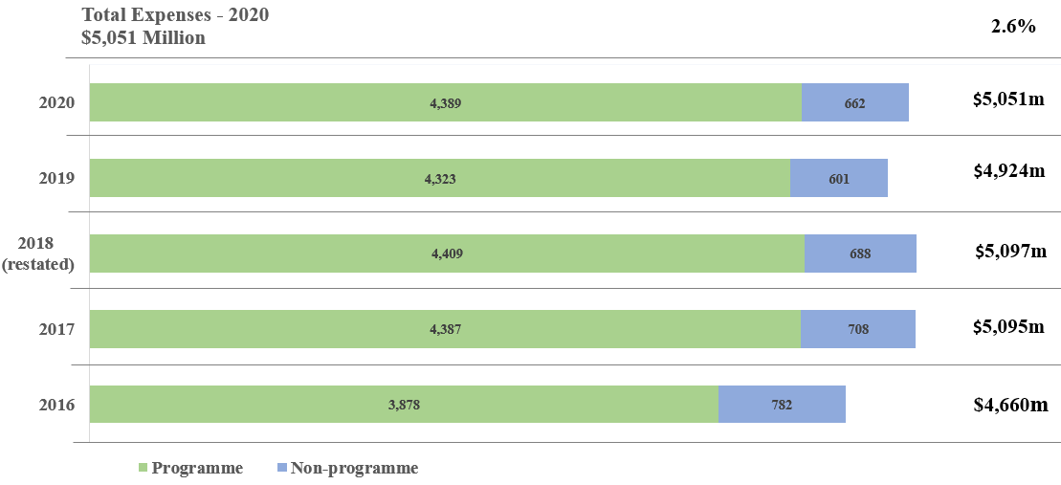
Figure I (b). UNDP total expenses trend
Note: Non-programme expenses consist of development effectiveness, United Nations development coordination, management and special purpose classifications.

Figure I (c). Total revenue and expenses trend, 2009-2020
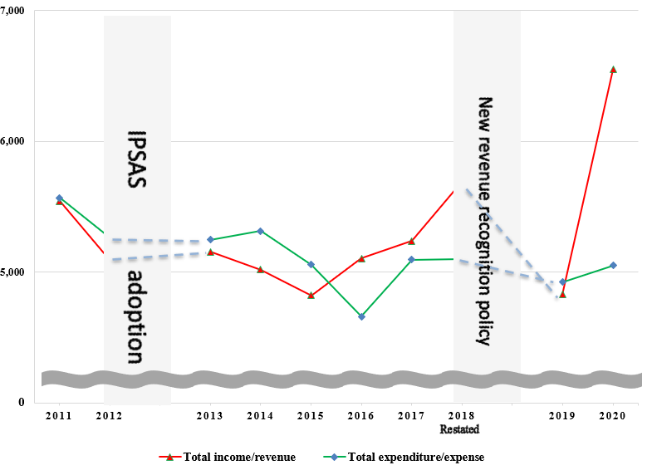
(in millions of United States dollars)

Note: IPSAS=International Public Sector Accounting Standards

- Financial highlights for 2020
  - Summary of UNDP financial situation
Table 1. UNDP financial situation, 2019-2020
(Millions of United States dollars) | 2020 | 2019 | Increase/  (Decrease) | Percentage change
Revenue ª | 6,618 | 4,829 | 1,789 | 37%
Expenses ª | 5,051 | 4,924 | 127 | 3%
Net revenue | 1,567 | (95) | 1,662 | -
Assets | 14,299 | 12,485 | 1,814 | 15%
Liabilities | 3,029 | 2,790 | 239 | 9%
Net assets | 11,270 | 9,695 | 1,575 | 16%
Composed of:
Accumulated balance | 10,968 | 9,409 | 1,559 | 17%
Reserves | 302 | 286 | 16 | 6%
 | 11,270 | 9,695 | 1,575 | 16%
ª Revenue and expense amounts are after elimination of $256 million in 2020 and $256 million in 2019.
Before elimination: Total revenue - $6,874 million in 2020; $5,085 million in 2019;
Total expense - $5,307 million in 2020; $5,180 million in 2019;

  - Revenue
- Total revenue (including contributions, investment revenue, exchange revenues, etc.) in 2020 was $6.6 billion, an increase of $1.8 billion or 37 per cent over 2019 revenue of $4.8 billion.

Voluntary Contributions
- Voluntary Contributions reported in the financial statements in 2020 totalled $6.3 billion, an increase of $1.8 billion (40 per cent) from the 2019 amount of $4.5 billion. Of the $6.3 billion, $551 million were contributions to regular (core) resources and $5.7 billion were contributions to other (non-core) resources. This increase was driven by multi-year agreements with several key donors, including the Global Fund to Fight AIDS, Tuberculosis and Malaria ($1.0 billion increase), European Union ($0.4 billion increase), Green Climate Fund and Global Environment Facility ($0.2 billion increase each), and Germany and Sweden ($0.1 billion increase each), as compared to 2019 when fewer new multi-year regular resource agreements were signed.
- Voluntary Contributions represent 95 per cent (2019: 93 per cent) of the total revenue, with the remaining 5 per cent largely consisting of other revenue and investment revenue, as set out in table 2a below.
- Based on the UNDP’s accounting policy on IPSAS 23 for recognizing revenue from voluntary contributions effective in 2019, UNDP records the full value of the contributions agreements signed (including multi-year agreements) being recognized as revenue in the year an agreement is signed. Under UNDP’s Financial Regulations and Rules, UNDP is only permitted to spend up to the amount of cash received; hence, in the following section of this document, where applicable, ‘Annual contributions’ are presented to align with the past revenue recognition policies for contributions (i.e., cash received in a reporting year, plus receivables due in a reporting year).
Table 2a. UNDP revenue, 2020
(in millions of United States dollars)

Resources | 2020 | 2019 | Increase/ (Decrease) | Percentage change
REVENUE
Voluntary contributions
Annual contributions | 5,563 | 4,796 | 767 | 16%
Net movement of future due contributions | 725 | (304) | 1029 | -
Subtotal: voluntary contributions | 6,288 | 4,492 | 1,796 | 40%
GLOC | 19 | 18 | 1 | 6%
Net contributor countries contributions | 7 | 8 | (1) | (13%)
Upper-middle-income-country contributions | 9 | 9 | - | -
Contributions in kind | 15 | 15 | - | -
Transfer of funds and refunds to donors | (65) | (69) | 4 | 6%
Voluntary contributions, net | 6,273 | 4,473 | 1,800 | 40%
Investment revenue | 118 | 167 | (49) | (29%)
Other revenue | 483 | 445 | 38 | 9%
Total revenue before elimination | 6,874 | 5,085 | 1,789 | 35%
Elimination – internal UNDP cost recovery | (256) | (256) | - | -
Total revenue after elimination | 6,618 | 4,829 | 1,789 | 37%

- During 2020, UNDP’s annual contributions were $5.6 billion, an increase of $767 million or 16 per cent from the 2019 amount of $4.8 billion. Figure II sets out the level of annual contributions of regular (core) resources in comparison to other (non-core) resources in 2020. In 2020, the ratio between regular and other resources was 13 per cent and 87 per cent respectively, which remains unchanged since 2019.
Figure II. Annual regular and other resources ratio, 2020
(in millions of United States dollars)
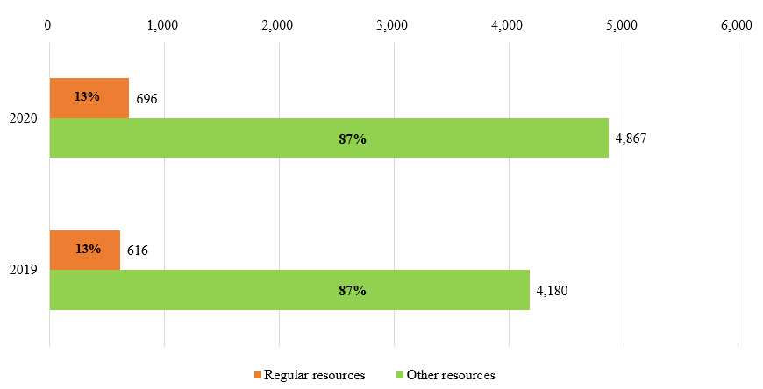
- Regular resources annual contributions received increased to $696 million from $616 million in 2019 a positive direction that should continue with the support of Member States, until the targets of the Funding Compact are met.
- Total other resources annual contributions increased by 16 per cent, to $4.9 billion (2019: $4.2 billion). Other resources are ‘earmarked’ for individual programmes or projects and are important complements to the ‘un-earmarked’ regular resources base. It consists of cost-sharing, trust funds, and reimbursable support services and miscellaneous activities. UNDP is committed to working with Member States to improve the flexibility of this funding.
- Annual Contributions are provided by the funding partners per table 2b and Figure III (a) below.
Table 2b. UNDP annual contributions by funding partners, 2019-2020
(in millions of United States dollars)
 | 2020 |  |  | 2019 |  |  | Total Increase | Percentage Change
 | Regular  Resources | Other  Resources | Total | Regular  Resources | Other  Resources | Total
Donor Country Governments | 673 | 1,512 | 2,185 | 594 | 1,463 | 2,057 | 128 | 6%
Programme Country Governments | 23 | 1,198 | 1,221 | 22 | 845 | 867 | 354 | 41%
Multilateral Partners | - | 2,157 | 2,157 | - | 1,872 | 1,872 | 285 | 15%
Total | 696 | 4,867 | 5,563 | 616 | 4,180 | 4,796 | 767 | 16%

Figure III (a). Annual contributions by funding partners, 2020
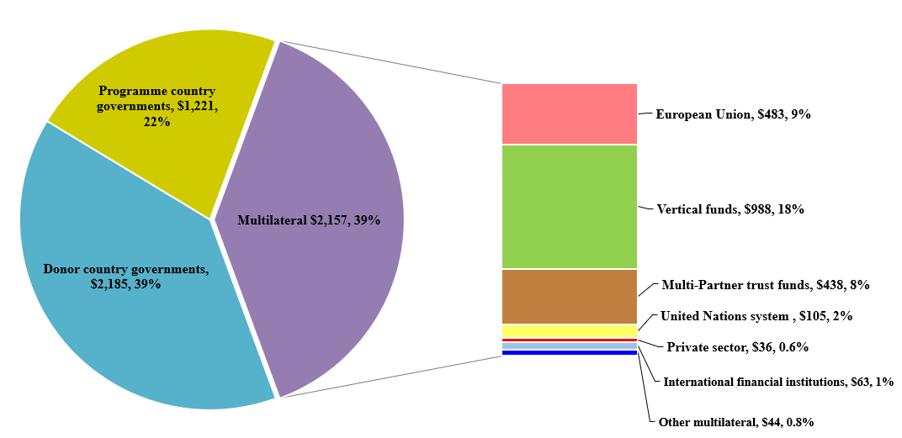
(in millions of United States dollars)

Government contributions to local office costs
- Annual government contributions to local office costs (GLOC) are an important source of revenue and can take the form of in-kind or cash contributions by host governments. In the low and middle-income countries categories, $27 million was received in 2020 (2019: 26 million), consisting of cash contributions of $19 million ($12 million for 2020 targets and $7 million against arrears) and in-kind contributions of $8 million for premises and utilities. The top 10 contributors are shown in figure III (b).
Figure III (b). Annual GLOC contributions by top 10 host governments, 2020
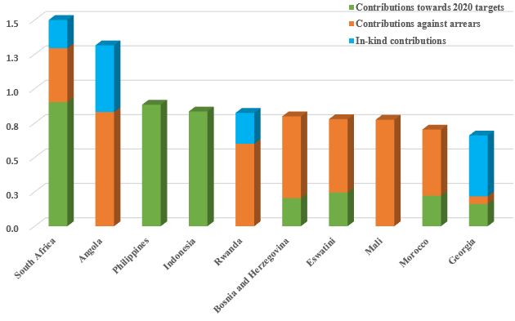
(in millions of dollars)
- Tables 8(a), 8(b) and 8(c) in appendix VII provide information on 2020 government cash contributions to local office costs in regular resources by countries in low and middle-income categories, cumulative arrears, and contributions towards arrears.

Net contributor country contributions
- Net contributor programme country governments contributed $7 million, a decrease of $1 million (13 per cent). (See details in appendix VII).

Upper-middle income country contributions
- Contributions from Upper-middle income programme countries with GNI per capita above $6,660 contributed $9 million, at the same level as 2019. (See details provided in appendix VII).

Investment revenue
- Total investment revenue totalled $118 million (2019: $167 million). This decrease of $49 million (29 per cent) was caused by the lower interest rates in 2020 due, in part, to the economic situation brought about by the COVID-19 pandemic.
- Hedging programme - UNDP’s hedging strategy resulted in a foreign exchange gain of $23 million (2019: $1 million) to core resources, partly attributable to higher volatility. Volatility has continued to decline from its peak during the early stages of the pandemic, and the large gain recorded in 2020 is not anticipated going forward.

Other revenue
- Other revenue totalled $483 million (2019: $445 million), mainly consisting of: cost recovery revenue of $344 million; for instance, $55 million revenue for providing services to the United Nations system; and miscellaneous revenue, such as foreign exchange gains.

Cost-recovery
- UNDP made every effort to recover the general management support and implementation costs associated with the delivery of other resources-funded programmes and projects and with United Nations entities.
- UNDP recovered $236 million through general management support service fees, $4 million lower than in 2019. Total cost recovery revenue decreased by 3 per cent to $344 million, (2019: $354 million), reflecting a change in mix of resources. Table 3 shows the breakdown of these revenues.
Table 3. Cost recovery, 2020
(in millions of United States dollars)

 | Programme and project delivery | Reimbursable support services | Total
Revenue
General management support services | 236 | - | 236
United Nations organizations – reimbursable services | - | 55 | 55
Administrative agent fees | 9 | - | 9
NCC contributions | 7 | - | 7
Upper MIC contributions | 9 | - | 9
Interest | 7 | - | 7
Other | 21 | - | 21
Total revenue | 289 | 55 | 344
Expenditure
Total expenditure | 311 | 60 | 371

- UNDP made every effort to attain full compliance with the cost recovery rate and seeks to further reduce the number of waivers. While infrequent, general management support waivers continue to be requested by funding partners. During 2020, only one new waiver on the general management support fee was granted for new project with financial impact of $34 thousands on 2020 delivery out of its total financial impact of $38 thousands. The details of GMS waivers issued in 2020 and prior to 2020 for activities on-going in 2020 are described in Appendix V.
  - Expenses
- In 2020, total expenses, after elimination, increased by 3 per cent or 127 million, to $5.1 billion (2019: $4.9 billion).
- Out of this total of $5.1 billion, $4.4 billion was for programme expenses, which represents 87 per cent of total expenses. The amount of $5.3 billion, before elimination, is composed of $757 million for regular resources and $4.5 billion for other resources.
Table 4. UNDP overall expenses, 2020
(in millions of United States dollars)
Resources | 2020 | 2019 | Increase/ (Decrease) | Percentage change
Expenses
Development activities
Programme | 4,389 | 4,323 | 66 | 2%
Development effectiveness | 181 | 176 | 5 | 3%
Subtotal – development activities | 4,570 | 4,499 | 71 | 2%
United Nations development coordination activities | 15 | 22 | (7) | (32%)
Management activities | 446 | 392 | 54 | 14%
Special purpose activities | 66 | 79 | (13) | (16%)
Other activities | 210 | 188 | 22 | 12%
Total expenses before elimination | 5,307 | 5,180 | 127 | 2%
Elimination | (256) | (256) | - | -
Total expenses | 5,051 | 4,924 | 127 | 3%

- Pursuant to Board decision 2010/32, expenditures are reported in four harmonized cost-classification categories: (a) development; (b) United Nations development coordination; (c) management; and (d) special purpose. Expenditures outside those classifications are reported under ‘other activities’ and are included as part of overall expenditure. Programme expenses are defined as development subtracting development effectiveness.
- The composition of total expenses and harmonized cost classification activities is shown in figure IV (a); comparison of programme expenses by region between 2019 and 2020 is shown in figure IV (b).
Figure IV (a). Total expenses by cost classification and programme expenses by region, 2020
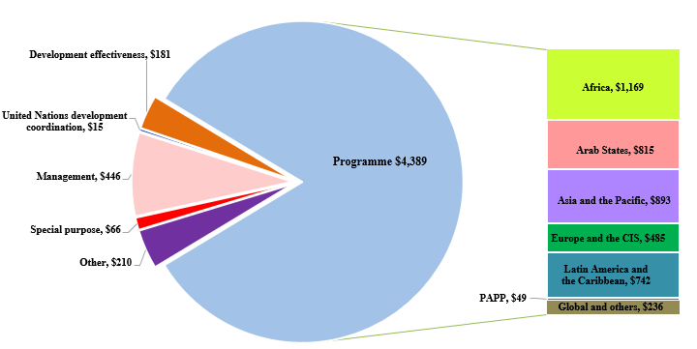
(in millions of United States dollars)

Development expenses
- Development expenses consist of programme expenses of $4.4 billion and development effectiveness of $181 million.

Programme expenses
- Total programme expense increased by 2 per cent, to $4.4 billion from $4.3 billion in 2019, which is UNDP’s second highest delivery rate in six years.
- UNDP took measures to curtail expenses, reflecting its focus on efficiency while shielding programme components, such as target for resource assignment from the core TRAC-1, TRAC-2, TRAC-3, South-South cooperation, and the Human Development Report Office, including multi-year allocations from TRAC-2.
- The $4.4 billion programme expenses include $2.0 billion related to donor cost-sharing, $948 million related to government cost-sharing, $739 million related to vertical funds, including the Global Fund to Fight AIDS, Tuberculosis and Malaria ($296 million), the Global Environment Facility ($310 million), the Green Climate Fund ($79 million) and the Montreal Protocol ($30 million)), and 97 million relating to the Law and Order Trust Fund for Afghanistan. Of the 10 largest UNDP programmes, seven are in fragile or crisis-affected countries, accounting for 36 percent of total programme delivery.
Figure IV (b). Programme expenses by region, 2019-2020
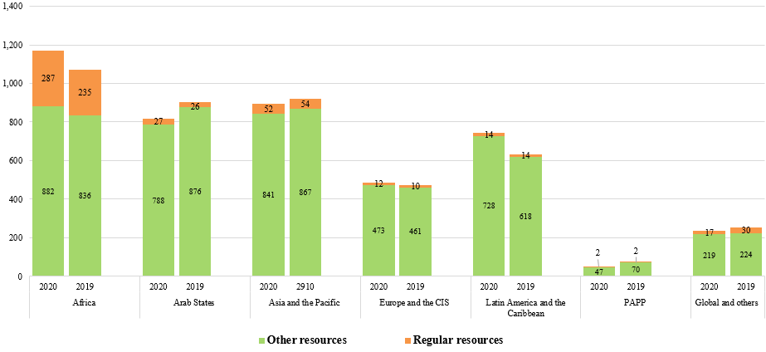
(in millions of United States dollars)

Comparison of programme expenses by region, 2019-2020
- Overall programme delivery in the Africa region increased by 9.2 per cent. The top three countries with the largest programme delivery in 2020 were Zimbabwe ($171 million), the Democratic Republic of the Congo ($85 million) and Central African Republic ($70 million). Of the $171 million delivery in Zimbabwe, $134 million (80 per cent) was funded by the Global Fund. Of the top seven Country Offices within this region with more than $50 million delivery, Central African Republic, Ethiopia, and Nigeria increased delivery by 24 million (52 per cent), by 20 million (54 per cent), and by 27 million (102 per cent), respectively.
- Overall programme delivery in the Arab States region decreased by 9.7 per cent. Iraq has the second largest programme delivery in UNDP. Iraq delivered a total of $236 million, a decrease of 27 per cent from the 2019 delivery of $323 million. Of that amount, 94 per cent was funded by donor country governments under third-party cost-sharing arrangements. Yemen was also one of the top ten countries, with total programme delivery of $122 million, of which 55 per cent were funded by the World Bank Group.
- In the Asia and the Pacific region, Afghanistan delivered the highest level of programme expenses in UNDP at $421 million, including $313 million under cost-sharing agreements and $97 million for the Law and Order Trust Fund for Afghanistan. Of the six Country Offices with more than $30 million delivery; Bangladesh, Pakistan, India, Fiji, and China have increased their delivery, each within a range of $1 million of $5 million.
- Overall programme delivery in the Europe and the Commonwealth of Independent States (CIS) region increased by 2.9 per cent. Ukraine has the highest programme delivery at $134 million, and the highest increase in programme delivery in this region was in Bosnia and Herzegovina, which increased to $48 million from $40 million in 2019, funded by government cost-sharing for the procurement of health products.
- In the Latin America and the Caribbean region, overall programme delivery increased by 17.3 per cent, as a result of the resource mobilization effort emanating from climate change-related initiatives. Argentina has the highest programme delivery, at $180 million, an increase of 44 per cent from the 2019 delivery of $125 million. The second highest delivery is Dominican Republic, which increased to $67 million from $43 million in 2019. Colombia has the third largest delivery of $67 million, and Honduras increased its programme delivery to $48 million from $14 million in 2019.

United Nations development coordination expenses
- UNDP effectively supported the rapid transition of the United Nations development system, following General Assembly resolution 72/279 on United Nations repositioning. In 2020, UNDP’s support to the resident coordinator system was $15.3 million, 0.3 per cent of UNDP total expenses. This amount includes UNDP’s contribution of $10.3 million (2019: $10.3 million) to the cost-sharing arrangement among United Nations development system entities, and an additional $5.0 million (2019: $12.1 million) of legacy coordination support activities continued on a transitionary basis at the request of UN Development Coordination Office and its funding partners.

Management expenses
- Management expenses rose by 14 per cent, to $446 million (2019: $392 million), remaining within the parameters of the integrated resources plan, 2018-2021, and included increased spending for the Independent Evaluation Office and the Office of Audit and Investigations, and non-discretionary inflationary increases on staff costs.
- It should be noted that, as a result of the delinking of the resident coordinator system from UNDP, many new UNDP leadership positions at the country level started to be filled during 2019 and the full on-boarding was completed by the end of 2019, which resulted in savings under management activities cost classifications category. Accordingly, 2020 is the first year to have full costs of those newly established leadership positions at the country level, which contributed to the increase in management expenses compared to 2019.

Special purpose expenses
- Special purpose expenses totalled $66 million (2019: $79 million). This amount includes expenses of $51 million for reimbursable support services, $3 million related to capital investments, $9 million related to UNV and $2 million related to UNCDF.

Other expenses
- Other expenses totalled $210 million (2019: $188 million), of which $33 million (2019: $37 million) related to after-service health insurance, $36 million (2019: $34 million) to common services, $34 million (2019: $34 million) to security-related activities, $17 million (2019: $19 million) to the junior professional office programme, and $19 million (2019: 13 million) to currency revaluation and exchange rate fluctuations to voluntary contributions, $15 million (2019: $15 million) to the support fee for the Joint Programme, and $13 million (2019: $7 million) to Management Service Agreement related activities.

Regular resources and integrated budget expenditure
- For activities reported in 2020, UNDP operates within the integrated budget, 2018-2021, as approved by the Executive Board in decision 2017/31, for regular resources-financed activities: (a) programmatic components; and (b) institutional components.
- Appendix II and figure V below compare the final approved budget, covering both programmatic and institutional components, with the actual expenditure amounts, calculated on the same basis as the corresponding budget for regular resources (modified accruals basis).
Figure V. Regular resources, comparison of budget to actual expenditure, 2020
(in millions of United States dollars)
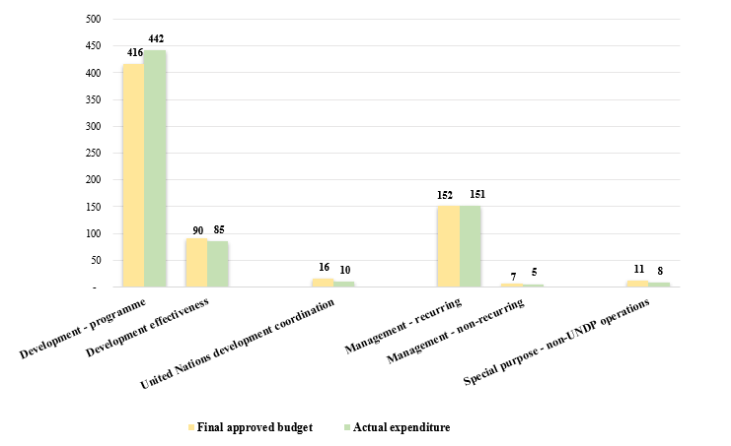
- UNDP’s performance in 2020 should be considered against the backdrop of two contexts:
- The overarching objective of the UNDP budget was to ensure financial sustainability with respect to the institutional and programmatic components, achieve a better equilibrium between regular and other resources, and increase productivity over time; and
- General Assembly resolution 72/279 of 31 May 2018 on the repositioning of the United Nations development system. UNDP continued to support the functioning of the independent and reinvigorated resident coordinator system, helping to ensure that Resident Coordinators and their offices are able to carry out their critical coordination functions seamlessly. At the same time, UNDP maintained its business continuity and continued successfully to drive forward the Strategic Plan, 2018-2021.
- Table 5 below compares actual expenditures for 2019 and 2020. In 2020, the share of regular resources spent for institutional activities was $216 million, which was $11 million or 5 per cent less, compared to $227 million in 2019. The share of regular resources spent for programmatic activities was $488 million, which was $48 million or 11 per cent more, compared to $440 million in 2019.
Table 5. Integrated budget expenditure, by cost classification category, 2019-2020
(in millions of United States dollars)

Regular resources | 2020 actual  expenditures | 2019 actual  expenditures
Programmatic component | 488 | 440
Institutional component | 216 | 227
Total | 704 | 667
Cost classification category | 2020 actual  expenditures | 2019 actual  expenditures
Development activities | 529 | 484
United Nations coordination activities | 10 | 11
Management activities | 156 | 164
Special purpose activities | 8 | 8
Total | 704 | 667
- Appendix III.A presents the integrated resources plan that covers regular and other resources for 2018-2020 and compares the plan with 2018-2020 actuals. This comparison shows that:
    - activities reported in 2020 remain within the integrated resources plan;
    - at the end of 2020, the expenditure ratio for management activities (regular (core) and other (non-core)) to total activities (i.e., management efficiency ratio) was 7.5 per cent (2019: 7.5 per cent);
    - the overall expenditure level of programmatic activities at the end of 2020 include utilization of prior years’ unspent balances and reached 106 per cent compared to 2020 programme budget (2019: 90.7 per cent).
- Appendix III.B presents 2018-2020 actuals versus estimates of the institutional components of the integrated resources plan by category of expenditures, while appendix III.C presents information on resources allocated to posts by location.
- Financial position
  - Assets
- Total assets registered $14.3 billion (2019: $12.5 billion), representing an increase of 15 per cent. UNDP assets consist mainly of investments to fund known liabilities, as well as contributions receivable, as set out below.
Figure VI. UNDP assets, 2019-2020
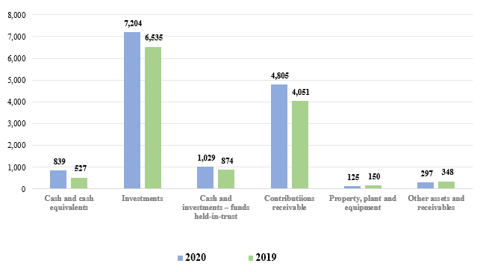
(in millions of United States dollars)

Cash and investments
- Total cash and cash equivalents and investments amounted to $839 million and $7.2 billion, respectively.
- The majority of investments and cash and cash equivalents in other resources are earmarked for programme activities funded through cost-sharing and trust fund agreements with donors. The investments and cash equivalents in regular resources and other resources also includes $918 million for after-service health insurance (ASHI) and the amount invested for the Executive Board mandated operational reserves of $299 million and the Programme of Assistance to the Palestinian People (PAPP) Endowment Fund of $3 million.
- The total cash and investments for Multi-Partner Trust Fund Office of $1,029 million (cash and cash equivalents of $339 million and investments of $690 million) represent funds provided to UNDP by funding partners to be held on their behalf for future disbursement to organizations of the United Nations system and to national governments.

Contributions receivable
- Contributions receivable from funding partners registered $4.8 billion, an increase of $754 million (19 per cent) from the 2019 amount of $4.1 billion.
- Contributions receivable amounts are recognized in full, including for multi-year contributions, at the time the agreement is signed, except for programme government contribution agreements and agreements that have performance conditions beyond the control of UNDP. As these funds are not yet received, they are not available for utilization.
- Contributions receivable of $4.8 billion include $4.7 billion committed to UNDP by donors in future years, as set out in the payment schedule in signed agreements. This amount is programmed accordingly for delivery in future years and consists of $192.5 million receivable for regular resources and $4.5 billion for other resources.
- Of the of $191.7 million regular resources contributions receivable, $192.5 million is due in future years, and the balance of -$860 thousands is allowance for the receivables due in 2020. Of the $4.6 billion other resources contributions receivable, $134 million is past due, $2.5 billion is due in 2021, and the balance of $2.0 billion is due in future years. Three donors (Global Fund to Fight AIDS, Tuberculosis and Malaria; Global Environment Fund, and European Union) account for 49 per cent (2019: 49 per cent) of total other (non-core) outstanding receivables. This provides visibility of future year funding available for programme pipeline.
Table 6. Contributions receivable, 2019-2020
(in millions of United States dollars)
Contributions receivable | 2020 | 2019 | increase/ (decrease)
Contributions past due | 133 | 104 | 29
Contributions due in future periods | 4,672 | 3,947 | 725
Total contributions receivables | 4,805 | 4,051 | 754
  - Liabilities
- Total liabilities amounted to $3.0 billion, an increase of $239 million, or 9 per cent over the 2019 amount of $2.8 billion. The change is mainly attributable to Payables for the Multi-Partner Trust Fund Office and Employee benefits, which increased by $157 million and $149 million, respectively.
- Funds received in advance and deferred revenue of $254 million comprises of $21 million funds received in advance for future periods specified in donor contribution agreements, $24 million deferred revenue for contributions, $ 103 million for common services to United Nations entities, and $106 million for clearing accounts with United Nations entities.
Figure VII. UNDP liabilities, 2019-2020
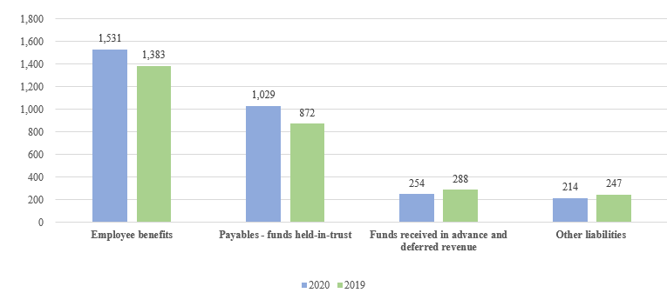
(in millions of United States dollars)

- UNDP liabilities also include $1.5 billion (2019: $1.4 billion) in liabilities for employee benefits, of which $1.2 billion is for after-service health insurance (ASHI). In 2020, ASHI liabilities increased by $127 million (12 per cent) from $1.0 billion, resulting in an increase in the proportion of the liability funded fully by UNDP from 74 per cent in 2019 to 78 per cent in 2020. UNDP participates in the United Nations system-wide valuation of post-retirement benefits, performed by an independent actuary. The latest valuation was carried out and the $127 million increase (12 per cent) in the liability was largely due to the decrease in interest rates (valuation discount rates) assumption which increased the liability as per the actuarial assessment. It is not known what portion of the increase in these employee benefit liabilities is related to COVID-19.
- UNDP continued to have a 15-year plan to fund its ASHI liability, which is assessed periodically. Of the $1.3 billion, $918 million had been funded as of 31 December 2020. The investment management of this portfolio is fully outsourced to external managers to ensure an adequate level of investment return given the longer-term nature of the liabilities. UNDP, UNFPA, UNCDF, the United Nations Children’s Fund (UNICEF) and the United Nations Entity for Gender Equality and the Empowerment of Women (UN-Women) collaborate in this arrangement.
- Of employee benefits, in 2020, annual leave balances increased by $20.5 million or 30 per cent to $88.8 million (2019: $68.3 million), while home leave liabilities increased by $2.3 million or 27 per cent, to $10.8 million (2019: $8.5 million). These increases are due to staff not taking their planned leave entitlements in 2020 as a result of the COVID-19 pandemic and travel limitations imposed to contain the pandemic.
- Payables (funds held in trust) represent funds provided by donors to UNDP to be held on their behalf for future disbursement to organizations of the United Nations system and to national governments. The amount of $1.0 billion in figure VII shows $1,029 million for multi-partner trust funds that UNDP administers.
  - Accumulated Surplus
- The financial regulations and rules of UNDP require it to operate on a fully funded basis for activities funded by other resources. In accordance with partnership agreements, all project balances are segregated for accounting and reporting purposes, with no commingling of balances between projects. Appropriate cash balances are held for settling liabilities.
- UNDP receives programmatic resources for multi-year programmes linked to individual programmes or projects. Hence, in any given year, there is an excess of resources over expenditure. This excess of resources is referred to as the accumulated surplus, which consists mainly of resources committed for future programme delivery.
- At 31 December 2020, the accumulated balance, excluding reserves, increased by 17 per cent, to $11.0 billion (2019: $9.4 billion). The increase in accumulated balance from 2017 is mostly attributed to the increase in receivables as a result of the change in the revenue recognition policy due to International Public Sector Accounting Standards. Accordingly, the accumulated surplus includes receivables from non-exchange transactions (net of past due) of $4.5 billion as at 31 December 2020 (2019: $3.8 billion). Under UNDP’s Financial Regulations and Rules, the organization is only permitted to spend when the cash is received. i.e., the organization is not permitted to spend the $4.5 billion stated above. Figure VIII (a) below illustrates the trend in the accumulated balances, and the impact of changes in the receivables of non-exchange transactions.
Figure VIII (a). Accumulated balance, regular resources and other resources
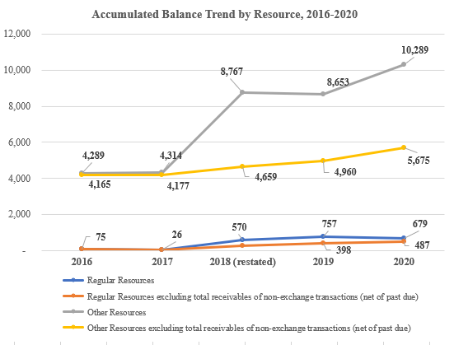
(in millions of United States dollars)
- Available accumulated regular resources (core) decreased by $78 million in 2020 mainly due to a deficit of $105 million in 2020 along with a net increase of $27 million in aggregate mostly as a result of the fair value adjustment of ASHI investments and the net actuarial revaluation. The deficit of $105 million was mainly caused by a decrease of $143 million in core voluntary contribution from $694 million in 2019 to $551 million in 2020. In addition, in line with Board decision 1999/9, a prudent level of liquidity for regular resources is equivalent to three to six months’ expenditures. UNDP maintained the year-end core liquidity position at 7.21 months of working capital, above the minimum threshold (2019: 6.61 months).
- Total accumulated other resources (non-core) programme balances increased by 1.6 billion, partially resulting from revenue recorded for multi-year programmes and projects that will be implemented in future periods and include accounts receivables of $4.3 billion (net of past due) for non-core resources as at December 2020 (2019: $3.4 billion). UNDP continued to seek opportunities to accelerate the delivery of development results and further draw down its accumulated balance, taking into account the late receipt of funds in 2020. Contributions received in the last quarter at 38 per cent (2019: 37 per cent) of total contributions in 2019 were too late for delivery in the same year and will have to be budgeted in the following year. Early payments of contributions by funding partners aid the timely delivery of development results.
- In 2020, $16 million (2019: $6 million) was released to the accumulated surpluses from the operational reserve, in accordance with the operational reserve formula approved by the Executive Board in decision 1999/9.
- The attribution of the accumulated balance to the various funding sources for future delivery is set out in figure VIII (b) below. This comprised of donor cost-sharing balance of $4.6 billion (2019: $4.3 billion), vertical funds balance of $3.4 billion (2019: $2.5 billion), programme cost-sharing balance of $1.0 billion (2019: $821 million), trust funds balance of $718 million (2019: $421 million), regular resources balance of $679 million (2019: $757 million), and reimbursable support services balance of $523 million (2019: $548 million).
Figure VIII (b). Accumulated balance by funding source, 2019-2020
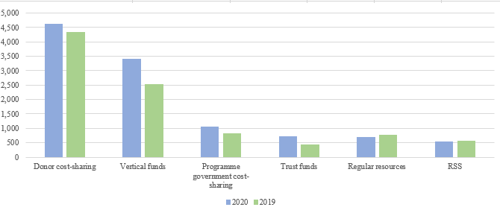
(in millions of United States dollars)
- Accumulated resources of vertical funds increased by $878 million, of which $686 million is contributed by the multi-year contribution agreements from the Global Fund to Fight AIDS, Tuberculosis and Malaria. Accumulated resources of donor cost-sharing increased by $267 million, of which, $350 million is due to resources from European Union.
- Others

Management service agreements
- Management service agreement contributions totalled -$1 million (2019: $3 million), total expenses registered $13 million (2019: $6 million), and the accumulated balance decreased to $34 million (2019: $48 million). Details are provided in document Appendix VII to Annex I to DP/2021/31.

United Nations Volunteers
- In 2020, the third year of the implementation of the UNV Strategic Framework, 2018-2021, the total financial volume amounted to $237.4 million, a $16.1 million increase from $221.3 million in 2019. UNV continued to monitor its costs and align them with financial resources and future projections. Correspondingly, the total cost from core, extrabudgetary, cost-recovery funds and the Special Voluntary Fund increased by 8 per cent in 2020, reflecting annual inflation and additional human resource capacity in support of volunteer mobilization and management.
- Unearmarked contributions from Member States form the bedrock of UNV’s institutional budget. In 2020, Member States contributed regular resources to UNV through UNDP amounting to $8.6 million. This is consistent with the annual average in the Strategic Framework 2018-2021 of $8.67 million, and a 15 per cent decrease compared to the annual average of the previous Strategic Framework 2014-2017.
- UNV continues to rely on the Special Voluntary Fund for volunteerism research and promotion, rapid response, and innovative solutions. In 2020, contributions to the fund came from 11 donors: Bangladesh, China, the Czech Republic, France, Germany, India, Ireland, Sweden, Switzerland, Thailand, and Turkey. The total amount of contributions was $6.2 million, inclusive of interest for 2020. However, over 90 per cent came from the top four donors – Germany, Sweden, Switzerland, and France – suggesting the need to further diversify the Special Voluntary Fund donor base.
- Contributions to the UNV full funding programme amounted $19.9 million in 2020.

United Nations Office of South-South Cooperation
- The overarching goal of the United Nations Office of South-South Cooperation (UNOSSC) Strategic Framework, 2018-2021, is to support of the efforts of Member States to eradicate poverty in all its forms and to promote gender equality and women’s empowerment so as to achieve the 2030 Agenda through enhanced South-South cooperation, including triangular cooperation.
- The UNOSSC implemented its strategic framework through an allocation of $2.3 million (2019: $2.3 million) from the UNDP’s institutional budget and $3.7 million (2019: $3.4 million) in core programming resources. In addition, it received $30.9 million in contributions from partners through its four trust funds: $22.4 million from the India-UN Development Partnership Fund, $4.2 million from the United Nations Fund for South-South Cooperation (UNFSSC), $4 million from the India, Brazil and South Africa Facility for Poverty and Hunger Alleviation, and $0.3 million from the Pérez-Guerrero Trust Fund for South-South Cooperation (PGTF).
- Despite the challenging global financial context caused by the pandemic, UNOSSC non-core resource contributions were at a record high, driven partly by efforts within United Nations Fund for South-South Cooperation (UNFSSC) and the India-UN Development Partnership Fund to respond to partner-country requests for COVID-19 response support.
- Within the UNOSSC portfolio, trust funds remained the instrument of choice for Member States seeking to facilitate South-South and triangular cooperation activities jointly with the United Nations system. Most contributions were channelled through funds: UNFSSC, the IBSA Facility for Poverty and Hunger Alleviation and the India-UN Development Partnership Fund. Thanks to its capital endowment and complementary Member States support, the PGTF continued to address matters of critical importance to the Group of 77.
- Most projects, if not directly linked to the COVID-19 response or re-purposed in response to the pandemic, experienced delays in their implementation. Fortunately, the fourth quarter of 2020 showed signs of an acceleration in delivery not only in the health sector but also across the 18 United Nations entities implementing UNOSSC trust fund projects. UNOSSC attained a delivery of $11.1 million for projects funded from non-core resources and achieved a full delivery rate of $6 million in core resources.
- United Nations reform and support to United Nations organizations
- UNDP undertakes many activities in partnership with and support to the United Nations system at large.
  - UNDP administrative agent function
- UNDP supports joint programming, including through its role in fund design and administration of joint programmes and multi-donor trust funds on behalf of the United Nations system and national governments, and through its programme implementation role as a participating United Nations organization. Details are set out in DP/2021/31, Section VI.
  - Support to United Nations organizations
- UNDP continued to be the operational backbone of the United Nations system in 2020. UNDP supported $2.51 billion in financial transactions for approximately 118 United Nations and other agencies in over 170 countries. UNDP provided common premises for other agencies in at least 126 countries, where they could avail of common services, including travel management.
  - United Nations development coordination activities
- UNDP continued to provide support of the repositioning of the United Nations development system from 1 January 2019, the following was requested by the GA resolution 72/279:
    - UNDP provided an annual contribution of $10.3 million (2019: $10.3 million) to the United Nations Sustainable Development Group through cost-sharing arrangement among United Nations development system entities.
    - A one per cent coordination levy on tightly earmarked third-party non-core contributions to United Nations development-related activities, to be paid at source. UNDP established internal guidance, processes, and communication channels to manage the levy collection and its transfer. UNDP monitors the process of levy collection and continuously engaged with Development Coordination Office and Resident Coordinator Offices on levy matters. UNDP transferred $4.6 million to the United Nations Secretariat as part of the 1 per cent levy on tightly earmarked other resources contributions. It is noted that UNDP incurred costs to administer the levy estimated to be $0.6 million (2019: $0.4 million), representing a substantial additional administrative cost that UNDP had to spend to able the levy collection in 2020.
  - United Nations-mandated security costs
- In its decision 2017/31, the Executive Board approved the UNDP integrated budget, 2018-2021. In document DP/2017/39 on the UNDP integrated budget, 2018-2021, and following prior practice, UNDP sought exceptional authority during 2018-2021 to disburse up to $30 million in regular resources for security measures, in addition to the approved appropriation from regular resources for the institutional component of the integrated budget of $1.1 billion, the use of which would be limited to new and emerging security mandates as defined in United Nations Department of Safety and Security directives. UNDP will report on these as and when they may occur. During 2020, $5 million was drawn from $30 million of the additional security measures approved by Executive Board and was related to COVID-19 activities e.g., medical evacuations of personnel.
- UNDP spent $27.6 million (2019: $30.2 million), of which $18.0 million (2019: $21.2 million) was associated with the UNDP share of the United Nations field security coordination programme; and $9.6 million (2019: $9.0 million) with security advisory services and security investments to ensure the compliance with minimum operating security standards, as well as staff safety and duty of care measures in response to COVID-19 pandemic.
- ‘Greening’ UNDP
- During 2020, UNDP has made substantial progress towards its ambitious ‘Greening Moonshot’ targets, committing to reduce Greenhouse Gas (GHG) emissions from global operations by 25 per cent by 2025 and 50 per cent by 2030. Between the corporate Moonshot Facility, 34 projects were selected for funding in 2020 with an overall investment of $1.92 million. With this investment, UNDP achieved, so far, a 6 per cent reduction in UNDP’s electricity carbon footprint and an overall 2.2 per cent reduction in UNDP’s carbon footprint. With an average payback period of 5.96 years, Moonshot projects are expected to save $420,000 per year in energy costs while increasing business continuity and improving the well-being and safety of our staff. If Moonshot investments continue at this or higher levels through 2030, UNDP will be on track to halve its facilities (electricity, generator fuels) footprint, a major contribution to the overall Moonshot target.
- To credibly track progress towards Moonshot progress and support GHG reduction claims, UNDP significantly increased its environmental reporting compliance: By end of 2020, 72 per cent of UNDP offices reported their impacts via UNDP’s Environmental Management Tool (EMT). Also reporting scopes and methodologies were further improved and reporting structures and responsibilities strengthened. The organization-wide 2019 carbon footprint of 59,995 tons CO2e was offset with Certified Emission Reductions (CERs) from the Adaptation Fund established under the Kyoto Protocol of the United Nations Framework Convention on Climate Change. Similarly, 2020 GHG emission data are collected during 2021 and UNDP’s 2020 Carbon Footprint is expected to be established, reported, and offset by end of 2021. As such, UNDP continues to be climate neutral in its global operations.
- In addition, UNDP’s vehicle policy has been updated to prioritize electric or hybrid representational vehicles where feasible. UNDP also developed a Fleet Management Tool enabling operational efficiencies in the fleet management, improving of Road safety and driving behaviour but also contributing to the reduction of carbon footprint through promoting car-pooling and enabling tracking of driving behaviour and speeding, resulting in a reduction in fuel use.
- Appendices (available on the UNDP Executive Board web page)
Contents
- UNDP overview
  - Statement of financial performance for the year ended 31 December 2020
  - Statement of financial position as at 31 December 2020
- Regular resources – comparison of budget to actual, 2020
- A. Integrated resources plan, 2018-2021 estimates compared to 2018-2020 actuals
B. Summary of institutional component of the integrated budget by category of expenditures: 2018-2020 annualized estimates versus 2018-2020 actual expenditures
C. Resources allocated to posts by location, 2020
- Regular resources – annual contributions from top 10 donors, 2019-2020
- Update on general management services cost-recovery waivers
- Explanation of terms used in Annex I to DP/2021/31
- Supporting information relating to the detailed annual review of the financial situation, 2020

On calculating the operational reserves for 2020, a net transfer of $16 million was made from accumulated surpluses. The operational reserve was established in 1979 by the Governing Council (now the Executive Board) of UNDP to ensure adequate liquidity of UNDP by funding such reserve through a defined formula that is calculated yearly.
Includes IPSAS revenue adjustments in 2019
Classified based on “States of Fragility 2020” published by Organisation for Economic Co-operation and Development (OECD).

