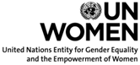

Joint meeting of the Executive Boards of UNDP/UNFPA/UNOPS, UNICEF, UN-Women and WFP
3 June 2016

Big data and the Sustainable Development Goals

Background paper prepared jointly by UNDP, UNFPA (co-coordinator), UNOPS, UNICEF, UN-Women and WFP (co-coordinator)

- Introduction: Why big data fills a gap for the Sustainable Development Goals

- The indicator framework for the Sustainable Development Goals places major demands on national statistical systems to produce and utilize quality, accessible, timely and reliable subnational sex- and age-disaggregated data. The central focus of the 2030 Agenda is to leave no one behind, based on the assumption that every country should be able to identify and locate the vulnerable, identify interventions that result in the greatest improvements in their welfare, and monitor equality of progress over a wide array of goals and targets.

- The Goals call for ensuring that all people have access to essential services or resources required to achieve a certain level of social, economic and physical well-being and a life of dignity. In the area of gender, for instance, current challenges go beyond the disaggregation of indicators. More active interaction is necessary between technicians who design and use the information and gender specialists.

- Improved understanding of subnational geographic and demographic variation and inequality in health status, educational attainment, wealth and access to resources within countries is increasingly recognized as central to achieving sustainable development, which requires a consistent, comparable, disaggregated and regularly updated understanding not only of how many people live in a country, but who and where the people are.

- Due to digitalization and increases in web data, new actors have become producers of data. 'Big data' refers to large amounts of digital data continuously generated as a by-product of everyday interactions with digital products or services. Big data are generated passively by humans and machines in high volume and with high velocity, and are loosely structured as data from social media, mobile phone records, point-of-sale terminals or global positioning system (GPS) devices.

- Big data, if harnessed and utilized effectively, have the potential to address the issues pertaining to sustainable development, the Sustainable Development Goals, inequalities including gender inequality, resilience and climate change. The world we live in is more and more connected and increasingly interdependent. Society and social interaction are undergoing significant change due to this connectivity and interdependence. Social and economic development is dependent on – enabled (or hindered) by – the governance, knowledge and assets that make up infrastructure systems which underpin effective and sustainable development and the associated demands for development.

- The gender dimension of big data is of utmost importance in the context of achieving the Sustainable Development Goals. This is an area where data gaps are significant. The United Nations Entity for Gender Equality and Empowerment of Women (UN-Women) is currently partnering with United Nations Global Pulse to ensure that the data revolution responds to women’s needs and issues of data inclusion. This collaboration is a continuation of commitments by UN-Women and Global Pulse to partner on gender and big data under the umbrella of the Data2X initiative. Both UN-Women and Global Pulse are looking into the potential of integrating innovative approaches to big data into programmes, policies and technical assistance in areas such as real-time monitoring, sentiment analysis and analysis of existing data sets based on new algorithms that differentiate gender. Policy considerations around access, availability of gender-disaggregated data and privacy as well as understanding the social and political norms and realities around gender equality and women’s empowerment and linkages with big data are necessary in order to effectively interpret the data.

- However, many developing countries are hampered in addressing sustainable development and redressing inequalities, in part because national statistical offices (NSOs) are underdeveloped or heavily oriented to data production, with inadequate attention paid to the institutional capacities required for sustainable production, analysis and use of data for long-term national planning and monitoring progress in sustainable development, including in gender equality. Further, while traditional data collection mechanisms, such as census and household surveys, allow for fine levels of disaggregation and granularity, they are generated infrequently and are often limited. Vital statistics and civil registration systems are often weak and real-time administrative data remain limited in most developing countries. Strengthening these systems through the use of big data should therefore be a priority. In some regions, instability and insecurity may make it impossible for traditional data systems to collect new census information and available data may quickly be outdated if instability leads to large movements of people. Surveys may exclude certain zones of a country, and the population situation may be changing too quickly to rely solely on infrequently collected data sources.

- As a result, there is growing enthusiasm for leveraging technological innovations around alternative data sources, including big data, to provide real-time estimations of the number and locations of people during or after humanitarian crises, or helping Governments to estimate the size and location and composition of their populations after sustained periods of conflict and displacement. Gender-sensitive data would be critical to ensuring adequate policy and programme responses, for example.

- In Lebanon, the World Food Programme (WFP) and the Leiden University Centre for Innovation are using data from cash-based transfer transactions to gain insights into the mobility of Syrian refugees (e.g., seasonal migration, migration within urban areas) and to detect anomalies in purchases in real time (e.g., transactions are unusually high in a given store) which could support programme quality. In Jordan, itemized receipts, in combination with registration data with demographic composition, provide a wide range of programmatic insights: traceability; beneficiary monitoring and profiling; price monitoring; nutrient content of purchases relative to needs; origin of produce for local purchase campaigns; and population movements.

- The WFP mobile Vulnerability Analysis and Mapping project uses voice calls, text messaging and interactive voice response call technology to collect real-time household and market-related food security information and communicate with beneficiaries. Data collected are made available publically through the Office for the Coordination of Humanitarian Affairs Humanitarian Data Exchange (HDX), an open platform for sharing data on crises. WFP has released an application programme interface which provides open access to large amounts of food security data that it collects in real time through mobile technology. This ensures that accurate and timely information is available to the members of the wider humanitarian community, enabling them to conduct better analysis to inform policies and programmes. Consequently, HDX built a first iteration of an interactive data visualization tool for monitoring countries' food-security data in real time. The tool facilitates the decision-making process by allowing a range of users to explore the data in intuitive ways, offering the possibility to conduct trend analyses. In Somalia, the WFP 'SCOPE' platform is being scaled up to support more than 1 million beneficiaries with a large network of point-of-sale terminals, enabling the delivery of assistance with biometric verification and GPS location tracking. This provides analysis of beneficiary behaviour and consumption patterns in near real time.

- Digital technologies have lowered the costs of producing and publishing data; they have eased the distribution and visualization of data and have hence democratized access to data and create new use cases for it. Information on health, education, food security, physical security, economic activity and other topics can be derived from big data sources as diverse as cell phones, wearable devices, remote sensors and Internet use. Analysis of cell phone data usage patterns can allow inferences to be made about users' sex, age, socioeconomic status, mobility patterns and financial activities.

- In response to the Ebola virus disease epidemic, UNICEF worked in partnership with the Government of Sierra Leone and mobile network operators to use call data records (CDRs) to map people’s mobility. It became clear that CDRs were a powerful proxy to: (a) identify risks (e.g., are people from hotspots moving to low-infection locations?); (b) design information campaigns (e.g., where can communication resources best be deployed to maximize coverage of information campaigns?); and (c) show the impact of actions (e.g., are curfews/blockades really working to keep people from moving after dark or across blockade lines?).
Figure 1. How analysis of call data records was used to predict the risk of the spread of Ebola virus disease
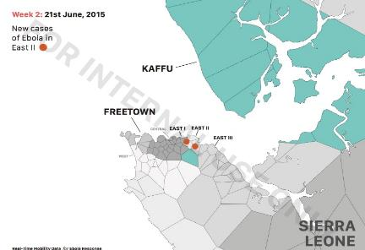
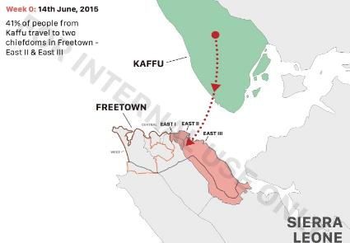
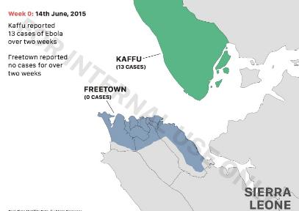
These three maps show how the CDR analysis can be used to predict risk of the spread of infectious diseases:
Image 1 (Week 0). On 14 June, 13 Ebola virus disease (EVD) cases were recorded in Kaffu Bullon chiefdom and 0 cases in Freetown.
Image 2 (Week 0). CDR mobility analysis shows that 41 per cent of the population in Kaffu travels towards East II and East III in Freetown, likely for economic or family reasons.
Image 3 (Week 2). By 21June, new EVD cases are recorded in East II in Freetown.
- Remote sensing reveals epidemiological trends of concern and provide information on physical access to markets, schools, clinics and other essential services. The expression of thoughts and emotions on social media platforms suggests insights into societal attitudes and social values and norms.
Figure 2. Mapping the population of Afghanistan using an ongoing socio-demographic survey, satellite imagery, other remote sensing data, urban data and GIS statistical modelling
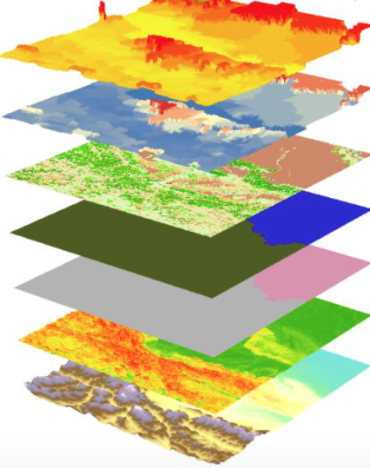
The last census of Afghanistan took place in 1979, and security concerns have prevented a more recent one. As an example of applying innovative data in unstable circumstances, the Government of Afghanistan requested the help of the United Nations in estimating the current population. Under the leadership of the United Nations Population Fund (UNFPA), the United Nations team in Afghanistan is currently providing technical support in collaboration with Flowminder, an organization that collects, aggregates, integrates and analyses anonymous mobile data, satellite and household survey data. UNFPA and Flowminder collaborate in Afghanistan to generate maps of the population using an ongoing socio-demographic survey, satellite imagery, other remote sensing data, urban data and GIS statistical modelling.
Source: Flowminder. 2016

Figure 3. Output of population estimation per grid based on combination of data sources
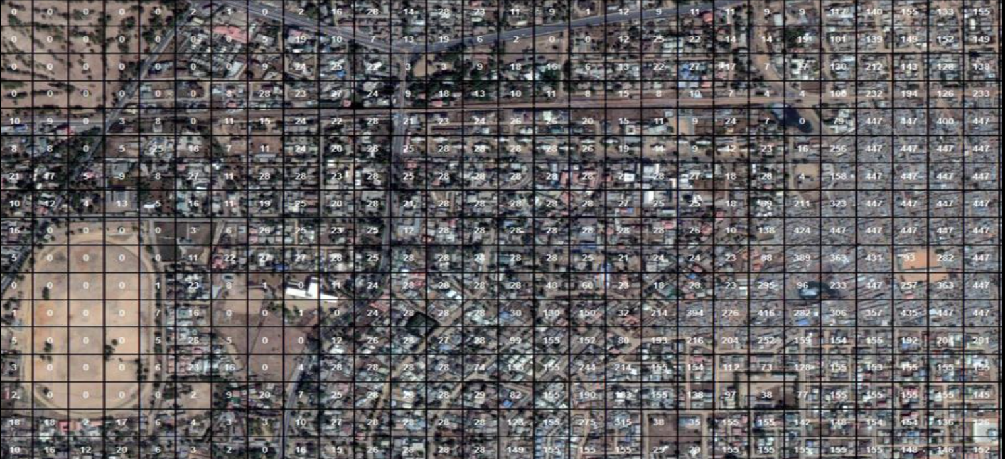
Source: Flowminder
- While these approaches need a strong demographic evidence base for calibrating big data, innovations and new technologies need to be embraced and integrated into the world’s growing data ecosystems. To achieve these aims, strong national statistical systems are required within each country, connecting the entire plethora of data producers and users, together with institutional capacity to use and integrate diverse types and sources of data.

- Countries will need to raise the political priority of national statistical systems to implement and monitor the Sustainable Development Goal agenda; prioritize long-term growth of institutions; redefine a central coordinating role for strengthened NSOs; and develop strategies for data collection and acquisition that are embedded within efforts to improve the use of such data by Governments and civil society to advance human rights and equality.

- While data from existing mechanisms should be used where possible, they will be unable to completely deliver all the evidence required for the level of ambition and complexity of the Sustainable Development Goals. Collecting and capturing data have become much easier than in previous decades and this is a key driver of big data. Benefits of big data include more data observations, higher frequency and greater granularity. All of this generates large volumes of data with accompanied challenges in terms of data management and analysis. This is a great opportunity to ensure gender-disaggregated data at all levels.
- While big data sources provide data in (near) real time, they offer a potentially interesting input for official statistics, for use both on their own and in combination with traditional data. Big data have the potential to produce more relevant and timelier statistics than traditional sources. Triangulation and the ability to integrate multiple types of data are therefore essential to effectively harness big data for sustainable development. Combining new information sources and traditional ones can result in powerful outcomes for achieving the 2030 Agenda more efficiently and effectively, addressing inequalities, closing existing global gender gaps and ensuring that no one is left behind.

- UNFPA and the Global Pulse Lab Kampala collaborated on a project to explore the use of real-time digital data to understand debate among Ugandans on contraception and teenage pregnancy, and to analyse perceptions of different types of contraception. The project resulted in a real-time interactive dashboard that analyses public Facebook posts and data from U-Report (a text message-based polling system for Ugandan youth developed with the United Nations Children's Fund (UNICEF)) for keywords related to contraception and teenage pregnancy. The dashboard allows for month-by-month tracking of emerging and trending topics and perceptions related to family planning. This project demonstrated the potential of using social data to supplement traditional means of gaining insights through less-frequent national surveys. In Uganda, teenage pregnancy is at a high level of 24 per cent and young women aged 15-24 years are a high-risk group for contracting HIV.

Figure 4. Relative frequency of messages mentioning different contraception types
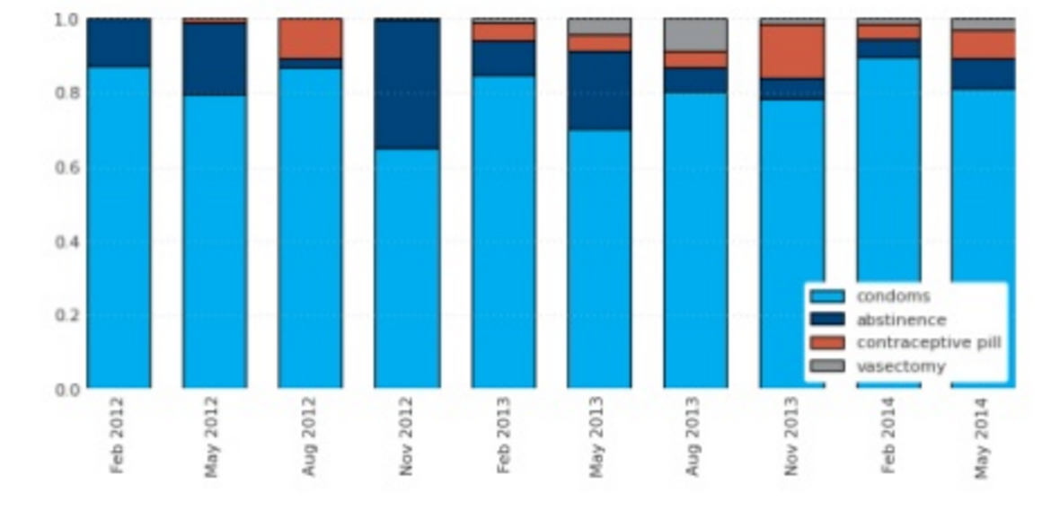
Source: UNFPA and United Nations Global Pulse
- Big data can feed into ongoing statistical activities and processes to measure progress towards the Sustainable Development Goals in various fashions:

- big data allow for descriptive analysis of inequalities via maps and other visualizations;

- big data allow making predictive inferences about current conditions and forecasts about future events;

- big data can be used in a diagnostic function to unveil causal relationships between digital behaviour and development outcomes, and help to suggest specific interventions.

- Acknowledging that national and international systems still release most of their information and procedures in the form of unstructured text, from legal documents to budgets or programmes, UNICEF is experimenting with the use of natural language processing and machine learning mechanisms to produce digestible views and draw global conclusions by automatically processing large collections of texts. Initial work includes the analysis of constitutional texts to understand influence and adoption of provisions, as well as large collections of UNICEF daily brief reports to understand global priorities and pressing programmatic or humanitarian issues. This work has been done in conjunction with researchers from the Massachusetts Institutes of Technology (MIT), the Commonwealth Scientific and Industrial Research Organisation and Graphext.

II. Key issues and challenges
A. Big data capacity
- The key challenge is leveraging and utilizing big data to support the implementation and monitoring of the Sustainable Development Goals. Knowing when, where and the extent to which conditions are changing that either hinder or advance desirable development outcomes is potentially invaluable information because it allows managers to make midcourse corrections; i.e., necessary and effective changes or adjustments to policies, investments and programmes.

- Strong national statistical systems within each country should incorporate alternative and new, dynamic data sources and include the institutional capacity to harness these data sources to ask critical questions driving sustainable development. The 2030 Agenda places NSOs at the core of the monitoring of the Sustainable Development Goals. The Secretary-General’s Independent Expert Advisory Group on the Data Revolution for Sustainable Development recommends that countries strengthen the capacities of their NSOs to accomplish a data revolution.

- Even beyond the necessity of measuring progress towards the Sustainable Development Goals, NSOs are mandated to generate knowledge about and for the societies in which they work. The Global Working Group on Big Data for Official Statistics, created by the United Nations Statistical Commission, recognized the importance of exploring new data sources such as big data to meet the expectations of the new development agenda, including by ensuring the generation of gender-responsive data at all levels. As stated in the Fundamental Principles of Nation Official Statistics, “Official statistics provide an indispensable element in the information system of a democratic society, serving the Government, the economy and the public with data about the economic, demographic, social and environmental situation”.

- However, NSOs in developing countries often lack sufficient capacity and funding, and those deficiencies extend to data producers and users in other parts of government, academia, civil society and the private sector. Monitoring a new set of Sustainable Development Goals will not be possible without new and sustained investments in building resilient national statistical systems and capacities across the board, focused on the integration of existing and new forms of data.

B. Big data digital divide
- Least developed countries seldom possess adequate infrastructure and resources to produce, process and leverage big data. Poor countries have little access to modern technologies that enable big data, including supercomputing, data centres, broadband and ubiquitous Internet access. Thus there is a strong probability of a digital divide extending to the big data realm, which would leave poor nations further behind.

- The digital divide refers to the gap between demographics and regions that have access to modern information and communications technology, and those that do not or have restricted access. This is particularly pronounced around gender, when access to and sophistication of use of technologies for generating big data such as mobile telephones and social media are affected by cultural or social norms. Similarly, a rural/urban divide may exist, where urban areas are more densely populated and better serviced by infrastructure than rural areas. Education and income levels can also be a discriminating factors, where better educated and higher-income groups are more active on social media than lower-income people who cannot afford the comparatively high costs of access to new technologies and the Internet. These disparities raise legitimate questions about the representativeness of available big data. They also provide an opportunity to use big data as a tool for addressing such gaps.

C. Key partnerships for critical new functions in operationalizing big data
- Measuring progress towards achieving the Sustainable Development Goals will require a steady flow of high-quality, disaggregated, timely, authoritative and accessible data. Through the Statistical Commission, the United Nations system collaborates in sharing statistical and big data datasets and works to close key gaps in access and use of data for sustainable development. The United Nations system also exercises a leadership role and long-standing convening power to bring together Governments, the private sector, civil society organizations, the media and academic institutions in order to ensure the data serves sustainable development.

- UNICEF is currently exploring how to use finance and corporate data from Bloomberg L.P. to fill data gaps related to children in a number of areas (e.g., poverty, corporate social responsibility, flow of remittance data, sentiment analysis of online news, etc.). UNICEF is also collaborating with mobile network providers in Brazil to overlay data that show critical areas for Zika virus infection and possible spread areas based on people’s mobility. In addition, with support from Google, Global Pulse and others, UNICEF is building a platform ('Magic Box') for real-time information and analysis that can be used in moments of global crisis and exogenous shock. To be effective, the platform needs to be fed with real-time information from private-sector partners. However, despite an increased awareness and experimentation in establishing data collaboratives, there exists little consensus about best practices and only a provisional understanding of how precisely data can be safely shared and used to enhance the public good. As a result, UNICEF has partnered with the New York University GovLab to catalyse data collaboratives and data philanthropy, especially with the private sector. The partnership seeks to draw on concrete examples of collaborations to build capacities, tools, policies and frameworks to enable sharing of data based on good practices.

- The United Nations system will facilitate partnerships to build data capacity within countries. To do so, private-public partnerships need to be identified to leverage expertise and analytical capacities and to strengthen access to and use of data. Since access to big data datasets is challenging, the United Nations funds and programmes will benefit from each other’s success as well as that of other United Nations partners in securing access to datasets.

- In April 2015, the United Nations System Chief Executives Board for Coordination (CEB) adopted a programme of work on the data revolution, which is designed as a starting point towards a comprehensive United Nations system approach to the data revolution. The programme of work aims to encourage all entities to join efforts in a coordinated manner to ensure that reliable, timely and accurate data informs development policy-making. On behalf of CEB, WFP and UNICEF are spearheading a big data innovation lab that will explore key aspects of operationalizing big data for United Nations organizations. The first meeting that will gather key United Nations stakeholders on big data is planned for May 2016.

- The United Nations funds and programmes will work to improve the United Nations reputation in the data science research community to lead research and development with academia on using big data for humanitarian and development work and for the most deprived.

- Advocacy efforts with Governments will be focused on generating an enabling environment for data access, ensuring the use of big data as appropriate when planning for interventions towards implementing the Sustainable Development Goals. Close collaboration with civil society and the private sector is of great importance to fostering ownership, innovation and integration of third-party big data sources in national statistical systems. Partnerships will be fostered with regional development banks, the World Bank and the private and public sectors to mobilize resources for strengthening national statistical systems and administrative sources, such as single civil registries, that can underpin national data analytics.

D. Data ethics, privacy and data protection guidance
- It is essential to integrate new data sources and technologies both in humanitarian assistance and in the process of achieving the Sustainable Development Goals. This integration cannot be done without proper data privacy and data protection frameworks and mechanisms to ensure that responsible data practices are implemented from the start.

- While attention to data privacy and data protection is growing globally, there are still many challenges, some of them due to a fragmented regulatory landscape; lack of privacy-enhancing methodologies and tools to ensure that the data can be used safely and freely for humanitarian and development causes; insufficient understanding of risk, harms and positive impacts; and a lack of risk-mitigation mechanisms, data literacy, capacity and expertise to address data-related challenges specific to humanitarian and development contexts. A number of United Nations agencies and partner organizations have taken steps to establish privacy and data protection policies and mechanisms in their practices. Global Pulse developed and implemented data privacy and protection principles, and established the Data Privacy Advisory Group. A number of United Nations agencies have been party to the development of the nine Principles for Digital Development.

- It is clear that the use of non-traditional data sources in humanitarian and development contexts requires further exploration and development of standards and frameworks. Norms and standards for using big data as well as data governance and open data access will need to be developed and disseminated. The United Nations system will base its work on the principles of data quality and integrity, disaggregation, timeliness, transparency and openness, human rights capacity development and data utilization for the development of policies and interventions. Terms and conditions for accessing the data from third-party entities should be clearly expressed.
E. Generating an enabling environment
- The data revolution is at the centre of the United Nations system-wide approach to policy engagement and capacity development at the country level. United Nations funds and programmes will increase their efforts in this direction, particularly within the context of the need to monitor progress towards the Sustainable Development Goals and partnerships with the private sector and other non-State actors to create an enabling environment for big data to serve sustainable development.

- In collaboration with different researchers from academia (MIT, Louvain), the United Nations, the private sector, Flowminder and Global Pulse, as well as mobile network operators such as Orange, Telefonica and Telenor, UNICEF has been analysing data-sharing modalities for a privacy-conscientious use of mobile phone data. In collaboration with Global Pulse and Real Impact Analytics, UNICEF developed and implemented such protocols during the Ebola epidemic, allowing privacy-conscious aggregation of data on human mobility to be shared in almost real time by the mobile network operators. UNICEF has been exploring how this data can be used to predict the risk of epidemics spreading, to improve monitoring of mobility restrictions and to better target communication campaigns and resource allocation such as temperature control posts.

- The United Nations system will work at global, regional, national and subnational levels to support South-South, North-South and triangular cooperation on big data methods and technology.

Figure 5. The National Infrastructure Systems Modelling (NISMOD) development platform
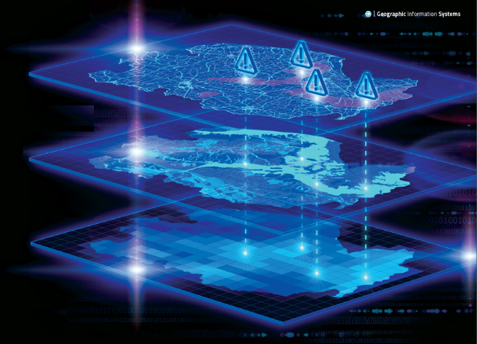
Source: Infrastructure Transitions Research Consortium (ITRC) Environmental Change Institute – University of Oxford
- The United Nations Office for Project Services (UNOPS), under its mandate for infrastructure and related capacity development, has formalized a partnership with Oxford University to roll out the latest infrastructure best practice, developed by the University on behalf of the Government of the United Kingdom under its Infrastructure Transitions Research Consortium. This new approach makes full and effective use of big data in modelling infrastructure systems in uncertain future scenarios, fully encompassing the demands of the Sustainable Development Goals related to resilience, sustainability and climate change which will affect all infrastructure systems and their future performance. With the development and implementation of this leading-edge ‘modelling and systems view’ of national infrastructure, including detailing of the interdependencies between infrastructure systems, ‘best practice’ models can be employed to project scenarios of the long-term demand for infrastructure. This when collated into a coordinated national infrastructure plan, can provide well-informed evidence of what infrastructure systems are required, and when, to meet these demands.

- Additionally, models can be used to assess the short-term resilience of systems, highlighting which critical assets within the systems to safeguard in order to prevent failures cascading through infrastructure systems. This approach will enable the Governments of pre- and post-disaster, fragile and conflict-affected States to deliver their national vision/development plans. The system facilitates evidence based decision-making and robust business case justification, and generates long-term certainty around investments and thereby reduces the risks the investment decision. This in turn generates the confidence needed to attract large-scale international private investment in infrastructure systems, placing these Governments in a position where they can attract the substantial international private investment in infrastructure that they so urgently require. UNOPS and Oxford University are currently rolling out this system under the auspices of the Government of the State of Palestine and are looking to do so in five or six other countries in East Africa and South East Asia.

Figure 6. National model of long-term performance of infrastructure system
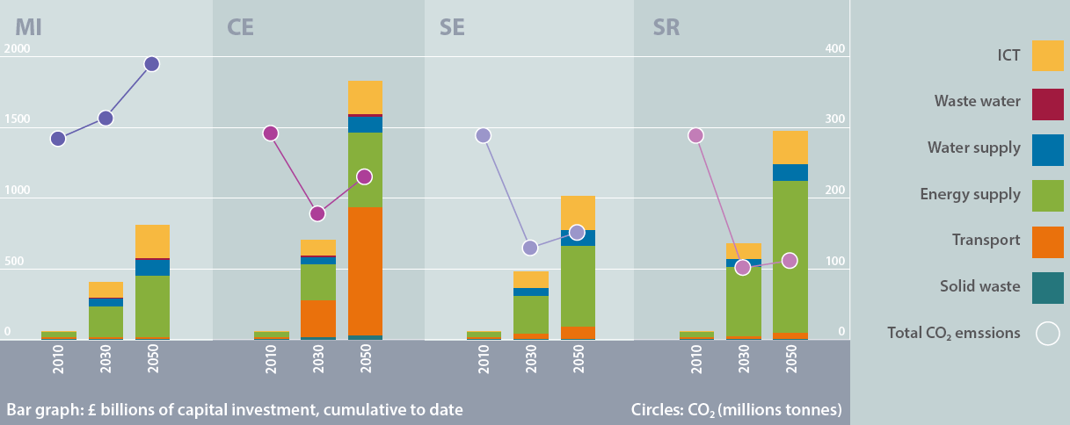
Minimum intervention (MI): Historic levels of investment, continued maintenance and incremental system change.
Capacity expansion (CE): Large-scale, long-term investment in physical capacity expansion.
System efficiency (SE): Technological and policy interventions to increase system throughput targeting supply and demand.
System restructuring (SR): Rethinking the system through innovation, design, new service delivery models, demand reduction.
Source: Infrastructure Transitions Research Consortium Environmental Change Institute –University of Oxford
- Norms and standards for using big data as well as data governance and open data access will need to be developed and disseminated. Privacy considerations are of utmost importance. The United Nations system aims to create a culture of big data for sustainable development and build capacities at all levels. To this end, the United Nations needs to attract and incorporate talent from academia and the private sector to make progress on big data methods and technology, including the development of a multilevel data collection infrastructure (e.g., data centres, back-up system). Country-level initiatives in statistical capacity-building need to integrate advocacy and facilitate local discussion, especially in countries with lesser capacities (least developed countries, fragile States, etc.).

- Lessons learned and conclusions

- There are huge expectations that big data and new technological innovations will be able to provide a much stronger evidence base for more effective, resilient, inclusive and sustainable development investments. However, consensus has not yet been attained about the best ways to capitalize on this emerging resource. There is limited knowledge about how to maximize the benefits of data sharing and minimize its associated risks, such as potential threats to privacy and competition. To address this, a number of United Nations country teams (UNCTs) have established 'data for development' theme groups or programme coordination groups, and more than 100 UNCTs are supporting the development of national data ecosystems and statistical capacities. The launch of the 2030 Agenda offers a historically unique opportunity to increase and structure collaboration in support of national data ecosystems, which when functioning effectively will significantly contribute to the overarching principle behind the Sustainable Development Goals of “no one left behind”.

_______________

The national statistical system is the ensemble of statistical organizations and units within a country that jointly collect, process and disseminate official statistics on behalf of national government.
Data Pop Alliance (2016): Opportunities and Requirements for Leveraging Big Data for Official Statistics and the Sustainable Development Goals in Latin America (page 6).
Noting that the accuracy and verification of remote sensing in its current form is as yet open to question and difficult to verify.
United Nations Economic Commission for Europe, (2014): Big data and modernization of statistical systems.
United Nations Global Pulse, “Analysing Attitudes towards Contraception and Teenage Pregnancy Using Social Data,” Global Pulse Project Series, no.8, 2014. (http://unglobalpulse.org/UNFPA-social-data).
Data Pop Alliance (2016): Opportunities and Requirements for Leveraging Big Data for Official Statistics and the Sustainable Development Goals in Latin America (page 9).
United Nations Secretary-General’s Independent Expert Advisory Group on a Data Revolution for Sustainable Development (2014): A World That Counts: Mobilising the Data Revolution for Sustainable Development.
http://unstats.un.org/unsd/bigdata/.
Adapted from Letouzé, E. (2013): 6 Considerations on Official Statistics and the (Big) Data Revolution.
http://www.unsceb.org/content/report-29th-session-march-2015-paris
General Assembly resolution 69/166 of 18 December 2014 addressed the right to privacy in the digital age. In its resolution 28/16, the Human Rights Council appointed a Special Rapporteur on the Right to Privacy in July 2015. Both actions reaffirmed the escalating need to address data and privacy rights globally.
http://www.unglobalpulse.org/privacy.
http://digitalprinciples.org/
In its resolution 65/176 of 20 December 2010, the General Assembly reaffirmed the role of UNOPS as a central resource for the United Nations system in procurement and contract management as well as in civil works and physical infrastructure development, including the related capacity development activities. See also Economic and Social Council resolution 2010/23 and decisions 2008/35, 2009/25, 2010/7 and 2010/21 of the UNDP/UNFPA/UNOPS Executive Board.

