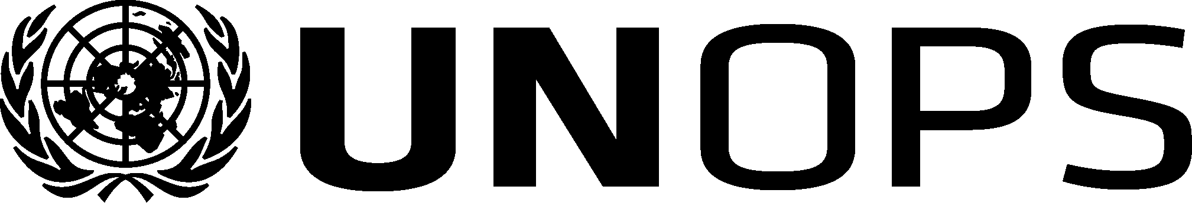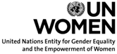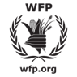

Agenda

2017 Joint Meeting of the Executive Boards of

UNDP/UNFPA/UNOPS, UNICEF, UN-Women and WFP
19 June 2017
Conference Room 4 (CB), United Nations, New York

Monday, 19 June 2017
Morning segment – 10.00 a.m. to 1.00 p.m.
10:00-10:05  10:05-10:10 | Welcome remarks by the Chair: President of the Executive Board of UNICEF,  H.E. Mr. Walton Alfonso Webson, Permanent Representative to the United Nations, Antigua and Barbuda  Opening statement by Ms. Amina J. Mohammed, Deputy Secretary-General of  the United Nations
Morning TOPIC:
Operationalizing the decisions of the QCPR, specifically taking into consideration climate change and building resilience
10:10-10:15  10:15-10:20  10:20-10:40  10:40-12:40  12:40-12:50  12:50-12:55  12:55-1:00 | Remarks by the UNICEF Executive Director,  Mr. Anthony Lake  Remarks by the UNOPS Executive Director,  Ms. Grete Faremo  Guest speakers:  - Dr. Themba Mhlongo, Deputy Executive Secretary, Southern African Development Community (via video link)  Presentation: UN system’s collective role in supporting implementation of the 2030 Agenda and building resilience at the country level  - Ms Shoko Noda, United Nations Resident Coordinator to the Maldives  Presentation: UNCT collaborative work, including developing the new UNDAF and implementing the SOPs  Moderated dialogue between the Presidents of the Executive Boards of UNDP/UNFPA/ UNOPS, UNICEF, WFP and UN-Women, the six Principals of United Nations agencies (UNDP, UNFPA, UNICEF, UNOPS, UN-Women and WFP), and interactive session with the membership of the Executive Boards.  Moderator: President of the Executive Board of UNDP/UNFPA/UNOPS  H.E. Mr. Ib Petersen, Permanent Representative of Denmark to the United Nations  Guest speaker:  - Mr. Elliot Harris, Assistant Secretary-General and Head of the New York Office, United Nations Environment Programme  Presentation: On the system-wide strategies adopted by HLCP and the collective role of the UN development system in supporting climate change and resilient development  Closing remarks by the UNDP Administrator  Mr. Achim Steiner  Closing remarks by the President of the Executive Board of UNDP/UNFPA/UNOPS  H.E. Mr. Ib Petersen, Permanent Representative of Denmark to the United Nations
Afternoon segment – 3:00 p.m. to 6:00 p.m.
15:00–15:05 | Opening remarks by the Chair: Vice-President of the Executive Board of UN-Women,  H.E. Ms. Ivana Pajević, Deputy Permanent Representative of Montenegro to  the United Nations
Afternoon TOPIC:
Working with adolescents and youth to achieve the Sustainable Development Goals

15:05–15:10  15:10–16:10  16:10–16:15  16:15–17:50 | Remarks by the UNFPA Deputy Executive Director  Ms. Laura Londén  Guest speaker  - Ms. Ruxanda Renita (Cuba), United Nations Major Group for Children and Youth  Presentation: Young people shaping and implementing the SDGs  - Short videos from a range of youth organizations from around the world  - Ms. Irem Tumer, Youth Advocate (Turkey) and UNFPA Youth Innovation Fellow  Presentation: Youth leadership and engagement in the UN – opportunities,  challenges and the way forward  Remarks by the Executive Director of UN-Women,  Ms. Phumzile Mlambo-Ngcuka  Interactive session between the Presidents of the Executive Boards of UNDP/UNFPA/UNOPS, UNICEF, WFP and UN-Women, the six Principals of  United Nations agencies (UNDP, UNFPA, UNICEF, UNOPS, UN-Women and WFP), and the membership of the Executive Boards  Moderator: President of the UNICEF Executive Board,  H.E. Mr. Walton Alfonso Webson, Permanent Representative to the United Nations, Antigua and Barbuda
17:50–17:55 | Closing remarks by the Deputy Executive Director of WFP,  Mr. Amir Abdulla
17:55–18:00 | Closing remarks by the Vice-President of the Executive Board of WFP,  Mr. Zoltán Kálmán, Minister Plenipotentiary and Permanent Representative of the  Republic of Hungary to the United Nations Food and Agriculture Agencies in Rome

