United Nations Development Programme
Frequently asked questions about cost-recovery

- What is the difference between regular and other resources? What is the difference between core and non-core resources?
Regular resources are sometimes referred to as ‘core’ resources. Similarly, other resources, comprised of thematic funds, UN pooled funding, funding earmarked for programmes or projects and vertical funds, are referred to as ‘non-core’ resources. The diagram below provides a brief description of the different types of funding.
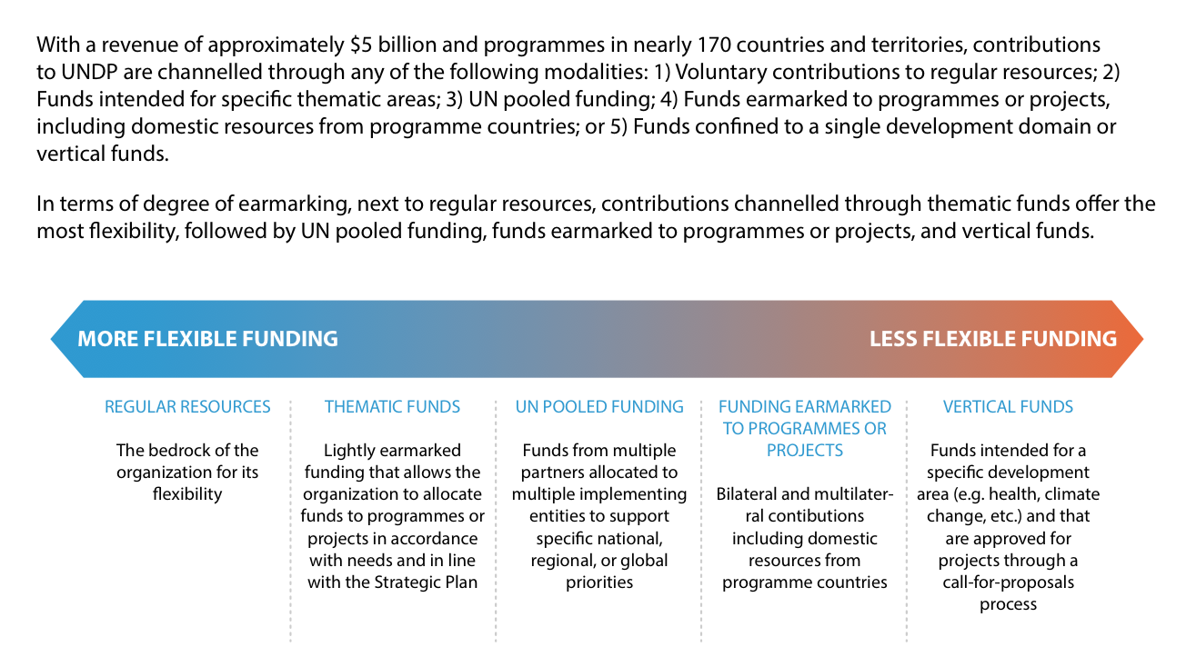
(Source: http://www.undp.org/content/dam/undp/library/corporate/Partnerships/Funding%20Compendium%202015.pdf )

- What are core contributions used for?
Regular resources contributions enable UNDP to leverage its key strengths to deliver on its Strategic Plan as illustrated in the figure below.

- What is meant by the term ‘harmonized approach’ when discussing cost recovery? What is the difference between ‘harmonized approach to cost classification’ and ‘harmonized approach to cost recovery’?

The term ‘harmonized approach’ refers to the principle that methodologies for cost classification and cost recovery are aligned. The principle applies to UNDP, UNICEF, UNFPA and UN Women (‘the four agencies’).

A ‘harmonized approach to cost classification’ refers to the categories approved by the Executive Board by which the four agencies all classify their activities and related costs:
- Development activities, with subcategories (a) Programme activities; and (b) Development effectiveness activities;
- UN Development Coordination activities;
- Management activities; and
- Special Purpose activities.

A ‘harmonized approach to cost recovery’ relates to the work of the four agencies to ensure there is a transparent methodology for calculation of a recovery rate in line with the classifications noted above. The Executive Boards of the agencies decided on the harmonized approach to cost recovery (EB decision 2013/9 for UNDP/UNFPA refers).

- Please explain the harmonized building block (LEGO) approach to cost recovery.
The essence of the ‘LEGO’ approach presented to the Executive Board in April 2017 is to provide a conceptual model to assist the Executive Board in its consideration of which Institutional Budget costs should be funded by core resources vs. those that should be charged via cost recovery from project activities. The costs could be ‘built’ beginning with the most essential activities first, with other activities’ costs being added (with additional blocks).

- Do other Funds and Programmes under the 2013 harmonized cost recovery EB decision have positive results?

Below is an overview of the progress made over the 2014-2016 period in the effective average cost recovery rates from the four agencies (source: April/2017 presentation to the Executive Board)

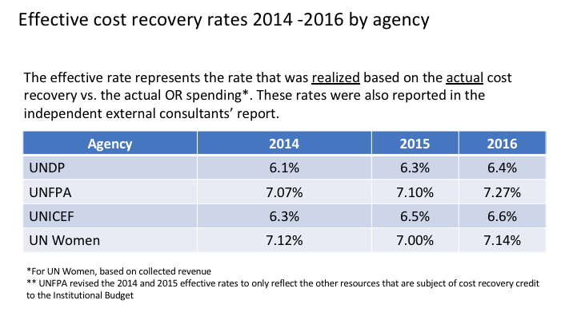

- How does country categorization (e.g., graduation to MIC status) affect cost recovery policy and resources available to MICs?

Country categorization does not per se affect the application of the cost recovery policy and resources available to MICs. Cost recovery policy (i.e., what rates are charged) is driven by the policies approved by the Executive Board and relates to the funding channel through which contributions are received.

- If core contributions have decreased, why has the cost recovery rate stayed the same?

The effective average cost recovery rate that UNDP has charged over the past three years has not stayed the same. It has increased from 6.1 per cent in 2014 to 6.4 per cent in 2016.

- What are the definitions of: (i) cost recovery; (ii) indirect costs; and (iii) direct costs?

The chart below illustrates and defines the relationship among cost recovery, indirect costs and direct costs.
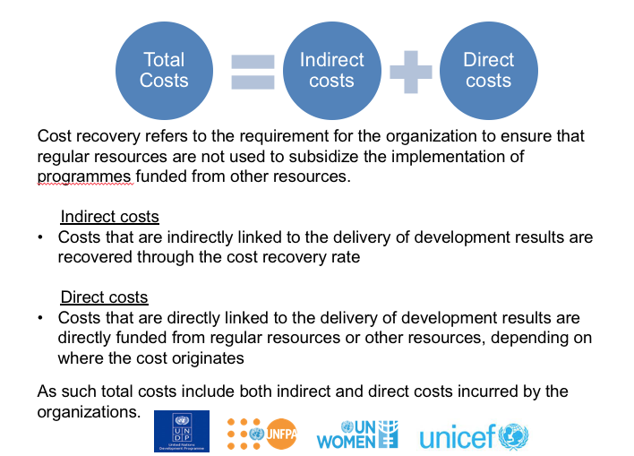

Note: This information was included in the February 2017 presentation by the four agencies to the joint Executive Boards.

- What are the definitions of GMS and DPC?

The nature of GMS (General Management Services) and DPC (Direct Project Costs) and the types of expenses categorized under each are in the table below:

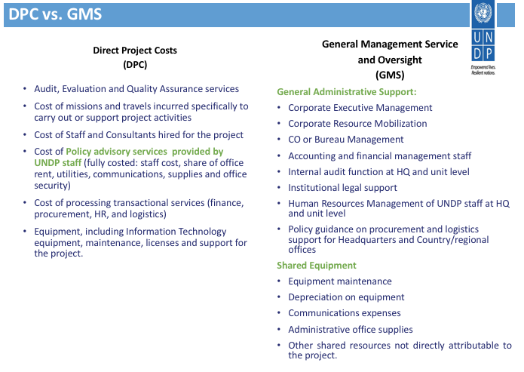
- What is the definition of GLOC?

GLOC is an abbreviation for ‘Government Local Office Cost Contributions.’ It is defined as contributions (in cash or in-kind) from programme governments to offset the cost of UNDP’s local office presence in the respective programme country.

- What is a GMS (cost recovery) waiver? Does UNDP still approve waivers?

A GMS waiver is approval by an agency to apply a cost recovery rate lower than the standard rate. The Executive Board decided that the head of each agency could grant a waiver of the standard cost recovery rate under exceptional circumstances as defined by the agency. The four agencies are tasked to report the number of waivers in their respective annual reports. The table below summarizes the number of waivers granted during the period 2014-2016.

Number of Waivers | 2014 | 2015 | 2016
UNDP | 24 | 9 | 12
UNFPA | 3 | 6 | 8
UNICEF | 1 | 9 | 0
UN Women | 1 | 1 | 6

- How does UNDP align its cost recovery policy with national policies which may limit/cap cost recovery?

UNDP is guided by the decisions of the Executive Board on its cost recovery policy.

- When UNDP says that its cost is 8 cents to 1 dollar, what costs is it referring to? Direct costs? Programme costs?

UNDP is referring to its management costs, which it has estimated are 8% (eight cents) of each dollar of programme resources.

- What are the transitionary measures?

The Executive Board has approved use of a limited amount of regular resources in the integrated budgets (2014-17 and 2018-21). These so-called transitionary measures were intended to financially ‘bridge’ the transition period until the cost recovery methodology approved by the Executive Board can take full effect. The need for such measures was highlighted in DP/FPA/2013/1, and illustrated during the discussions on cost recovery held at the first regular session 2013 of the Executive Board.

- Where can we find the EB decisions and documents relevant/related to cost recovery?

The pertinent EB documents and decisions related to cost recovery can be found on the Executive Board websites of the respective agencies. See below overview with URLS.

- DP-FPA/2012/1 - Roadmap to the integrated budget: Joint UNDP, UNFPA and UNICEF review on the impact of cost definitions and classification of activities on harmonized cost-recovery rates

- DP-FPA/2013/1 - The road map to an integrated budget: joint review of the impact of cost definitions and classifications of activities on the harmonized cost recovery rates

- DP/2014/2 - UNDP Executive Board decision 2013/9, on the ‘Road map towards an integrated budget, beginning 2014, and update on cost recovery’ (pgs. 10-12)

- DP/2017/2 - UNDP Executive Board decision 2016/16 on ‘UNDP funding issues’ (pgs. 20-21)

- DP/2018/3 - UNDP Executive Board decision 2017/11 on the ‘Cumulative review of the UNDP Integrated Budget, 2014-2017; (pgs. 11-12)

- What specific types of expenses are included in each cost classification category?

The types of expenses included in each category are described below. The four agencies all utilize the same classification system.

Development activities: costs associated with ‘programmes’ and ‘development effectiveness’ activities which contribute to the effective delivery of development results, as follows:
Programmes: activities and associated costs traced to specific programme components or projects, which contribute to delivery of development results contained in country/regional/global programme documents or other programming arrangements;
Development effectiveness: the costs of activities of a policy-advisory, technical and implementation nature that are needed for achievement of the objectives of programmes and projects in the focus areas of the organizations. These inputs are essential to the delivery of development results, and are not included in specific programme components or projects in country, regional, or global programme documents.
United Nations development coordination: activities and associated costs supporting the coordination of development activities of the United Nations system.
Management: activities and associated costs whose primary function is the promotion of the identity, direction and well-being of an organization. These include executive direction, representation, external relations and partnerships, corporate communications, legal, oversight, audit, corporate evaluation, information technology, finance, administration, security and human resources.
Special purpose: activities and associated costs of a cross-cutting nature that (a) involve material capital investments; or (b) do not represent a cost related to the management activities of the organization.

