Annex 2. UNCDF Strategic Framework 2018-2021: Theory of change

Aligned with the 2030 Agenda, with a primary focus on SDG 1 on poverty eradication and SDG 17 on the means of implementation, UNCDF aims, under its Strategic Framework, 2018-2021, to promote the social and economic transformation of least developed countries (LDCs). It seeks to achieve this by helping to build inclusive financial markets and local development finance systems and to unlock public and private finance that can help LDCs get more and better resources flowing to the local level.

UNCDF is designed to have a risk tolerance to operate where few others see viability and seeks to create demonstration value for changing the dynamic of how risk is perceived and addressed in the public and private sectors, so that more and better resources flow to poor men and women, small businesses, and local governments so that they can build a better future. UNCDF’s work provides concrete examples of how LDCs can bring public and private capital and approaches together for more SDG-positive and inclusive results. The potential for scaling up is critical to UNCDF’s business model, and is reflected in UNCDF’s approaches, results indicators, and theory of change.

This document outlines the theory of change underlying the results chain of the Strategic Framework, 2018-2021. The full results chain has three tiers – impact, outcomes and outputs – supported by the financing model and institutional enablers. It articulates UNCDF’s priorities in targeting poor and vulnerable populations to reach the last mile, and presents a gender-responsive theory of change (Annex 3 to the Strategic Framework), which explains how UNCDF’s work specifically addresses gender equality and women’s economic empowerment.

Output to Outcome pathways

UNCDF’s Strategic Framework presents two mutually-supportive outcomes:

- Enhanced inclusive financial markets and local development finance systems that benefit poor and vulnerable populations, and
- Unlocked public and private finance for the poor.

Progress under each outcome requires, and contributes to, progress under the other. For example, helping to build inclusive financial markets contributes to helping poor households and SMEs access finance; and unlocking public and private finance for local investments helps build robust local development finance systems. The end goal is to create inclusive, equitable, and resilient financial markets and local finance systems that are more efficient and effective in their ability to empower poor men and women, SMEs, and local governments in LDCs.

Figure 1. Results chain under UNCDF Outcome 1

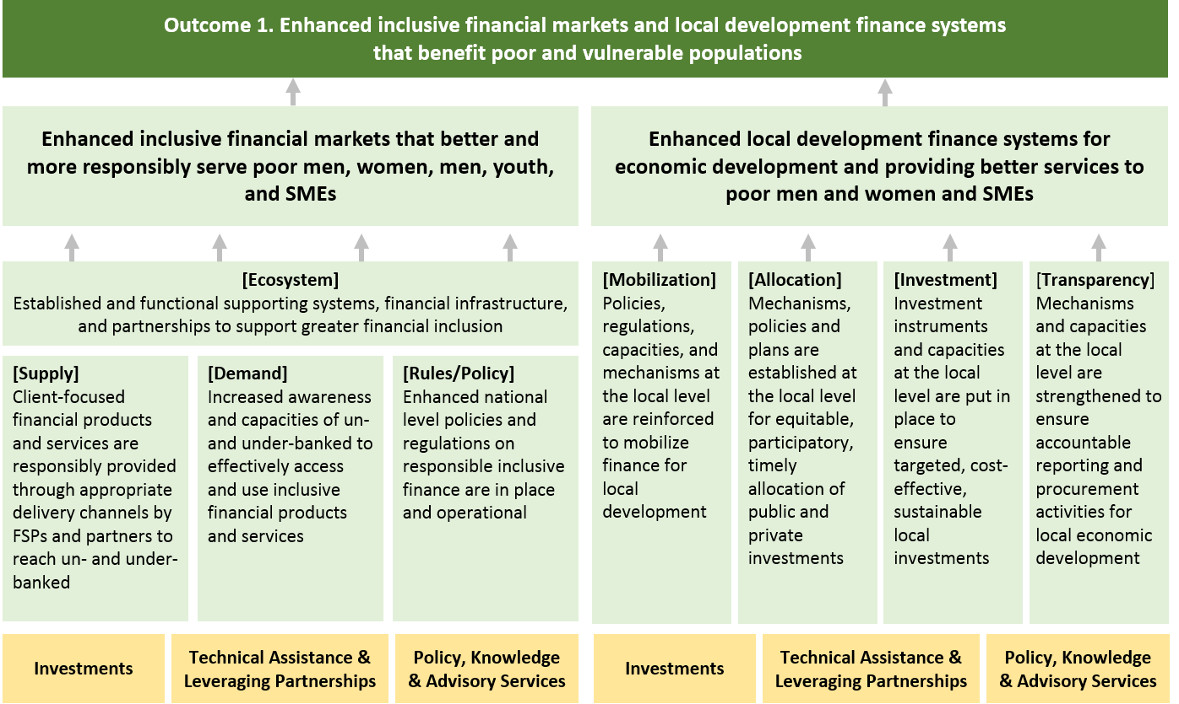

Outcome 1 focuses on promoting markets and systems change through inclusive financial market systems and local development finance systems that specifically target poor and vulnerable populations and households. The two systems are inter-related in that resources such as domestic savings mobilized by the expansion of financial markets can be invested in local development systems that boost economic development at the local level. Also, the creation of digital payments infrastructure can create the possibilities for greater transparency in local resource management.

A systems- and market-development approach recognizes that systems and markets are composed of multiple factors and actors, and that changing those systems and markets therefore requires sustained actions on multiple fronts that can affect those various factors and actors. For UNCDF – with its limited and focused application of resources – changing local systems and markets involves in-depth data collection and diagnostics; testing out ideas with practical pilots through public and private actors who bring their own equity or sustainability models; providing demonstration effect on financial viability and change in poor people’s lives; and influencing follow-on behaviour change in markets and investment patterns for replication/scale.

UNCDF specifically positions its interventions in a space where few other financing actors see viability to operate, and explicitly embeds in its programme design and implementation the need to work with national authorities as well as many funding and implementing partners to consolidate and then scale what works.

This way, UNCDF is able to alter how risk is perceived and addressed in the public and private sectors; shift the dynamics of how public and private investments are allocated to the local level; and reveal markets and opportunities to a wider pool of investors, so that more and better resources flow to the poor men and women, small businesses, and local governments so they can build a better future.

In its work on financial inclusion, UNCDF operationalizes its inclusive financial market systems approach by focusing broadly on ecosystems development, through which it seeks to influence three dimensions of 1) supply, 2) demand, 3) rules, policies and norms. UNCDF deploys a strong set of data-driven diagnostics to understand the dynamics of the financial ecosystem and creates national platforms to enhance coordination and engagement among financial inclusion stakeholders. This helps create the enabling environments that foster innovations and scale up in financial inclusion.

Combined with this policy level change, UNCDF also partners with financial service providers, including mobile network operators, financial technology (fintech) firms, domestic banks, and microfinance institutions to create a ‘safe’ environment for testing and carrying out an iterative process to design client-oriented financial innovations that can reach underserved populations in LDCs. This human-centred design can be key to understanding differences between women, men, adolescent girls and boys, and adjusting products and services to meet their needs. In these cases, for example, UNCDF supports service providers to create ‘innovation labs’ where they can engage with outside experts and funders to design and test variations of services, pricing, transaction channel functionalities, and marketing approaches until the product in question achieves a commercially sustainable level of customer adoption. Using its data and diagnostics, UNCDF also partners with major retail banks to understand customer service needs and gaps and then, through performance-based grants and challenge funds as well as customized technical assistance, helps them provide tailored solutions to improve the access and usage of financial products that target un-banked and under-banked men, women, and youth.

In other cases, UNCDF partners with a range of financial service providers to incentivize them – through performance-based grants with clear metrics attached, challenge funds, technical assistance, as well as data and research that reveal market opportunities – to develop products that target market segments they ordinarily would not reach without UNCDF’s support. Based on how successful and effective these products prove to be, the financial service providers may then decide to retain or expand the offering to the last mile market segments (women, youth, smallholder farmers, etc.). In addition, these demonstration effects – that show the financial viability of serving hard-to-reach or under-banked or un-banked populations – can lead to other market players seeing the opportunity of developing such products and competing to develop products and services to expand the frontier of finance.

In these ways, through its demonstration effects and partnerships, UNCDF is able to help financial markets evolve and become more inclusive; more money is brought from out of the mattresses into formal savings products; and financial service providers have more resources to on-loan to micro- and small- and medium-sized enterprises (MSMEs) and other economic actors.

In local development finance, UNCDF’s approach focuses on mobilizing, allocating, investing, and accounting for increased resource flows, both public and private, to the local level in ways that the market or government can sustainably take to scale. To this end, UNCDF focuses on supporting local governments and municipalities where its fiscal decentralization and blended finance approaches can reduce poverty by boosting local social and economic development. Its interventions aim to enhance capacities of local governments, expand their public investments, and build enabling environments that drive economic transformation at the local level. This includes linking local governments with private sector actors, including domestic banks, local value chains, and enterprises as technical and financial partners for local development.

In the case of fiscal decentralization, for example, UNCDF takes a long-term approach that typically sees UNCDF partner with a small set of local governments in a limited number of regions to test out new responsibilities and enhance capacities to manage, invest, and mobilize resources in ways that are accountable and can transform local economies. For instance, UNCDF provides discretionary development funding to local authorities and strengthens their engagement with the local private sector, so that local businesses can compete for public tenders. These systems have been established in half of the world’s 47 LDCs. These local finance systems also provide a platform for national and local governments to address new and emerging challenges, such as climate change. For instance, UNCDF helped establish intergovernmental fiscal transfer systems to demonstrate their effectiveness in reducing greenhouse gas emissions contributing to reaching the Paris Agreement. In such cases, UNCDF adopts a phased approach, beginning with selected local governments and capturing the lessons before expanding to others. The demonstration effects of this approach also help governments access global climate finance, for example through the Green Climate Fund, by providing a model for accredited National Implementing Entities to access climate finance directly and channel it to the local level for measurable results through a national mechanism. This is more efficient than delivering climate finance through individual time bound projects.

A similar approach is applied to blended finance, where UNCDF works with local governments to develop priority local infrastructure with measurable catalytic and transformative effects, but that have remained under-funded due to a combination of low technical capacity and a high pricing of risk by domestic and international banks. UNCDF identifies projects for which it can provide additionality and not crowd-out the private sector. UNCDF tests finance solutions to demonstrate their effectiveness in leveraging private finance with public funds and enables the public sector to replicate the solutions and take successful business models to scale. UNCDF also supports scale up by working with regulatory bodies, central banks, and ministries of finance to establish an enabling environment for blended finance at the local level.

Under these approaches, blended finance solutions primarily target domestic private finance (eg banks and pension funds), because this broadens and deepens the resilience and depth of domestic financial systems in LDCs. The public sector part of the blend often includes a local government and/or municipal contribution. Local authorities promote the structural transformation of LDCs through their contribution to building local fiscal space and local fixed capital formation. Public sector finance can also include concessional finance from national and international development finance institutions such as the Green Climate Fund and national development banks. The impact measurement of the investments in the pipeline is tightly linked to specific international and national development goals and targets – ideally enshrined in legislation and national commitments, because this creates a sustainable model for taking the blended finance innovation to scale.

Figure 2. Results chain under UNCDF Outcome 2

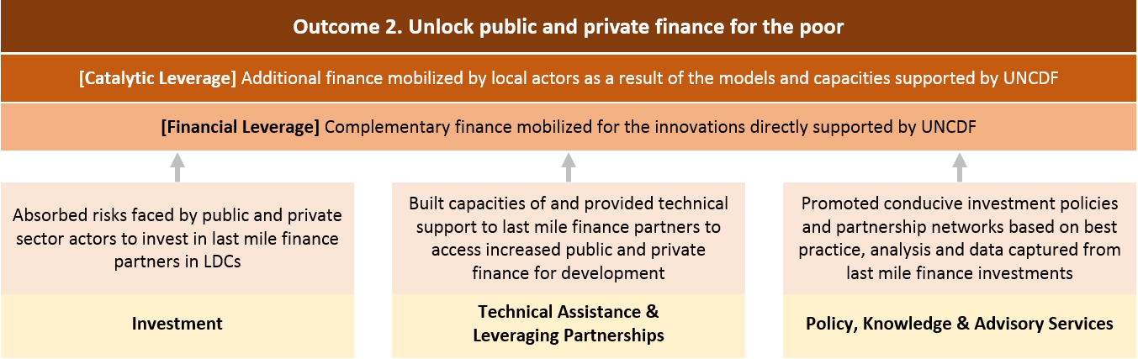

Outcome 2 on unlocking finance for the poor is closely interlinked with and mutually supportive of outcome 1 on market systems development. The transformation of the markets and systems should reveal new market opportunities and reduce risk in investing in the last mile finance sector for public and private investors to crowd-in additional finance, forming a positive feedback loop between outcome 1 and 2.

UNCDF deploys a diverse set of investment tools including grants, loans, and guarantees that are specifically designed to leverage additional resources and extend the reach of the financial mechanisms, systems and markets where they would not go without the incentives and demonstration value provided by UNCDF. UNCDF’s financial and technical support targets a frontier market of SDG-aligned investments where traditional development finance institutions and private sector partners have not yet ventured into at scale. UNCDF focuses on providing capital to initiatives that have been deemed too costly or risky or too small for larger development finance institutions to target.

UNCDF’s approach is to absorb and mitigate some of the risks faced by public actors wary of allocating resources in the last mile, as well as the risks perceived by private sector actors in order to incentivize them to e.g. test new technologies; launch start-ups; or to just expand social impact oriented businesses in geographically very challenging business environments. This is achieved by providing business support or credit enhancements, or both in combination. For instance, UNCDF may incentivize a private bank to provide credit to a project by issuing a subordinated structured loan in a loan transaction. This means that if there are any problems with the repayment, the private bank will have the priority rights to any payments to their loan before the loan of UNCDF is paid off. UNCDF could also use another tool, a guarantee, to partially guarantee repayments of a loan from a borrower. The guarantee will reduce the risk of losses for the lending financial institution, and, in so doing, make the business more attractive to finance with a loan. Hence, by providing a guarantee, UNCDF leverages additional finance from the private sector, most likely from a local bank or an international investor. Furthermore, UNCDF also provides grants and technical assistance, such as business support, to help borrowers mitigate risk factors, such as legal, environment, social and business issues. These UNCDF interventions are used to demonstrate to other private sector partners that investing in the LDCs, even in SDG-aligned investments, can be financially viable.

By absorbing risk in vital investments, providing technical assistance to its partners, and building the enabling environment to attract additional funds to these niche market opportunities, UNCDF aims to mobilize complementary finance for the innovations directly supported by UNCDF. This is referred to as ‘financial leverage’. For instance, UNCDF seeks to enhance development resources available to the local governments and enterprises by helping them increase own-revenue generation (such as from taxes, user-fees, or ongoing revenue in the case of a small business) as well as through the introduction of new financial solutions, such as structured project finance, which help local actors mobilize additional resources to bring a project to closure on the back of UNCDF’s initial support and investments. UNCDF also provides seed capital to financial services providers, which is leveraged by the company’s own equity and investments from other investors to expand and scale up its services, which in turn leads to increased resources for financial intermediation in the market.

Building on the financial leverage, UNCDF also works to achieve ‘catalytic leverage’, which refers to additional follow-on and scaled up finance mobilized by local actors as a result of the models and capacities originally supported by UNCDF. This builds on the demonstration effects and partnership-building created through UNCDF’s financial leverage, and focuses on the replication and scale up of the last mile finance models by local public and private actors. In local development finance, UNCDF works with governments to build fiscal decentralization systems that scale UNCDF’s pilots to a full-fledged national programme, mobilizing catalytic finance for local infrastructure investments from national accounts, actors such as IFIs, as well as bilateral donors. For instance, in Uganda, UNCDF first piloted a decentralized development fund in 5 local governments with US$14 million, which was later scaled up to all local governments with over US$600 million by the World Bank, the Government of Uganda, and other development organisations. In financial inclusion, UNCDF’s ecosystem approach seeks to help financial service providers expand the reach of their products. This then allows them, on an ongoing basis, to mobilize resources from out of the mattresses and to help eradicate poverty and support women’s economic empowerment. For example, UNCDF-supported financial service providers have achieved a net increase in deposits of US$1 billion mobilized since 2013 within a context of a total of US$3 billion in savings, demonstrating UNCDF’s leverage effect. Through the outcomes of financial and catalytic leverage, UNCDF aims to show how small amounts of ODA can help LDCs blend public and private resources for maximum development impact.

UNCDF will continue to work closely with a wide range of UN entities, IFIs, public and private sector actors as innovators, implementing partners, and possibly funders for market development and unlocking finance. It will also expand its engagement with new partners, including impact investors, foundations, and smaller institutional investors that have shown an interest in expanding the reach of finance in local economics in the LDCs.

Outcome to Impact pathways

UNCDF will work as an enabler, accelerator, facilitator, and convener both to transform the way other actors invest, and to help LDCs create the right conditions to mobilize and channel a wider range of resources to the local level. This means that UNCDF works with a diverse group of public and private sector partners, peer networks, UN agencies, regional organizations, and IFIs both to understand where its models and approaches can tackle entrenched inequalities and exclusions, and to ensure that examples of what works are relevant, credible, and widely known so that demonstration effects can be taken to scale to benefit more people and localities, either within the same country and/or in another country.

Figure 3 charts how the two outcome areas of enhanced financial markets and local development systems and unlocked finance lead to UNCDF’s final goal of ‘making finance work for poor men and women, SMEs, and local governments’.

Figure 3. Overall results chain from UNCDF outcomes to impact

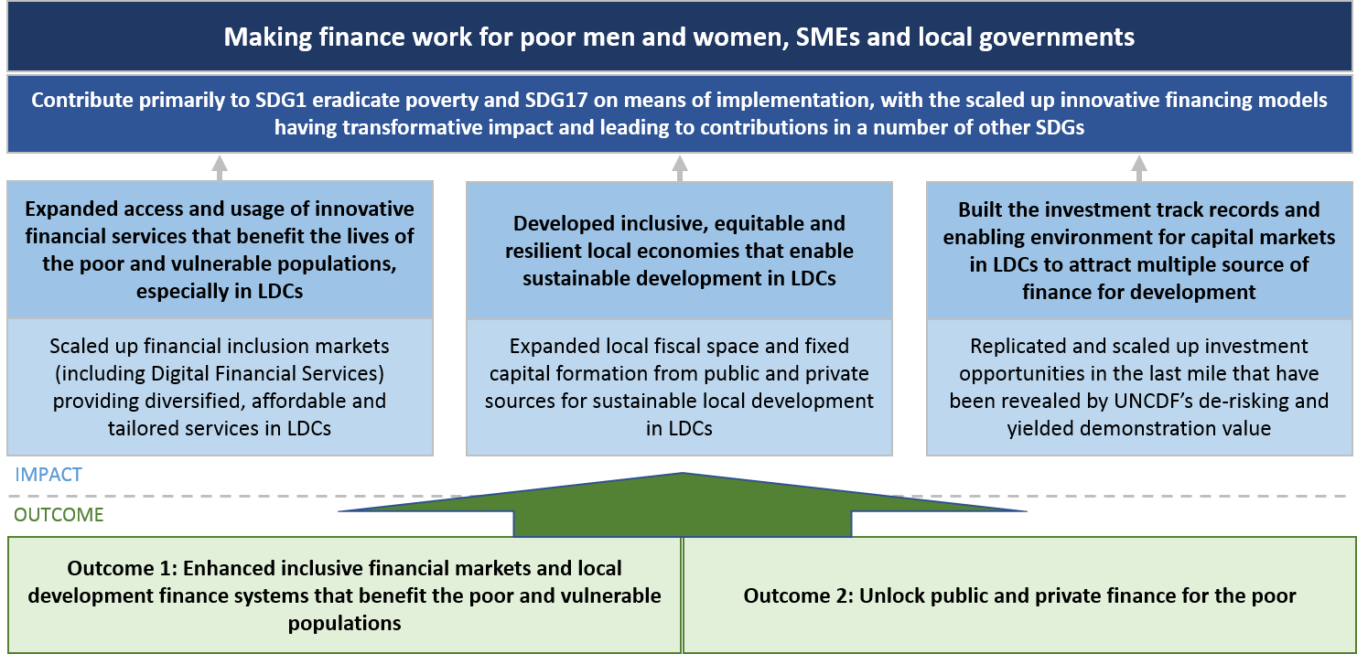

Through UNCDF’s expected outcomes, UNCDF aims to generate demonstration effects and concrete examples of how LDCs can bring public and private capital and approaches together for more SDG-positive and inclusive results at the local level; to absorb risk in the last mile investments and reveal market opportunities in the LDCs; and to help LDCs mobilize finance that improves the lives and livelihoods of those at risk of being left behind.

Based on these outcome level changes, the impact level of making finance work for the poor is expected to be reached through the scale up and transformation of the financial markets and local development finance systems and greater amounts of public and private, domestic and international finance that is unlocked and applied in ways that are SDG-positive. This is linked to the catalytic leverage UNCDF generates.

Specifically, the inclusive financial markets that UNCDF helps develop and then, through its work with funding and implementing partners, helps to scale up is expected to result in increased access and usage of the tailored financial services that support poor and vulnerable populations to escape poverty and build resilient and sustainable livelihoods. Impact studies have consistently shown positive economic outcomes for women with access to savings, including increasing the productivity of rural women, expanding their profits, increasing investment in their businesses, and expanding their legal control over funds. Having a private, low-cost means of managing financial resources can itself meaningfully reduce poverty rates among vulnerable groups. For women, even financial inclusion at a basic level enhances their ability to manage those financial resources that are already accessible. Access to mobile money has lifted as many as 194,000 households – 2% of the Kenyan population – out of poverty, and has been effective in improving the economic lives of poor women and of members of female-headed households. Financial inclusion can support overall economic growth and the achievement of broader development goals. There is also growing evidence of financial inclusion creating more stable financial systems and economies. Creating digital payment systems can also support mobilizing domestic resources by boosting government revenue.

The transformation and upscaling of local development financing systems is expected to result in the expansion of local fiscal space and fixed capital formation at the local level. For UNCDF, local fiscal space applies the concept of ‘fiscal space’ to the territorial jurisdiction of local governments, referring to the financing capacity of local governments to invest in local economies and to promote local value chains and catalytic infrastructure. This means that local government will have better access to the resources they need to provide necessary public services and opportunities that are essential to inclusive, equitable, and resilient local economies that benefit the lives of the poor and vulnerable populations. Inclusive growth requires that capital investments reach all geographic areas, and that the investment requirements of secondary cities, growing peri-urban areas, and rural regions are fully financed. This accelerates transformative growth and retain value within local economies, avoiding patterns of high growth and low poverty reduction. Responsibility for meeting the enormous demand for infrastructure and services has increasingly shifted from national to sub-national governments. Yet, local governments outside major cities often lack the capacities, financial resources, management systems, and pipeline of bankable projects to fulfil this responsibility. Increasing the capacity and fiscal space of local authorities can empower secondary cities, towns, and rural areas to contribute in important ways to national social and economic development goals.

Along with the markets and systems changes, UNCDF’s investments are expected to be replicated and scaled in the niche last mile finance markets with the leveraging of catalytic finance. This helps to build the investment track record and enabling environments for local capital markets in LDCs to attract new sources of funds for development impact. This is envisioned to provide the financial conditions and prove the business case for large scale additional resources such as remittances, foreign direct investments, and private domestic and international finance to flow into the LDC markets supporting SDG-positive activities.

In these ways, UNCDF aims to contribute to SDG 1 on eradicating poverty in all forms with a focus on reaching the last mile in LDCs and SDG 17 on strengthening the means of implementation for the SDGs at the local level. Further, by identifying market segments where innovative financing models can have transformational impact, UNCDF also aims to contribute to a number of other SDGs – This includes goals 5, 7, 8, 9, 10, 11 and 13. UNCDF work can also contribute to wider goal 16-related responses in countries affected by conflict or natural disasters. For instance, UNCDF implements programmes on enhancing climate adaptation finance for poor and vulnerable groups that build on its decades-long work on local development finance; this contributes to SDG 13 on climate change. The mainstreaming of gender equality and women’s economic empowerment throughout UNCDF’s interventions and results contributes to SDG 5 on gender equality and women’s empowerment.

Targeting the poor and vulnerable populations to reach the last mile

UNCDF seeks to target its interventions to reach the last mile. By the last mile, UNCDF refers not only to the poorest of the poor, but also to the people, places and small enterprise levels that are under-served and excluded, where development needs are greatest, and where resources are most scarce. The “last mile” will vary by the specific objectives of a programme – in some cases, this could mean focusing on rural women or unbanked youth, in other cases it could be targeting small businesses that are unable to grow without access to capital, and yet other cases could include working in rural areas or secondary cities of a country that are at risk of falling behind national averages. But in all cases the focus is on bridging gaps where finance is not flowing and where, by changing the dynamic of how finance is allocated and spent, UNCDF can help improve lives and livelihoods and support growth that is more inclusive and resilient.

To this end, UNCDF will tailor and design its interventions to reach poor and vulnerable populations – both those in the formal and informal economies - and address their lifecycle needs. Many populations targeted through UNCDF support work in the informal economy and/or have access to or make use of informal financial services. UNCDF partners with traditional banks, microfinance institutions, or digital financial service providers to understand the customer journey of low income populations, including women, young people, smallholder farmers, and MSMEs, and to help them design and test financial services, innovations, and products that meet customers’ specific needs. This work also covers linking informal savings groups with formal financial service providers; connecting smallholder farmers into formal value chains; or helping MSMEs access the capital they need to grow. Evidence shows that expanding access to finance can empower women, reduce poverty, smooth consumption, help people mitigate risk, and support economic growth.

UNCDF also works with local authorities where resources are not flowing and development needs are the greatest to help them crowd-in public and private finance for projects with proven development impact in lagging regions. To this end, this work involves targeting local governments beyond capital cities and in secondary cities, rural, and peri-urban areas. Together with government partners, for example, UNCDF is building a pipeline of revenue generating investments in LDCs. These can be public-private partnerships or fully private sector initiatives. All are measured by two criteria – development impact on the poor and financial viability – in the areas of climate adaptation, food security, women’s economic empowerment, and local economic development. UNCDF helps identify the investable projects, shore up the viability of the management structure, provide technical assistance to prepare the financial portfolios, and create relationships with domestic banks and other possible investors to help open their doors to projects they would not normally have funded. UNCDF then strategically places its own grants and loans to help de-risk and incentivize investments.

UNCDF’s work on local development finance seeks to improve the quality of life at the grassroots level. UNCDF works with local governments, promoting financial and fiscal accountability to its citizens through local financial mechanisms and enhancing their participation at the planning, budgeting, and decision-making stages – this can help make sure that services and infrastructure provided benefit all segments of society. In addition, UNCDF supports local governments to procure goods and services from local small businesses, empowering the local private sector and helping to create more vibrant local economies. Independent programme evaluations and other evidence have shown that local development finance projects helping local governments to deliver services and build necessary local infrastructure have benefited vulnerable households in the targeted local communities and helped to reduce poverty and improve food security.

Furthermore, across both areas of work, many UNCDF beneficiary small businesses are also increasingly investment-ready and could benefit from developing sound relationships with local, regional and international financial investors. There are more and more cases where loans and guarantees, specifically designed by UNCDF to absorb risks, may be the most appropriate interventions to create the market incentives that leverage other resources and to nurture the local private sector. Through deploying such catalytic financial instruments, UNCDF can help financial service providers and other local private sector actors to access finance that they might not otherwise obtain through formal channels or afford through the market. The enacting of formal relationships between formal investors and UNCDF beneficiary small businesses may require such businesses to form the right legal entities, and obtain proper certifications and licenses to conduct businesses formally. In these ways, they can access commercial capital through formal services more easily. This way, UNCDF will not only ensure the expected development impact of the investment, but will also support the operation to be financially viable in the long run, andhelp create credit data, and hence formal credit worthiness, for borrowers over time.

UNCDF will ensure a last mile focus by ensuring its clear reflection and articulation in programme design and by reinforcing monitoring and evaluation systems to track customer journeys and development impact using an array of results-based management tools including the IRRM; selective case studies that take a wider-lens view of UNCDF impact; evaluations; and innovative data collection and analyses carried out at the programmatic level.

Assumptions and Risks

Achieving the results foreseen is based on a number of assumptions and the need to mitigate risk factors. These are presented in Figure 4.

At the institutional effectiveness level covering UNCDF’s financing and partnership model and institutional enablers, UNCDF assumes that it will be able to mobilize at least a ‘critical mass’ of core resources as well as non-core resources for its four-window funding architecture to ensure implementation.

At the output level, the results framework assumes mutually-supportive interactions among the output areas. UNCDF also assumes strong partnerships, especially with national and local institutions and private sector entities in target LDCs, that demonstrate solid capacities to manage and sustain activities effectively and efficiently, and also with funding partners who are willing to take risks with UNCDF and have the patience to test out new approaches and see programmes through from innovation to scale. It also assumes that there is an overall commitment to and conducive environment for making finance work for the poor in the target countries, and that best practices and knowledge from one context can be codified, shared with peer networks, and transferred to another country, region, or programme. External risks at this level include risks on partners’ capacity, transparency, and accountability as well as the need for data to measure results.

At the outcome level, UNCDF assumes a strong relationship and feedback loop between the two outcomes as well as good coordination and partnerships with other actors working in the relevant outcome areas. The main risks here are also related to partnerships, both if there is limited coordination with national and other development initiatives in a context where UNCDF has a ‘thin’ country presence, and if implementing partners have limited capacities. Furthermore, UNCDF will need to ensure that its actions do not distort markets and put in place sufficient safeguards against social and environmental risks from some of its interventions.

Finally, at the impact level, UNCDF assumes that the end beneficiaries of its interventions have sufficient capacities in place so that the strengthened systems and unlocked finance translate into development impact in terms of poverty reduction, local economic development, and overall sustainable development. It also assumes there is sufficient follow-on support from a range of possible actors to replicate and scale what works. Major risks at this level are political and socio-economic instabilities and vulnerabilities that can negatively affect results; constraints related to legal and socio-cultural norms that serve as barriers to structural change; and programmes that do not build linkages with governments and other partners to take innovations to scale.

UNCDF has devised responses and strategies to mitigate the identified risks as shown in Table 1. UNCDF is regularly updating its risk log, assessing the likelihood of the risks affecting UNCDF’s results, and identifying appropriate mitigating actions.

Figure 4. UNCDF Strategic Framework 2018-2021 Results Chain, Assumptions and Risks
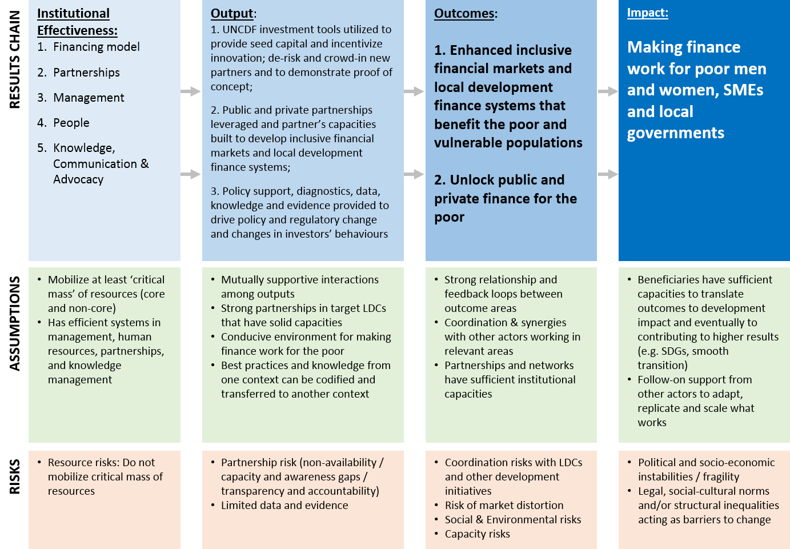

Table 1. UNCDF risks and risk mitigating strategies

Levels | Risks | Risk mitigating strategies
Institutional Effectiveness | Resource risks: do not mobilize critical mass of core resources required | UNCDF is working diligently to diversify and shore up its core resource funding base, engaging with new and emerging donors. It has updated its four-window funding architecture to reflect new trends in development finance; this includes establishing an LDC Investment Fund which is working to operationalize and capitalize through grant and other sources of funding, including from the private sector. UNCDF continues to strengthen its outreach, knowledge management, communications, and advocacy to support its resource mobilization goals and ensure that its demonstration effects are well-known and credible. UNCDF is also ensuring staff are equipped to deliver on their goals, and strengthening skills for strategic engagement with new partners, including foundations, development banks, and the private sector. UNCDF will also strengthen its skills base related to applying diversified financing instruments and in areas where local finance solutions can unblock barriers to SDG achievement.
Output | Partnerships risks: Non-availability of capable partners, awareness gaps in partners, transparency and accountability risks | UNCDF has established a strong selection process to identify capable partners through RFPs and Investment Committees. Its PBAs and review processes ensure compliance of partnerships.
 | Evidence risks: Limited data and evidence to track progress and respond to risks | UNCDF is reinforcing its RBM system and processes with the roll out of the new Strategic Framework and IRRM, in addition to a strong focus on programme-level RBM. Further, UNCDF will be improving its knowledge management activities to inform evidence-based programming and ensure that results are relevant and credible.
Outcome | Coordination risks: Lack of, or have limited coordination with LDCs, UN Country Teams, and other development actors and initiatives to trigger higher level results, especially due to ‘thin’ UNCDF country presence | UNCDF will reinforce its coordination with UNCTs, peer networks, and other development agencies centred primarily around the UNDAF, and has been rolling out a country focal point system. It has been developing UNCDF country value propositions and enhancing strategic coordination by participating in inter-agency and inter-governmental processes.
 | Market risks: Market interventions result in market distortion at the local level | UNCDF will closely monitor the market effects of its interventions and reinforce its due diligence and investment policies to select its investments in sectors that enhance competition and maximize social and economic impact.
 | Social and environmental risks: Interventions result in harming social rights and/or the environment | UNCDF has adopted the social and environmental safeguards devised by UNDP in its programmes and will closely monitor and evaluate programme impact in these areas through evaluations and other tools. UNCDF will respond with appropriate management response when needed.
 | Capacity risks: Local institutions and ecosystems have limited capacity to ensure sustainability of programmes and their scale up | UNCDF will closely work with UN and other partners to enhance the overall capacities of the local partner institutions and ecosystems, and use its maturity model to take lessons learned from its pilots to inform national policies and systems.
Impact | Risk of instability: political and socio-economic instabilities and fragility result in disrupting progress | UNCDF will enhance coordination with UNCTs to monitor and respond to fragility and instability risks. It will also review how it could actively support crisis settings building on its past experience and using its toolsets to enhance local resilience and post-crisis rebuilding. In addition, UNCDF’s PBAs mean that resources will not be invested if the risk to an intended result is too great because of increased instability.
 | Normative risks: legal, socio-cultural norms and/or structural inequalities act as barriers to change | UNCDF’s interventions acknowledge the importance of, and are designed to overcome structural barriers to change. This includes carefully identifying inequalities and exclusions where local finance solutions can have transformational impact; working closely with UN and other partners where UNCDF’s financing expertise and the sector expertise of that entity can together accelerate progress; and through its  ‘learning by doing’ approach that sees UNCDF first pilot ideas and then modify programmes based on lessons learned and scale what works.

**********

See Meadows, D.H. (2008) Thinking in Systems: A Primer. London: Sustainability Institute.
UNCDF’s definition of financial market systems is broadly in line with the market systems approach to financial inclusion proposed by CGAP in Burjorjee, D.M., and Scola, B., A market systems approach to financial inclusion: Guidelines for funders, 2015, CGAP.
‘Promoting Women’s Economic Empowerment, What Works?’ World Bank, Policy Research Paper 7087, November 2014.
See “The long-run poverty and gender impacts of mobile money”, Tavneet Suri, William Jack, Science 09 Dec 2016: Vol. 354, Issue 6317, pp. 1288-1292 http://science.sciencemag.org/content/354/6317/1288.full.pdf+html
See, for example, Financial Inclusion: Can It Meet Multiple Macroeconomic Goals?, September 2015, IMF Discussion Note
See, for example, Financial Stability and Financial Inclusion, 2014, Asian Development Bank Institute
See, for example, https://www.betterthancash.org/tools-research/case-studies/person-to-government-payments-lessons-from-tanzanias-digitization-efforts
Getting to the last mile in least developed countries, 2016, UNDP & UNCDF.
See footnotes 4 and 5.
For instance, see PADEL Report : Congo, Y., et al. (2017) Évaluation finale du Programme d’appui au développement local (PADEL) — Niger, UNCDF, New York

