United Nations Office for Project Services

The UNOPS management response to the 2019 annual reports on internal audit, investigations and ethics

A. Introduction 1
B. The UNOPS Audit Advisory Committee 1
C. Role and functions of the Internal Audit and Investigations Group 1
D. IAIG Audits 2
E. IAIG Investigations 7
F. Strategic response to audit recommendations 8
G. UNOPS Ethics 11
Annexes 13

A. Introduction
- UNOPS offers the following management response to the 2019 annual reports on internal audit, investigations and ethics.
- The response to the annual report of the Audit Advisory Committee in 2019 (DP/OPS/2020/2 - Annex 3), is provided in accordance with Executive Board decision 2008/37. The response to the annual report of the Internal Audit and Investigations Group on internal audit and investigations activities in 2019 (DP/OPS/2020/2) is provided in accordance with Executive Board decision 2005/19. The response to the activities of the UNOPS Ethics Office in 2019 (DP/OPS/2020/3), is provided in accordance with Executive Board decision 2012/19.

B. The UNOPS Audit Advisory Committee
- The United Nations Office for Project Services (UNOPS) is committed to the United Nations system’s harmonization and simplification of business processes, including those supporting the Executive Board, and subsidiary committees advising the Executive Director.
- Pursuant to Executive Board decisions 2015/4 and 2015/12, the Audit Advisory Committee (AAC) of the United Nations Office for Project Services was established on 2 March 2015 (ref. DP/OPS/2015/CRP.1). The roles and responsibilities of the AAC, as outlined in its Terms of Reference (EOI.ED.2019.01), are consistent with those of UN agencies that are under the purview of the Executive Board. During 2019, management completed a review of the Terms of Reference as announced to the Executive Board at the first regular session in 2019.
- The Audit Advisory Committee provides external, independent, senior level advice regarding the Organization’s oversight, financial management and reporting, internal audit and investigation, external audit, risk management, systems of internal control and accountability, and application of best practice and industry standards for strategy implementation. The Committee has an advisory role and assists the Executive Director in fulfilling her responsibilities.
- Management is pleased to note the significant contributions provided by the AAC in 2019 and its concurrence with the observations reflected in the Audit Advisory Committee 2019 Annual Report (DP/OPS/2020/2 − Annex 3). Management notes that the AAC, in its advisory capacity, continues its substantive engagement with the organization, demonstrating the value-add of executive advice for strategic risk management. Finally, management would like to extend its appreciation to the current and past members of the Committee.
- Effective 1 March 2019, the UNOPS Executive Director appointed three new members to the AAC, bringing the AAC’s membership to six, with full gender parity. These three new members were at the time of their appointment to the AAC members of the Strategic Advisory Group of Experts (SAGE). To ensure the efficiency and effectiveness of external advisory functions, the Executive Director subsequently effectuated the merge of the AAC and the SAGE with the promulgation of the Executive Office Instruction providing the revised terms of reference of the Audit Advisory Committee.

C. Role and functions of the Internal Audit and Investigations Group

Role and functions
- Management recognizes the important role which the Internal Audit and Investigation Group (IAIG) plays in providing assurance, offering advice, recommending improvements, and helping to enhance the organization’s risk management, control and governance systems.
- Management also recognizes the IAIG role in promoting and supporting accountability by conducting investigations of potential violations of applicable regulations, rules and policy directives and instructions. Furthermore, the IAIG endeavours to support management in the application of UNOPS general policies and objectives as described in the UNOPS strategic plan, 2018-2021 (DP/OPS/2017/5) are appreciated. As such, IAIG is a central component of UNOPS accountability framework, adding valuable contributions to the management of strategic and operational risks.

Mandate
- The mandate of the UNOPS internal audit and investigation function is prescribed by Regulations 6.01, 6.02 and 6.03, and Rules 106.01, 106.02 and 106.03 in Article 6 of UNOPS IPSAS-compliant Financial Regulations and Rules (FRRs), which were reissued effective 13 March 2017 in line with UNOPS Governance, Risk and Compliance Framework.

Coordination and collaboration
- Management encourages the IAIG continuous coordination with the United Nations Board of Auditors (UNBOA), the United Nations Representatives of Internal Audit Services (UN-RIAS), the United Nations Representatives of Investigative Services (UN-RIS), and the Joint Inspection Unit (JIU).
- Management supports the strong collaboration and coordination of IAIG with various UNOPS business units, including the Legal Group, the Procurement Group, the People and Change Group, the Ethics and Compliance Officer and regional/country offices, promoting inter-departmental cooperation, support and continuous follow-up on specific matters.

D. IAIG Audits

Overview
- The reports of IAIG internal audit comprise two types: a) internal audits and thematic reviews and b) project audits, including forensic and special scope audits, as summarized in Table 1. Management notes that the overall number of reports in 2019 (49) is higher than the number of reports made in 2018 (45). In principle, the number of reports may fluctuate between years, due to normal variations in the number of client requests and reporting requirements as per project agreements. Management commends IAIG on its efforts to complete current and prior year work plans, which resulted in no audit assignments carried over to 2020.
Table 1: Number of reports of internal audit made, 2018-2019*
Year | 2018 | 2019 | Change
# Internal audits and thematic reviews | 14 | 18 | 4
# Project audits | 31 | 31 | 0
Total number of audit reports | 45 | 49 | 4
*Developed based on IAIG annual reports for 2018 (DP/OPS/2019/4) and 2019 (DP/OPS/2020/2).
- In total, IAIG made 174 audit recommendations in 2019, compared to 160 recommendations in 2018 and 315 recommendations in 2017. Management notes that the overall average number of recommendations per internal audit report and thematic review decreased from 14.3 in 2017 to 8 in 2018 and further to 6.5 in 2019. The average number of recommendations for project audit reports increased from 1.4 in 2018 to 1.8 in 2019. Management notes that the continued lower number of recommendations in the overall average is consistent with a trend since 2010, and encourages IAIG to maintain efforts in this regard.

Table 2: Number of audit recommendations made, 2018-2019*
Year | 2018 |  | 2019
 | total | average | total | average
# Internal audits and thematic reviews | 117 | 8.0 | 117 | 6.5
# Project audits | 43 | 1.4 | 57 | 1.8
Total number of audit recommendations | 160 | 3.6 | 174 | 4
*Developed based on IAIG annual reports for 2018 (DP/OPS/2019/4) and 2019 (DP/OPS/2020/2).
- During the year, 170 recommendations were closed, following significant management efforts in 2018 which saw 346 recommendations closed. Management is committed to continue its efforts to implement recommendations. UNOPS management has thus maintained its high rate of implementation of audit recommendations, at 96 per cent in 2019 and 2018. This is well above the annual target of 90 per cent, and significantly higher than the 92 per cent implementation rate in 2017.
- The total number of open recommendations stood at 176 at the end of 2019, a marginal increase over the 172 at the end of 2018. Management notes the reduced share of recommendations issued during the last quarter of the year, at 25 per cent compared to 40 per cent of the recommendations made during the last two months of 2018.
- Since 2011, management has made concerted effort to address audit recommendations which by the end of the calendar year will have been open for more than 18 months. At the end of 2019, the number of such recommendations had been reduced to one. The final outstanding recommendation is expected to be addressed by the end of March, 2020. This represents a significant improvement over 2017 and 2018, with 12 such recommendations open at the respective year-end. It is also an all-time low.

Internal audits and thematic reviews
- In 2019, IAIG audited four UNOPS country offices, as well as one hosted entity and one global services unit, issuing ratings for five of these six audits. It also conducted one advisory review and one follow-up review, which carried no ratings. In two business units, the respective internal controls and risk management processes were found to be partially satisfactory with some improvements needed; and in three business units the rating was partially satisfactory with major improvements needed. Management notes the value of the ratings and is taking action to ensure that adequate internal controls, governance and risk management processes are established in accordance with the IAIG recommendations.
- Management notes that no reports found the adequacy and effectiveness of governance, risk management and control processes to be unsatisfactory. This is a marked improvement compared to 2018 where three audits had a rating of unsatisfactory. Management remains committed to prioritise early response to recommendations resulting from audits with a rating of unsatisfactory.
- IAIG also conducted nine thematic reviews and one continuous audit. No overall ratings are provided for this type of internal audit.
Table 3: Ratings of internal audit reports, 2018-2019*
Year | 2018 | 2019
Satisfactory | 0 | 0
Partially Satisfactory (some improvements needed) | 3 | 2
Partially Satisfactory (major improvements needed) | 2 | 3
Unsatisfactory | 3 | 0
Total number of IAIG internal audit ratings | 8 | 5
Not rated | 7 | 13
Total | 15 | 18
*Developed based on IAIG annual reports for 2018 (DP/OPS/2019/4) and 2019 (DP/OPS/2020/2).
- Management notes a decrease in the share of recommendations with a high level of importance, suggesting that the severity of issues observed has decreased in 2019. Management appreciates that low-priority recommendations are typically addressed during the fieldwork stage of the audit.
Table 4: Internal audit recommendations by level of importance, 2017-2019*
Level of importance | Number of recommendations |  |  | percentage of total
 | 2017 | 2018 | 2019 | 2017 | 2018 | 2019
High | 100 | 73 | 58 | 50 | 62 | 50
Medium | 100 | 44 | 59 | 50 | 38 | 50
Total | 200 | 117 | 117 | 100 | 100 | 100
*Developed based on IAIG annual reports for 2018 (DP/OPS/2019/4) and 2019 (DP/OPS/2020/2).
- Management continues to follow up and coordinate with relevant business units on the implementation of recommendations. In order to ensure systematic and timely action, management classifies all oversight recommendations by functional area. If the primary responsible business unit is different from the business unit responsible for policy and control in the functional area, the latter is typically assigned as secondary responsible for ensuring timely implementation of the recommendation. Management will continue to work closely with IAIG to ensure these measures are reflected in relevant systems utilized and reports issued.
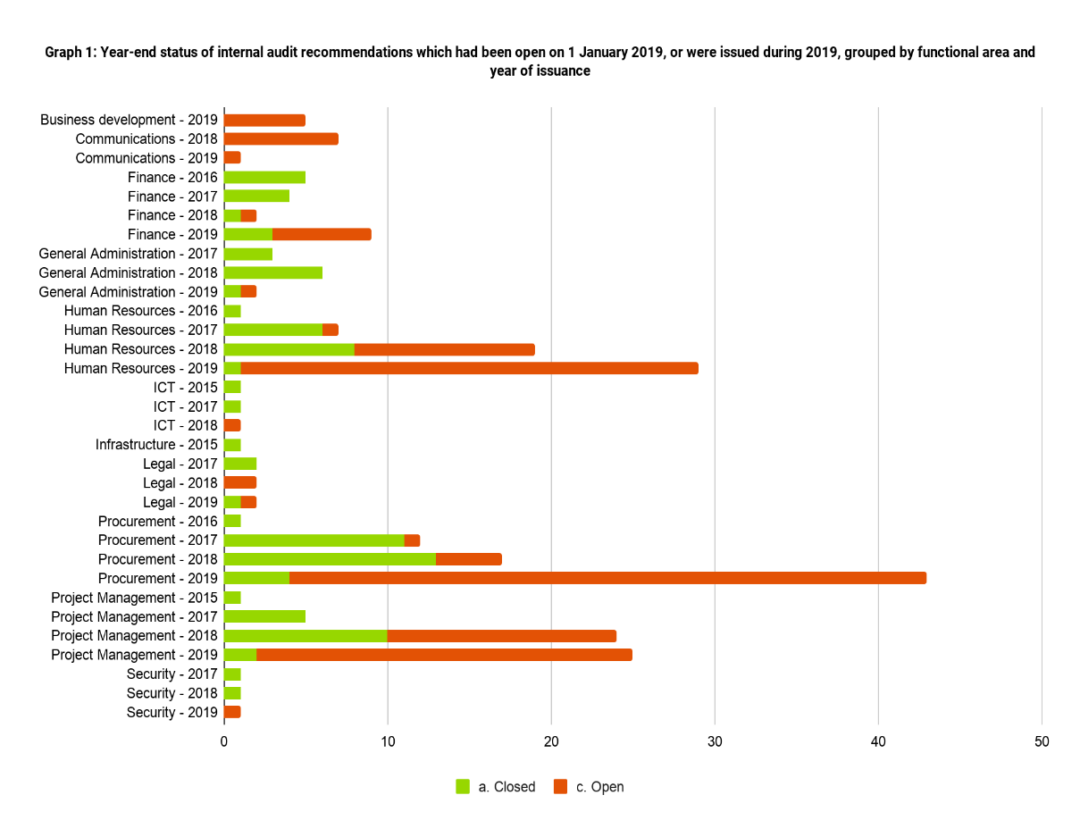
- With regard to the functional distribution of internal audit recommendations, management notes peaks in recommendations for Procurement (2018/2019), Human Resources (2018/2019) and Project Management (2018/2019), as well as Finance (2019). These findings correlate (a) to the focus on globally operating business units that delivered project management services during 2018-2019, and (b) to the functional focus of internal audit reports compiled by IAIG during 2018 and 2019, which included a review of contract management systems and a review relating to core Human Resources processes.

Project audits
- Management notes that in 2019, 94 per cent of financial statements of projects audited received unqualified opinions; and that the one instance of a qualified opinion relates to an issue with causal factors outside the control of UNOPS. Rectification of the issue and the related financial impact of USD 339,413 (cumulative) has been concluded by management in close collaboration with the project partners, and remaining issues continue to be addressed.
- Management notes that also in 2019 the majority of project audits concluded with an opinion of satisfactory levels of internal controls. Notwithstanding, it observes a slight decrease in these ratings, indicating that management’s attention to continuous improvement of systems and operational practices is warranted. At the same time, management notes that there were no unsatisfactory ratings pertaining to project audits in 2019, the second year in a row. One forensic and one special scope project audit did not carry a rating.
- Management notes the refinement of rating categories of the overall level of internal control, as introduced by IAIG during the 2017 work plan cycle.
Table 5. Summary of project audit opinions and ratings of internal controls for project audits,
2017-2019*
Type of opinion or rating | Number of audit reports |  |  | percentage of total
 | 2017 | 2018 | 2019 | 2017 | 2018 | 2019
Audit opinion on financial statement of projects
Unqualified opinion | 27 | 27 | 26 | 90 | 93 | 96
Qualified opinion | 3 | 2 | 1 | 10 | 7 | 4
Total | 30 | 29 | 27 | 100 | 100 | 100
Audit opinion on level of internal control of projects
Satisfactory | 14 | 15 | 13 | 58 | 79 | 68
Partially satisfactory (old rating) | 5 | N/A | N/A | 21 | N/A | N/A
Partially satisfactory  (some improvements needed) | 3 | 4 | 5 | 13 | 21 | 26
Partially satisfactory  (major improvements needed) | 0 | 0 | 1 | 0 | 0 | 5
Unsatisfactory | 2 | 0 | 0 | 8 | 0 | 0
Total | 24 | 19 | 19 | 100 | 100 | 100
*Developed based on IAIG annual reports for 2018 (DP/OPS/2019/4) and 2019 (DP/OPS/2020/2).
- In relation to the level of importance assigned to project audit recommendations, management notes an increase of six percentage points for items of high priority compared to 2018. Management is committed to ensuring that also all recommendations resulting from project audits are implemented in a timely manner.
Table 6. Project audit recommendations by level of importance, 2017-2019*
Level of importance | Number of recommendations |  |  | percentage of total
 | 2017 | 2018 | 2019 | 2017 | 2018 | 2019
High | 31 | 9 | 15 | 27 | 20 | 26
Medium | 84 | 34 | 42 | 73 | 80 | 74
Low | 0 | 0 | 0 | 0 | 0 | 0
Total | 115 | 43 | 57 | 100 | 100 | 100
*Developed based on IAIG annual reports for 2018 (DP/OPS/2019/4) and 2019 (DP/OPS/2020/2).
- Management applies the same logic and approach on functional area and secondary responsibility for recommendations resulting from project audits, as for recommendations resulting from internal audits. With regard to the functional distribution of project audit recommendations, management notes peaks in recommendations for Project Management, Finance and General Administration, all in 2019. This is commensurate with the functional focus of project audits. It further notes that by the end of the year the majority of these project audit recommendations had been closed.
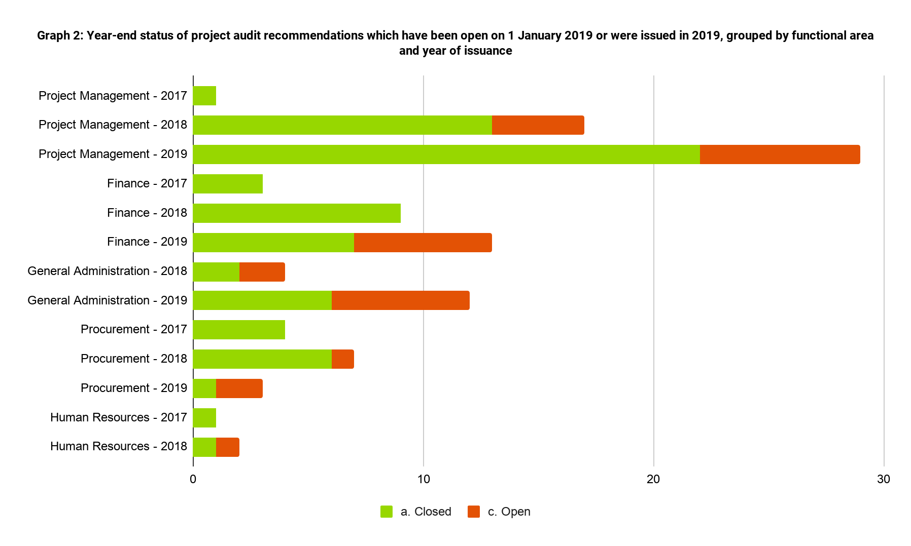
Strengthening of the audit function
- Management appreciates the close collaboration of IAIG and the ICT function for the development of a real-time audit recommendation tracking tool that is fully integrated with the oneUNOPS enterprise resource planning system (ERP), including the resulting enhanced efficiency and timeliness of reporting.
- Management notes with appreciation the successful completion of an internal assessment of all current data analytics tests and the work undertaken to further enhance the systematic, focused and data-driven review of key business processes, including efforts to leverage machine learning for this purpose. This further enables timely detection and action to address issues in relation to, for example, payments, hiring and tendering. To ensure further strengthening of responses, management will continue its collaboration with IAIG to ensure visibility of actionable data.
- Management notes that IAIG continues to seek out external assessments and benchmarks for the purpose of continuous improvement, including a voluntary assessment against the standards of the Institute of Internal Auditors (IIA), where it achieved the highest rating possible.
- Management notes with appreciation that IAIG has implemented an approach to reduce subjectivity with regards to the level of importance across commonly occurring audit recommendations, based on the type and occurrence of the identified issue.

E. IAIG Investigations
- Management notes the IAIG investigations function’s attention to ensuring close coordination with relevant internal and external entities, inter alia, through internal collaboration with UNOPS Legal Group, the People and Change Group, the Vendor Review Committee, and the Ethics and Compliance Office; as well as external collaboration in the context of the United Nations Heads of Investigations Groups, with the Office of Internal Oversight Services (OIOS), the investigation services of the other UN funds and programmes, and investigations offices of other international and national agencies.
- It is noted that the number of complaints received and processed by IAIG increased from 151 in 2018 to 230 in 2019. It is also noted that out of these 230 complaints, 99 became investigation cases, 39 investigation cases more than in 2018; and that the average time for completing cases continued a downward trend. Management notes the distribution of 78 cases of alleged fraud or financial irregularities, eight cases pertaining to sexual exploitation and abuse, and three cases that involved alleged sexual harassment. Another ten cases involved other types of misconduct. Management appreciates the IAIG efforts to work with legal officers, senior managers, the People and Change Group, and the UNOPS Vendor Review Committee to deter issues of this nature and reduce recurrence.
- Management notes the financial losses substantiated in investigations cases, and remains committed to taking action, including the sanctioning of vendors, disciplinary action for personnel up to and including separation, and recovery of defrauded or lost amounts.
- Management appreciates the various efforts to strengthen the investigations function during the year, including, inter alia, the introduction of new controls in oneUNOPS ERP to facilitate the recovery of misappropriated funds.
- With regard to fraud prevention, management notes the continued efforts to raise awareness, and to educate personnel on standards of conduct and means to identify and report potential issues. In 2019, this continued to include two “Standards of Conduct” workshops.
- Management appreciates the continued collaboration with various UNOPS business units and other investigation units, including the United Nations Representatives of Investigative Services (UN-RIS), and the United Nations Representatives of Internal Audit Services (UN-RIAS); the efforts to participate in relevant partnerships, for example the Association of Certified Fraud Examiners (ACFE); and continued expansion of cooperation agreements, most recently with the World Bank Group, the Inter-American Development Bank, and the International Federation of the Red Cross.
- With regard to protection against sexual harassment and abuse, management notes the support to a number of initiatives, including a thematic working group, an inter-agency vetting database for employees separated for sexual harassment, and internal as well as inter-agency workshops on the topic.
- Management remains committed to the timely implementation of recommendations resulting from IAIG investigations.

F. Strategic response to audit recommendations
- By the end of 2019, only one audit recommendation had been open for more than 18 months. This is an all-time low and represents a significant improvement over 2018 and 2017 levels, where 12 were open. Management is committed to continue the coordinated drive for the implementation of audit recommendations.
- Management note the utility of functionally sorting audit recommendations and appreciates the continued collaboration with IAIG in ensuring timely implementation of internal audit recommendations through incorporation of results into performance data for various UNOPS business units. Management believes that further efforts to realize the potential of systematically analysing functional distribution, cause and objective are required, and is looking forward to enhancing the collaboration with IAIG on this matter.

Continued strengthening of organizational leadership and governance
- In 2019, the organization undertook a realignment of its leadership structure, with the goal of reinforcing its core functions, ensuring greater consistency and coherence, and thus facilitating efficiency and effectiveness. Under the overall leadership of the Executive Director, a Senior Leadership Team (SLT) was formed. Its members represent the UNOPS core functions of delivery and business development; finance and administration; implementation practices; and the Office of the General Counsel. Pursuant, the Corporate Operations Group (COG) was abolished.
- In early 2019, the organization finalized the alignment of its policy framework to the Governance, Risk and Compliance (GRC) principled performance framework, in line with the principles of simplification and empowerment. This was commensurate with the Secretary-General’s vision of a reformed United Nations, aiming to minimise conflict of interest and mitigate potential risks of errors.
- By the end of 2019 the UNOPS policy framework comprised five Executive Office Directives, ten Executive Office Instructions, 13 Operational Directives, and 44 Operational Instructions. During 2020, management will continue to review and revise UNOPS body of management policies to ensure the policies’ appropriateness for the organization’s ever-changing business environment and maturity level.

Leveraging processes, policies and an integrated landscape of systems and tools to drive quality
- Accessible, reliable instructions and guidance on organizational core processes are key to further operationalizing the GRC. In conjunction with the revision of the UNOPS legislative framework, the organization reinforced the role of the Process and Quality Management System (PQMS) as the designated one-stop source of information on all UNOPS policies and processes. Designated process owners across all policy functions are accountable and responsible to ensure processes are regularly reviewed and continuously improved, including through feedback from the operations.
- In 2019, policy owners continued to add relevant processes in line with the updated body of policies, and maintained documented processes in accordance with a defined schedule. At the end of 2019, more than 430 processes were available in the PQMS. A review of quantitative user statistics shows that use of PQMS content as a trusted reference for colleagues managing operations continues to increase.
- The Implementation Standards Management Framework, encompassing policies, standards, guidance and guidelines, as well as tools and templates, for the core areas of project management, infrastructure and procurement, continued to be expanded and refined in 2019. The ‘Project Management Manual’ (PMM), introduced in 2018 and mandatory as of January 2019, contains a set of minimum requirements for project management. Likewise, the Procurement Manual, released in an updated version in April 2019, establishes clear directions on UNOPS procurement processes, including a focus on sustainability, and a range of measures with a particular view to risk management. In early 2020, UNOPS was awarded gold level certification from the Chartered Institute of Procurement & Supply (CIPS) for the fourth consecutive year for its achievements in sustainable procurement.
- To ensure UNOPS suppliers operate responsibly and with integrity, the organization in 2018 introduced an initiative to enhance the management of vendors. The initiative is called Delivering Responsibility in Vendor Engagement - DRiVE. DRiVE is focused on mitigating risks relating to human right, labour rights, child labour, ethical conduct, environmental responsibility, and sexual exploitation and abuse. In 2020, UNOPS will launch a mandatory online course for vendors, which amongst others includes a module on ethics and fraud prevention.
- Tools and systems supporting corporate processes are a critical contributor to organizational efficiency, effectiveness and compliance. UNOPS enterprise resource planning (ERP) system ‘oneUNOPS’, a platform for organization-wide efficiency, control, and business intelligence, has been in place since 2016. It offers an integrated solution for core business processes and management information to ensure speed and compliance.
- In 2019, UNOPS continued its efforts to optimize supporting business processes and associated controls in the ERP system, while also expanding the overall number of processes handled within oneUNOPS, in close collaboration with, and significant input from, UNOPS personnel in field locations. The continued successful and timely closure of UNOPS Financial Statements since the new ERP was introduced is a testament to the stability and reliability of oneUNOPS.
- As of April 2019, oneUNOPS Projects, an enterprise portfolio and project management system, has become mandatory. It is fully integrated with the organization’s IT landscape, particularly the ERP system. Among other things, OneUNOPS Projects enables the capturing, aggregation and management of organizational risks from the project level upwards. It was developed alongside the Project Management Manual (PMM), and supports the implementation of the mandatory requirements.
- The organization will continue to expand and refine its integrated application architecture for the purpose of enhanced visibility of information internally, and a targeted management of risks. It is foreseen that a new application, oneUNOPS Reports, will be released in 2020. Fully integrated with the existing landscape of tools, it will make data accessible in one centralized location, as a basis for live dashboards and reports. Further improvement efforts and enhancements will focus on the strengthening of core controls throughout the ERP.
- 2019 saw the addition of the position of Chief Information Security Officer (CISO). Initial focus of work was on assessments of the current status of information security in UNOPS operations, and the creation of a core set of policies, guidelines and training. Efforts going forward will aim to strengthen processes, data practices, readiness and culture.
- To enhance collaboration and exchange of knowledge across the organization, including lessons learnt, the organization adopted G Suite, completing the full move to this integrated set of tools. This was complemented by the move to a new organizational intranet, under the overall aim of creating a seamless user experience within an integrated landscape of oneUNOPS systems and tools.
- External certification of compliance with internationally recognized standards is a central component of UNOPS phased implementation of its risk management systems. Furthermore, the organization is committed to benchmarking its effectiveness and results against a range of industries and organizational types.
- In 2019, the organization maintained its global certifications to ISO 9001 for Quality Management. In addition to the global certification, UNOPS expanded the number of offices certified against ISO 14001 on environmental management system covering infrastructure projects from 15 to 18. Furthermore, it maintained certification of its health and safety management system for infrastructure operations against OHSAS 18001 for select offices. In addition, it undertook concerted efforts to prepare for a major push for increased health and safety in its operations in 2020, led by a dedicated multi-disciplinary working group.

Driving a culture of engagement and risk management
- Management coordination and cross-functional integration are important means of mitigating risks. In 2019, UNOPS sustained efforts to strengthen the organization's management fora. Until it was disbanded in mid-2019, the Corporate Operations Group (COG) convened one formal meeting and one retreat. The newly convened Senior Leadership Team (SLT) then continued in this function, by deliberating and providing executive advice on a wide range of recurring and ad hoc areas. This included, inter alia, gender parity, health and safety in UNOPS operations, corporate performance, business and operational planning, growth aspirations, reform of the United Nations development system, and strategic positioning in the core areas of UNOPS activities.
- The detailed results of the 2019 People Survey, conducted by PriceWaterhouseCoopers, were made available to UNOPS personnel and management in early 2020. At 75 per cent the response rate remained high. Responses showed a continued strong overall engagement score of 83 per cent across UNOPS personnel. During 2020, detailed results will be shared with the respective offices, followed by action planning at the corporate, regional/group and local office levels, respectively.
- Gender parity remains a strategic priority for the organization. The Gender Advisory Panel, Gender Parity Strategy, and a commensurate Gender Action Plan remain in place. High-level targets were established through the 2018-2019 biennial budget estimates. In addition, management devised temporary special measures with a focus on talent outreach and recruitment. Management continues to be committed to achieving equal representation of genders across all UNOPS personnel by the end of 2020, and to increasing the representation of women at senior and decision-making level.
- UNOPS offers its personnel access to individual certification programmes based on externally recognized international standards to address causes of audit recommendations, which may be attributable to inadequate knowledge and skills. The focus is on the effectiveness of learning actions, rather than time allocated to learning activities.
- In 2019, more than 5,000 personnel benefited from UNOPS learning opportunities, up from 3,800 in 2018. Approximately 90 per cent of participants were from country and regional offices, against a target of 70 per cent. About 45 per cent of learners were women, against a target of 42 per cent and a rate of 40 per cent in 2018. Across all learning activities, 89 per cent of participants in learning programmes rated the relevance of the learning opportunities provided as very relevant or relevant, and 98 per cent of participants would recommend the course they partook in. Both figures are indicative of the high content quality. The organization aims to continuously expand and adjust its learning content in line with business requirements.
- Training in 2019 included, inter alia, industry-recognized certifications aligned to the organization’s core mandated areas, i.e. infrastructure, procurement and project management. Additional internally certified training was identified, prioritized and provided to ensure continued capacity building for operational support in the areas of finance, health and safety, and asset management. These courses leverage real-life examples, problems and challenges that UNOPS personnel may face in their work, in order to deliver content that is relevant through tailored contextualization, and immediately actionable.
- As of 1 January 2019, it became mandatory for all personnel to complete the United Nations online course on Prevention of Sexual Exploitation and Abuse (PSEA). In addition to mandatory courses on human rights, ethics and integrity, and prevention of harassment, 274 personnel attended in-person learning on requirements as per the organization’s health, safety, social and environmental system; and more than 600 personnel were trained on UNOPS enterprise portfolio and project management system, oneUNOPS Projects.

G. UNOPS Ethics
- Established pursuant to General Assembly resolution 60/1, the UNOPS Ethics Office operates in accordance with the terms of reference laid out in the Secretary-General’s bulletin (ST/SGB/2007/11, as amended). Its mandate is to promote the highest standards of integrity and to foster a culture of ethics, transparency and accountability within UNOPS.
- In 2019, the UNOPS Ethics function was reviewed and, in line with the governance, risk and compliance (GRC) framework’s objective of principled performance, re-set as the Office of Ethics and Compliance. A new Chief Ethics and Compliance Officer and Director, Office of Ethics and Compliance, joined the organization in August 2019. The location of the Office remains in Copenhagen. Management welcomes the new Office’s long-term work plan.
- Management notes with appreciation the report on the Activities of the UNOPS Ethics and Compliance Office in 2019 (DP/OPS/2020/3), which covers the eleventh full year of operation of a separate and independent ethics function in UNOPS. During the year, the Ethics and Compliance Office has assisted the Executive Director in ensuring that all staff conduct themselves with integrity and professionalism and uphold the Charter of the United Nations.

Administering the UNOPS financial disclosure programme
- Management notes that 850 of the 851 personnel required to file a financial disclosure and conflict of interest statement had done so, resulting in a 99.88 per cent filing rate. Management further notes that an analysis of the 2019 filings is ongoing.
- Management notes with regret that the conclusion of the 2019 financial disclosure and conflict of interest programme is pending. It strongly supports the various steps undertaken by the Office to ensure conclusion in a timely manner. Management notes that (a) the Office in close collaboration with the human resources function has introduced financial consequences for non-compliance with filing requirements, by linking them to the UNOPS merit award; (b) the annual filing process was launched a month earlier than in 2018; (c) a new question was introduced to ensure any relations with a vendor are disclosed; and (d) the process for following up in cases where a filer reports the same situation year on year was strengthened.

Protecting staff against retaliation for reporting misconduct
- Management notes the importance of the ethics function’s impartial preliminary review of complaints of retaliation; its close collaboration with IAIG; and its advice on measures to protect from retaliation. In this regard, management also notes with appreciation the Office’s efforts, in close collaboration with the Ethics Panel of the United Nations (EPUN), to address the extended duration of processes and limited information sharing in cases where the complainant and the alleged perpetrator involved in a case are from different UN entities, and the other entity rather than UNOPS is leading the investigation procedure in line with its own policy framework and prescribed process.
- Management notes the commissioning of an external, independent review of UNOPS protection against retaliation policy and procedures, and is looking forward to the resulting recommendations.
- Management notes with appreciation the completion of the preliminary review of fifteen cases of request for protection against retaliation; the advice provided by the office in matters relating to protection against retaliation; and the additional generic steps introduced to prevent retaliatory action.

Setting standard, developing tools, training and education, and reaching out on ethics issues
- Management notes the reduced level of activity of the Office with regards to the issuance and revision of policies, which is commensurate with the high level of efforts in this regard in the previous year, and the overall matured policy framework in the organization, as indicatively further evidenced by the significantly reduced number of requests for advice on policy and process in 2019, when compared to 2018.
- Management notes with appreciation the establishment of a new externally managed whistle-blower hotline for the reporting of suspected misconduct, envisioned as a single reporting channel for individuals (personnel and non-personnel), and replacing rather than supplementing existing reporting channels going forward. Management believes that by removing the burden of identifying the correct reporting channel, personnel will be further encouraged and supported in reporting suspected misconduct, including allegations of retaliation against whistle-blowers.
- Management appreciates the Office’s active contributions to, and collaboration with, the human resources as well as procurement functions, to further develop and mainstream training materials on ethics issues and provide training to colleagues. In 2019, this included, inter alia, training to personnel in supervisor roles on how to manage allegations of misconduct; a training of procurement professionals in ethics in procurement; a new training on conflict of interest; an ethics component of a new online course issued by the procurement function and mandatory for UNOPS vendors; and an update to the e-learning course for Human Resources practitioners, as managed by the Human Resources function.
- Management takes note of the collaboration between the Office, the Human Resources function and IAIG to identify and integrate relevant ethics questions into the biennial People Survey, in lieu of maintaining a separate Integrity, Fraud and Ethics Awareness Survey. In view of the usually high response rate to the People Survey, management believes that such integration will be beneficial for informing the activities of the Office.
- Management notes the Ethics Officer’s engagement with the UNOPS Audit Advisory Committee. It further notes that the Officer has been kept abreast of minutes of UNOPS meetings of the Senior Leadership Team (SLT), and was invited to present on select topics in relevant meetings. Going forward, the Ethics Officer will be invited to provide a briefing to the SLT on quarterly basis.
- Management notes the contributions made by the Ethics Office in 2019 to the working group on Prevention of Sexual Exploitation and Abuse (PSEA). Management further notes the comprehensive communication plan developed by the Office in support of the long-term work plan; and appreciates the efforts undertaken to raise awareness about the Office’s role. It further appreciates the Ethics Office’s close collaboration with other corporate functions, including legal, human resources, procurement and internal audit on providing policy advice and guidance.

Providing confidential advice and guidance to staff on ethical issues
- Management notes that during 2019 the Office received 401 requests for advice, compared to 342 in 2018, representing an increase of 15 per cent. This stands in contrast to the overall decrease in the number of requests received by the Office across all categories, from 1055 in 2018 to 868 in 2019. Due to these opposing trends, the share of requests for services pertaining to ethics advice increased to 46 per cent, demonstrating the significance of the advisory function of the Ethics Office. This rate also seems to indicate general awareness and confidence among personnel to engage with the ethics function for advice.
- Management takes note that a growing number of requests of advice pertain to outside activities, and in this regard also takes note of the Office’s perspectives thereon.

Supporting ethics standard-setting and policy coherence within the UN system
- Also in 2019, the Office has exercised its mandate in close coordination and collaboration with the Ethics Panel of the United Nations and played an active role in the Ethics Network of Multilateral Organizations.
- Finally, management notes the services provided by the Ethics Office as an outside reviewer for requests for review by personnel in whistle-blower cases for the World Intellectual Property Organization (WIPO).

Annexes

Annex I – Extract from UNOPS Financial Regulations and Rules, effective 1 Jan. 2012
Regulation 6.01
The Internal Audit and Investigations Group shall be responsible for the internal audit of UNOPS. It shall conduct independent, objective assurance and advisory activities in conformity with the International Standards for the Professional Practice of Internal Auditing. It shall evaluate and contribute to the improvement of governance, risk management and control processes, and report thereon. It shall exercise operational independence in the performance of its duties.
Regulation 6.02
The Internal Audit and Investigations Group shall be responsible for assessing and investigating allegations of fraud and corruption committed by UNOPS personnel or committed by others to the detriment of UNOPS.
Regulation 6.03
The internal audit function’s purpose, authority and responsibility shall be further defined in the Charter of the Internal Audit and Investigations Group.
Rule 106.01
The Internal Audit function shall evaluate the adequacy and effectiveness of governance, risk management and control processes regarding the:
(a) reliability and integrity of financial and other information;
(b) effectiveness and efficiency of operations;
(c) safeguarding of assets; and
(d) compliance with legislative mandates, regulations, rules, policies and procedures.
Rule 106.02
The Internal Audit and Investigations Group shall have free access to the organization’s records, personnel and premises, as necessary, in its opinion, for the performance of its duties.
Rule 106.03
The Internal Audit and Investigations Group shall submit its results to the Executive Director and other senior managers as appropriate. At least annually, the Director of the Internal Audit and Investigations Group shall submit a report to the Executive Board on the internal audit and investigation activities and on significant findings, providing insight into the efficient and effective utilization of resources.

Annex II – UNOPS policies effective as of 31 March 2020
Executive Director Principles (EDP), Executive Office Directives (EOD) and Instructions (EOI), and Operational Directives (OD)
Policy | Title
EDP | Executive Director Principles
EOD | Legislative Framework
EOD | Organizational Principles and Governance Model
EOD | Health & Safety and Social & Environmental Management
EOD | Financial Regulations and Rules
EOD | Privacy and information security
EOI | Drafting and Promulgating Requirements for Directives and Instructions
EOI | Implementation of three levels of requirements for health & safety and social & environmental management
EOI | Policy and process management
EOI | Reporting and management of health & safety, and social & environment incidents
EOI | Organizational Structure
EOI | Delegation of Authority and Accountability Framework
EOI | Business Continuity Planning
EOI | Audit Advisory Committee
EOI | Privacy and information security governance
EOI | Information Classification
OD | ICT & Digital Systems management
OD | Finance and Asset Management
OD | Strategy Setting
OD | Value proposition and Cost Recovery Model
OD | Management of UNOPS Partners and Resulting Agreements
OD | Human Resources, Ethics and Culture
OD | Procurement Framework
OD | Legal
OD | Safety and Security
OD | Risk Management
OD | Internal Audit and Investigations Charter
OD | Communications
OD | Internal Control Framework
Operational Instructions
Policy | Title
OI | Budgeting and Internal Investment Management
OI | Fixed and Intangible Asset Management
OI | Statement of Investment Principles and Investment Committee Terms of Reference
OI | Acceptance of Engagement Agreements
OI | Acceptance of Framework, Collaborative and Teaming Agreements
OI | Personnel Management Framework
OI | Procurement Procedures
OI | Vendor Sanctions
OI | Project Management
OI | Design Review of Infrastructure Works
OI | Grant Support
OI | Quality Management
OI | Construction Supervision
OI | UNOPS Works Contracts
OI | Protection against retaliation for reporting misconduct or cooperating with duly authorized fact-finding activities
OI | Financial Disclosures and Conflict of Interest Statements
OI | Prohibition of accepting gifts, honours, decorations, favours or non-UN remuneration or benefits from governmental and non-governmental sources
OI | Outside Activities
OI | Official Duty Travel
OI | Hospitality Provided at the Cost of UNOPS
OI | Legal Advisor Roles and Responsibilities and Legal Practice
OI | Claims Reporting
OI | Document Retention
OI | Information Disclosure
OI | Contract and Property Committees Members and Duties
OI | Contracts and Property Committees - Submissions and Reviews
OI | Investigations and Measures Relating to Misconduct Allegations Against UNOPS Personnel
OI | Policy to Address Fraud and Corruption
OI | Media relations and website
OI | Use of UNOPS Name and Logo
OI | Use of Social Media
OI | Crisis Communication
OI | Aviation Safety
OI | Safety and Security Management
OI | Compliance
OI | Establishment and Approval of Write-offs and Provisions for Write-offs
OI | Treasury and Cash Management
OI | Engagement Financial Management and Reporting
OI | Risk Management
OI | Engagement Pricing and Costing
OI | ICT Security and Access
OI | Due Diligence
OI | Financial Accounting and Reporting
OI | Hosting Engagements
OI | Hosting Services

An extract of Regulations 6.01, 6.02 and 6.03, and Rules 106.01, 106.02 and 106.03 can be found in Annex I.
The 13 functions include: communications, business development, project management, infrastructure, procurement, legal, human resources, security, finance, general administration, ICT, corporate oversight, and audit and investigations.
A complete list of policies effective as of 31 March 2020 can be found in Annex II.

