Annexes to DP/2020/09

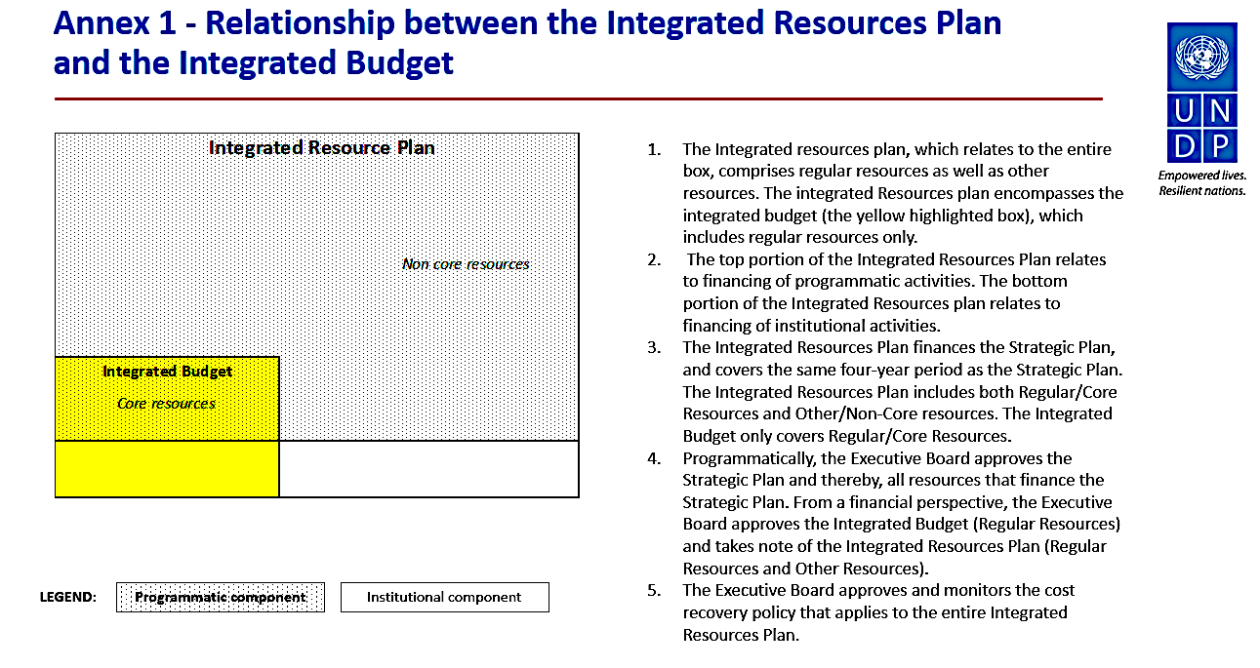

Annex 2. Detailed Tables and Figures

Figure A. Initial planned use of total resources compared to updated estimates 2018-2021

Table 1. 2018-2019 initial plan compared to 2018-2019 actuals

in millions of dollars

Table 2. Integrated resources plan, 2018-2021: original estimates compared to updated estimates
in millions of dollars

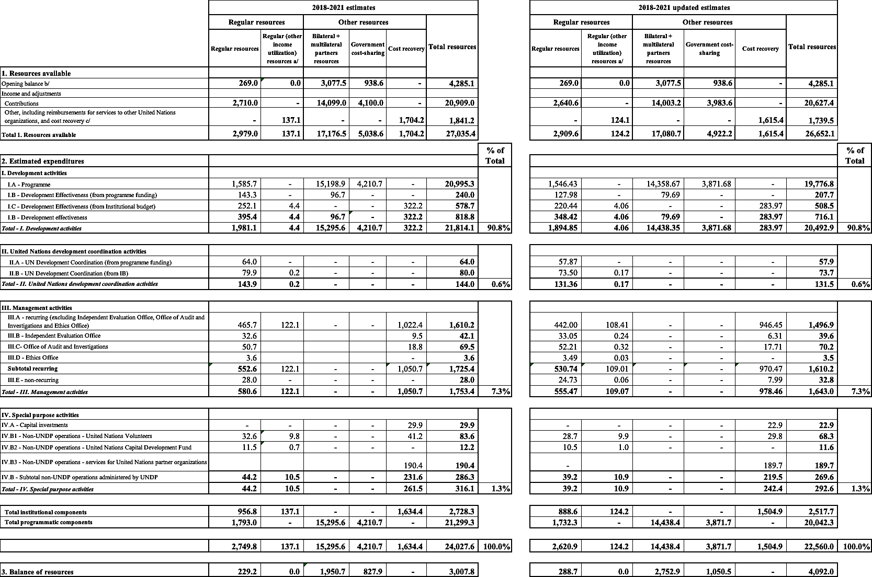

Table 3. Institutional component of the integrated budget by expenditures category 2018-2021 budget estimates compared to 2018-2019 actuals and 2020-2021 estimates

in millions of dollars

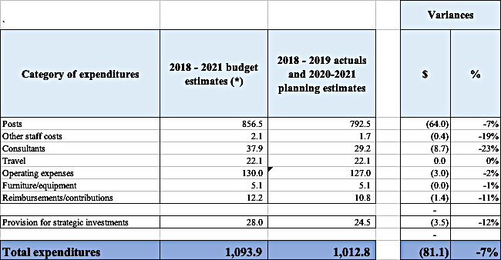

Table 4. Programmatic component of the integrated budget by line:
2018-2021 budget estimates compared to 2018-2019 actuals and 2020-2021 estimates

in millions of dollars
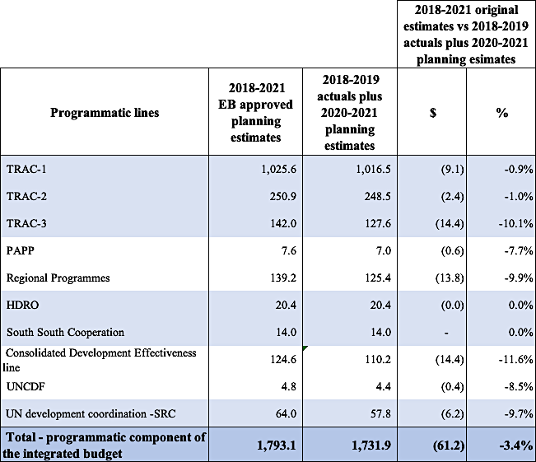

Figure B. Programmatic component of the integrated budget by line: EB approved planning estimates compared to 2018-2019 actuals and 2020-2021 planning estimates
in millions of dollars

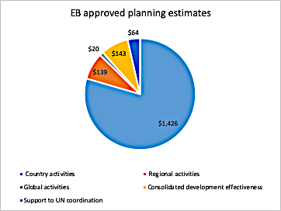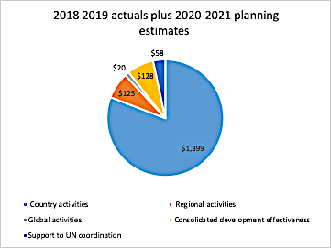

Table 5. Integrated budget by component:
2018-2021 budget estimates compared to 2018-2019 actuals and 2020-2021 updated planning estimates
in millions of dollars

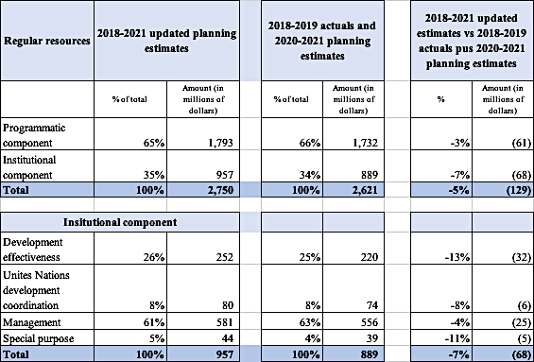

Figure C. Institutional component of the integrated budget by cost classification category: 2018-2021 EB approved planning estimates compared to 2018-2019 actuals and 2020-2021 planning estimates

in millions of dollars

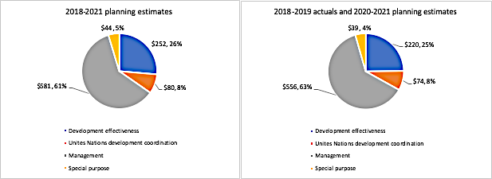

Table 6. Regular resources senior posts, by location

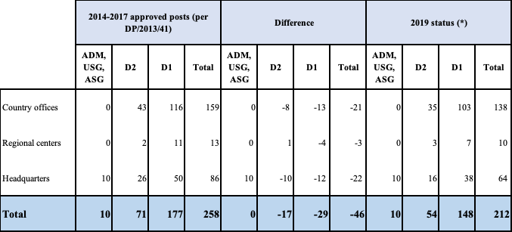
(*) Data as of December 2019

Table 7. Estimated resources by strategic plan outcome for the period 2018-2021

in millions of dollars

Annex 3. Update on general management services cost-recovery waivers

- The Executive Board in its decision 2013/9 endorsed “a general, harmonized cost recovery rate of 8 per cent for non-core contributions,” and further endorsed the following differentiated cost recovery rate structure: “(a) a harmonized 1 per cent reduction for the thematic contributions at the global, regional and country level in UNDP, UNFPA and UNICEF (8 per cent - 1 per cent = 7 per cent), with the United Nations Entity for Gender Equality and the Empowerment of Women (UN-Women) maintaining the 8 per cent as a temporary arrangement; and (b) maintaining the existing preferential rates for government cost-sharing, South- South contributions and private-sector contributions.”

- In the same decision, the Executive Board also decided that on an exceptional basis, and when the urgency of the circumstances requires, “the Administrator of UNDP and the Executive Director of UNFPA may consider granting a waiver of the cost-recovery rates on a case-by-case basis, taking into account specific priorities, modalities that incur lower management costs, and harmonization goals, and that the Executive Board will be informed of these waivers in the annual financial reports;”

- Consistent with decision 2013/9, UNDP has annually reported to the Executive board on the cost recovery waivers through the successive annual reviews of the financial situation as well as the cumulative review of the UNDP integrated budgets. In addition, UNDP continues to work closely with UNFPA, UNICEF, and UN-Women, on the topic of cost-recovery. Most recently, at the second regular session of the Executive Boards in September 2019, the four agencies have jointly reported on this topic to the Executive Boards.

- In the decision 2018/21 of the Executive Board in September 2018, the Executive Board requested “UNDP and UNFPA, together with UNICEF and UN-Women, to reduce the granting of waivers lowering the agreed cost-recovery rates and to provide an update on the steps taken in this regard, including on the application of waivers across their organizations, to the Executive Board at its annual session in 2019”.

- UNDP makes every effort to apply the Executive Board decision (2013/9) regulating the General Management Services (GMS) cost recovery rate applied to non-core programme expenses, to recover the costs incurred by UNDP in managing programmes funded from non-core resources. Whilst infrequent, GMS waivers continue to be demanded by funding partners. UNDP considers carefully all demands by funding partners for waivers, and has agreed to such demands only in exceptional cases where the project funding would otherwise be at risk, negatively impacting UNDP’s ability to help programme countries to achieve development results.

- Accordingly, information on GMS waivers is presented in this addendum in two segments:
- GMS waivers issued in 2019; and
- GMS waivers issued prior to 2019 for activities on-going in 2019

- Separate from the above referred GMS waivers, this addendum also sets out framework agreements with multilateral funding partners where GMS rates were agreed below the current 8% GMS rate.

    - GMS waivers issued in 2019

- During 2019, no new waiver was granted for new projects, but the following three waivers were renewed at previously approved reduced GMS rates:

- A reduced (3 per cent) fee for a contribution to the "Yemen Crisis Response III”;
- A reduced (5 per cent) fee for a contribution to the "UN Democratic Republic of the Congo Humanitarian Fund”;
- A reduced (7 per cent) fee for a contribution to "Improve Access and Mobility of IDPs through infrastructure rehabilitation and Livelihoods” and “Solid Waste Management in the affected communities in Syria.

The financial impact of these renewed waivers based on total agreement or expected delivery is summarized below:

 | GMS rate | Funding partner | Financial impact of GMS waived | Justification
Yemen Crisis Response III | 3% | World Bank | $4,494,786 | World Bank stipulates 3% GMS for grants between $50 million - $100 million
UN DRC Humanitarian Fund in the Democratic Republic of the Congo | 5% | UNOCHA | $979,083 | UNOCHA stipulates 5% GMS for their pooled funds
Improve Access & Mobility of IDPs through infrastructure rehabilitation and Livelihoods and Solid Waste Management in the affected communities in Syria | 7% | UNOCHA | $23,066 | UNOCHA stipulates 5% GMS for their pooled funds
Total impact: |  |  | $5,496,935

- GMS waivers issued prior to 2019 for activities on-going in 2019

- In addition to the above, two further projects with reduced GMS rates were ongoing in 2019 where the donors have insisted on retaining the previously agreed GMS rates due to project size and scale:

  - A reduced (4 per cent) fee was applied for a contribution from Global Fund for "Commitment Towards Fast Tracking 90-90-90 Targets and Ending AIDS by 2030" in Zimbabwe, as previously reported in the annexes to the Annual review of the situation, 2017 (DP/2018/19); and
  - A reduced (4 per cent) fee was applied for contributions to "Law & Order Trust Fund for Afghanistan – MOIA (Ministry of Interior Affairs) Afghanistan Development Outcome – Capacities for reform and accountable and efficient MOIA management and oversight are improved with integrated civilian and uniformed leadership and management and Support to payroll management”, as previously reported in the annexes to the Annual review of the financial situation, 2015 (DP/2015/26).

The financial impact of these two waivers in 2018-2019 is summarized below:
 |  |  | Financial impact of GMS waived
Project | GMS rate | Funding partner | 2018 | 2019
"Commitment Towards Fast Tracking 90-90-90 Targets and Ending AIDS by 2030" in Zimbabwe (Approved in 2017) | 4% | GFATM | $3,518,566 | $5,260,059
"Law & Order Trust Fund for Afghanistan” (Approved in 2014) | 4% | Multiple donors, see details below: | Total: $14,635,077 | Total: $12,723,652
 |  | Government of Japan | $4,673,636 | $3,115,152
 |  | European Commission | $1,643,704 | $2,470,943
 |  | Government of Germany | $2,969,172 | $4,091,599
 |  | Government of Italy | $2,373,257 | $2,494,138
 |  | Government of the United Kingdom | $1,775,929
 |  | Government of Australia | $546,695
 |  | Government of Norway | $222,696 | $421,021
 |  | Government of Republic of Korea | $151,977
 |  | Government of New Zealand | $87,692
 |  | Government of United States of America | $41,248 | $54,274
 |  | Government of Croatia | $38,462 | $19,231
 |  | Government of Switzerland | $34,487
 |  | Government of Netherlands | $29,372 | $35,482
 |  | Government of Estonia, Republic | $19,135 | $11,752
 |  | Government of Afghanistan | $14,282
 |  | Government of Poland | $11,108 | $10,060
 |  | Government of Romania | $2,226
Total Impact: |  |  | $18,153,643 | $17,983,711

- A summary of the GMS waivers approved in 2016-2019 with the associated financial impact is set out in the below table. It indicates that over the 2016-2019 period, the number of waivers granted has notably declined from 12 to 3. The table also indicates that there has been a slight increase in the financial impact of GMS waivers granted in previous years from $17.0 million in 2016 to $18 million in 2019 ($1m increase in financial impact – a 6% increase in the impact). The latter reflects donor reluctance to agree to higher cost recovery rates relating to previously signed contribution agreements, noting that the development activities are already in progress – in some cases over multiple years.

 | 2016 | 2017 | 2018 | 2019
Number of GMS waivers granted: | 12 | 6 | 5 | 3
Financial impact of GMS waivers:
Impact of GMS waivers which were granted in the year: | $3,673,980 | $12,075,664 | $1,226,516 | $5,496,935
Impact of GMS waivers which were granted in previous years: | $16,974,697 | $17,127,497 | $18,153,643 | $17,983,711
Total financial impact | $20,648,677 | $29,203,161 | $19,380,159 | $23,480,646

Framework agreement with multilateral funding partners

- In addition to the GMS waivers detailed in the first section of this addendum, there are a number of framework agreements with multilateral funding where GMS rates have been agreed below the 8% rate. In 2019, contributions from the European Commission, UNOCHA/CERF, the UN Trust Fund for Human Security (UNTFHS), Global Fund to Fight AIDS, Tuberculosis and Malaria (GFATM), Global Environmental Fund’s small grant programme, Montreal Protocol, and other UN entities were received at GMS rate below the 8% rate. As per the policy on fee structures for accredited entities of the Green Climate Fund (GCF), all projects/programmes except micro-size projects will be subject to the cost recovery rate below 8%. The financial impact of the framework agreements with reduced cost recovery rates is summarized below:

 |  | Financial impact of the reduced cost recovery rate
Funding Partners | GMS Rate applied | 2018 | 2019
European Commission | 7% | $2,174,735 | $1,914,951
Global Fund to Fight AIDS, Tuberculosis and Malaria (GFATM) | 7% | $1,977,110 | $1,657,720
Montreal Protocol | 7% | $431,015 | $258,078
UNOCHA/CERF | 7% | $66,847 | $37,871
UN Trust Fund for Human Security (UNTFHS) | 7% | $23,099 | $25,733
Green Climate fund (Small, Medium or Large size projects) | 4%-7% |  | $1,712
Global Environmental Programme - Small Grant Programme | 4% | $1,816,037 | $1,859,195
Funds received from other UN Agencies with lower than 8% GMS:
UN | 7% or below | $6,901 | $908,220
UNICEF | 7% or below | $7,949 | $838
UNFPA | 7% or below | $2,228
UNOPS | 7% or below |  | $17,944
UNWOMEN | 7% or below |  | $5,106
WFP | 7% or below |  | $1,135
Total |  | $6,505,921 | $6,688,503

Annex 4. Actual expenditure by country typology (LIC/MIC/LDC/Non-LDC)

Distribution of 2018-2019 resources by region, typology and LDC/non-LDC

Part 1 – highlights by country typology
in millions of dollars

 | Programme |  |  |  |  |  | Institutional |  |  |  |  |  | Total
 | Regular resources |  | Other resources |  | Total |  | Regular resources |  | Other resources |  | Total |  | Regular resources |  | Other resources |  | Regular and other resources
 | $m | % | $m | % | $m | % | $m | % | $m | % | $m | % | $m | % | $m | % | $m | %
LIC | 493 | 83% | 3,079 | 40% | 3,572 | 43% | 105 | 42% | 92 | 35% | 198 | 38% | 598 | 77% | 3,172 | 40% | 3,770 | 43%
MIC (GNI p.c. < $6,660) | 88 | 15% | 3,194 | 42% | 3,282 | 40% | 115 | 45% | 101 | 38% | 215 | 42% | 203 | 20% | 3,295 | 42% | 3,498 | 40%
MIC (GNI p.c. > $6,660) | 11 | 2% | 1,145 | 15% | 1,157 | 14% | 27 | 11% | 52 | 20% | 79 | 15% | 38 | 3% | 1,198 | 15% | 1,236 | 14%
NCC | 1 | 0% | 246 | 3% | 246 | 3% | 6 | 2% | 21 | 8% | 26 | 5% | 7 | 0% | 266 | 3% | 273 | 3%
Total | 593 | 100% | 7,664 | 100% | 8,258 | 100% | 253 | 100% | 266 | 100% | 519 | 100% | 846 | 100% | 7,930 | 100% | 8,776 | 100%

Part 2 – regular (core) resources

in millions of dollars

2018-2019 allocation of regular (core) resources by region

Core: TRAC-1, 2 and 3
 | Programmatic resources |  | Institutional resources |  | Total resources
 | $ | % | $ | % | $ | %
Africa | 415 | 70% | 103 | 41% | 517 | 61%
Asia and Pacific | 94 | 16% | 51 | 20% | 145 | 17%
Arab States | 44 | 7% | 31 | 12% | 75 | 9%
Europe and the CIS | 17 | 3% | 29 | 12% | 47 | 6%
Latin America and the Caribbean | 23 | 4% | 39 | 15% | 62 | 7%
Total | 593 | 100% | 253 | 100% | 846 | 100%
2018-2019 allocation of regular (core) resources by country typology
Core: TRAC-1, 2 and 3
 | Programmatic resources |  | Institutional resources |  | Total resources
 | $ | % | $ | % | $ | %
LIC | 493 | 83% | 105 | 42% | 598 | 71%
MIC | 88 | 15% | 115 | 45% | 203 | 24%
MIC (GNI per capita > $6,660) | 11 | 2% | 27 | 11% | 38 | 5%
NCC | 1 | 0% | 6 | 2% | 7 | 1%
Total | 593 | 100% | 253 | 100% | 846 | 100%
2018-2019 allocation of regular (core) resources by development status
Core: TRAC-1, 2 and 3
 | Programmatic resources |  | Institutional resources |  | Total resources
 | $ | % | $ | % | $ | %
LDC | 490 | 83% | 113 | 45% | 603 | 71%
Non-LDC | 103 | 17% | 140 | 55% | 243 | 29%
Total | 593 | 100% | 253 | 100% | 846 | 100%

Part 3 – other (non-core) resources
in millions of dollars

2018-2019 allocation of other (non-core) resources by region
 | Share of programmatic resources |  |  |  | Share of institutional resources |  | Total resources
 | Bilateral/multilateral |  | Government cost sharing
 | $ | % | $ | % | $ | % | $ | %
Africa | 1,560 | 26% | 133 | 8% | 67 | 25% | 1,760 | 22%
Asia and Pacific | 1,731 | 29% | 86 | 5% | 54 | 20% | 1,871 | 24%
Arab States | 1,651 | 28% | 296 | 17% | 65 | 25% | 2,012 | 25%
Europe and the CIS | 472 | 8% | 426 | 24% | 23 | 9% | 921 | 12%
Latin America and the Caribbean | 490 | 8% | 820 | 47% | 56 | 21% | 1,366 | 17%
Total | 5,904 | 100% | 1,760 | 100% | 266 | 100% | 7,930 | 100%
2018-2019 allocation of other (non -ore) resources by income typology
 | Share of programmatic resources |  |  |  | Share of institutional resources |  | Total resources
 | Bilateral/multilateral |  | Government cost sharing
 | $ | % | $ | % | $ | % | $ | %
LIC | 2,981 | 50% | 98 | 6% | 92 | 35% | 3,172 | 40%
MIC | 2,308 | 39% | 886 | 50% | 101 | 38% | 3,295 | 42%
MIC (GNI per capita > $6,660 | 554 | 9% | 591 | 34% | 52 | 20% | 1,198 | 15%
NCC and Transitional NCC | 61 | 1% | 185 | 10% | 21 | 8% | 266 | 3%
Total | 5,904 | 100% | 1,760 | 100% | 266 | 100% | 7,930 | 100%
2018-2019 allocation of other (non-core) resources by development status
 | Share of programmatic resources |  |  |  | Share of institutional resources |  | Total resources
 | Bilateral/multilateral |  | Government cost sharing
 | $ | % | $ | % | $ | % | $ | %
LDC | 2,725 | 46% | 161 | 9% | 99 | 37% | 2,985 | 38%
Non-LDC | 3,179 | 54% | 1,600 | 91% | 167 | 63% | 4,945 | 62%
Total | 5,904 | 100% | 1,760 | 100% | 266 | 100% | 7,930 | 100%

Part 4 – total (core and non-core) resources

in millions of dollars

2018-2019 allocation of total (core and non-core) resources by region
Core: TRAC-1, 2 and 3
 | Share of programmatic resources |  |  |  | Share of institutional resources |  | Total resources
 | Bilateral/multilateral and core resources |  | Government cost sharing
 | $ | % | $ | % | $ | % | $ | %
Africa | 1,974 | 30% | 133 | 8% | 170 | 33% | 2,277 | 26%
Asia and Pacific | 1,825 | 28% | 86 | 5% | 105 | 20% | 2,016 | 23%
Arab States | 1,695 | 26% | 296 | 17% | 96 | 19% | 2,087 | 24%
Europe and the CIS | 489 | 8% | 426 | 24% | 53 | 10% | 968 | 11%
Latin America and the Caribbean | 513 | 8% | 820 | 47% | 95 | 18% | 1,428 | 16%
Total | 6,497 | 100% | 1,760 | 100% | 519 | 100% | 8,776 | 100%
2018-2019 allocation of total (core and non-core) resources by income typology
Core: TRAC-1, 2 and 3
 | Share of programmatic resources |  |  |  | Share of institutional resources |  | Total resources
 | Bilateral/multilateral and core resources |  | Government cost sharing
 | $ | % | $ | % | $ | % | $ | %
LIC | 3,474 | 53% | 98 | 6% | 198 | 38% | 3,770 | 43%
MIC | 2,396 | 37% | 886 | 50% | 215 | 42% | 3,498 | 40%
MIC (GNI per capita > $6,660 | 565 | 9% | 591 | 34% | 79 | 15% | 1,236 | 14%
NCC and Transitional NCC | 62 | 1% | 185 | 10% | 26 | 5% | 273 | 3%
Total | 6,497 | 100% | 1,760 | 100% | 519 | 100% | 8,776 | 100%
2018-2019 allocation of total (core and non-core) resources by development status
Core: TRAC-1, 2 and 3
 | Share of programmatic resources |  |  |  | Share of institutional resources |  | Total resources
 | Bilateral/multilateral and core resources |  | Government cost sharing
 | $ | % | $ | % | $ | % | $ | %
LDC | 3,215 | 49% | 161 | 9% | 213 | 41% | 3,588 | 41%
Non-LDC | 3,282 | 51% | 1,600 | 91% | 307 | 59% | 5,188 | 59%
Total | 6,497 | 100% | 1,760 | 100% | 520 | 100% | 8,776 | 100%

Excludes regular (core) resources funded backbone of the United Nations resident coordination activities.

