Appendix I.

UNDP overview
- Statement of financial performance for the year ended 31 December 2019
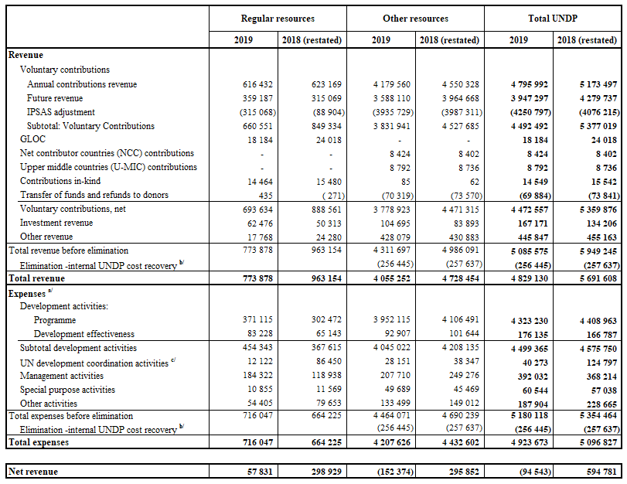
(in thousands of United States dollars)
Source: Table 2a, DP/2020/20 Appendix VI to Annex I. Appendix I to Annex I expenses presented based on cost classifications.
a/ Includes general management support service cost.
b/ This adjustment is required to remove the effect of internal UNDP cost recovery.
c/ Includes $17.9m of the reimbursable support services to the resident coordinator system for 2019.

- Statement of financial position as at 31 December 2019
(in thousands of United States dollars)
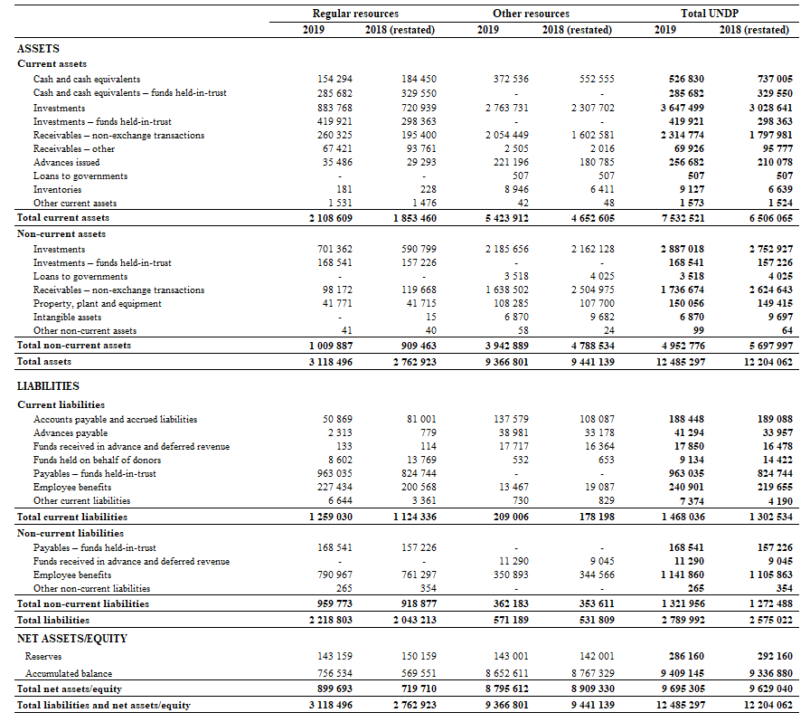

Appendix II.

Regular resources – comparison of budget to actual, 2019
(in thousands of United States dollars)
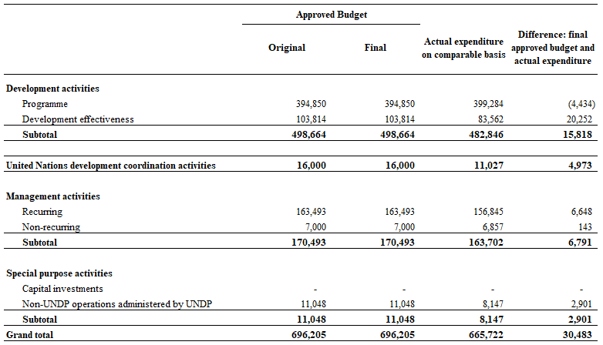

Appendix III.
- Integrated resources plan, 2018-2021 estimates compared to 2018-2019 actuals
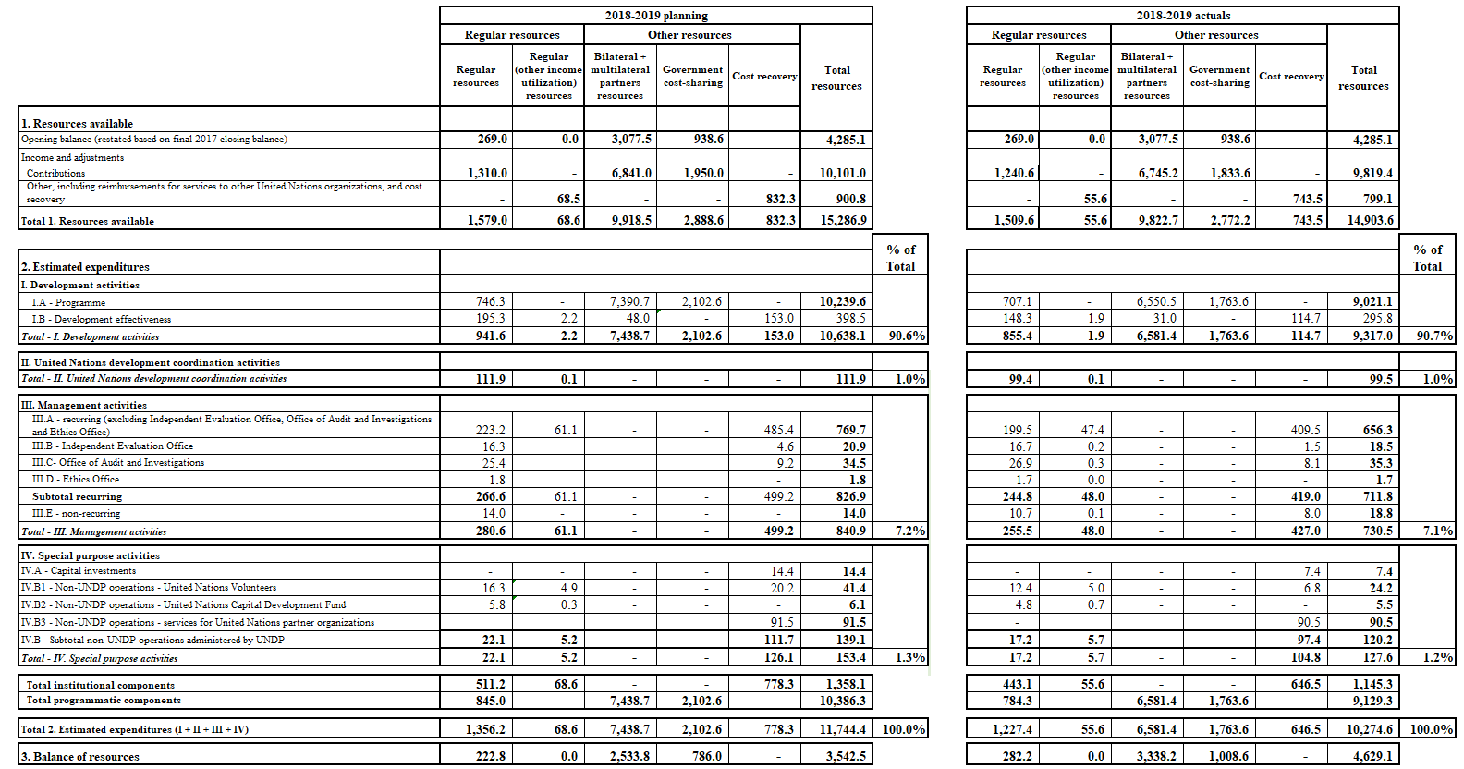
(in millions of United States dollars)

- Summary of institutional component of the integrated budget by category of expenditures:
2018-2019 annualized estimates vs 2018-2019 actual expenditures
(in millions of United States dollars)
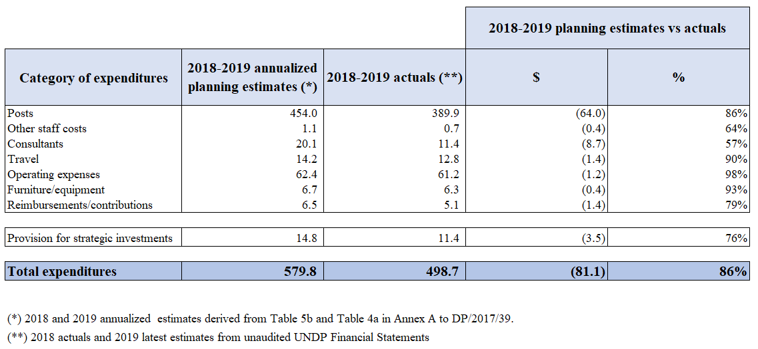

- Resources allocated to posts by location, 2019
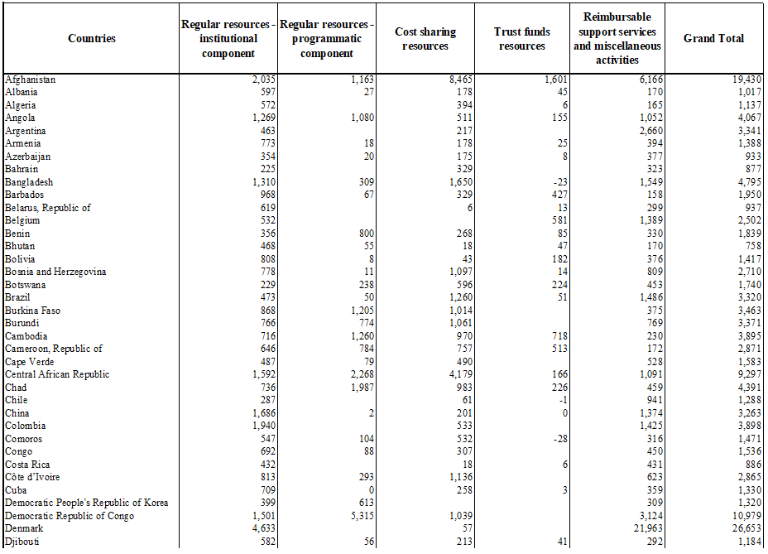
(in thousands of United States dollars)

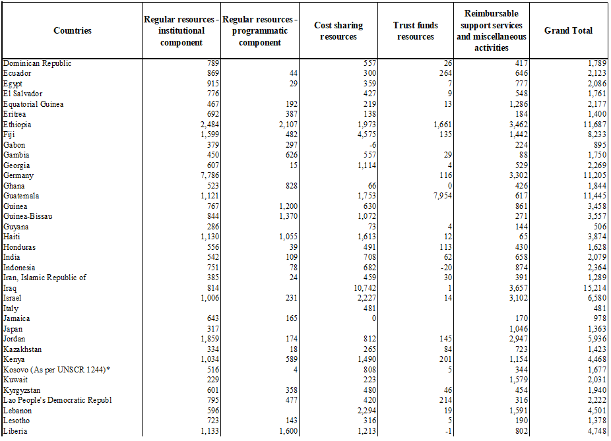

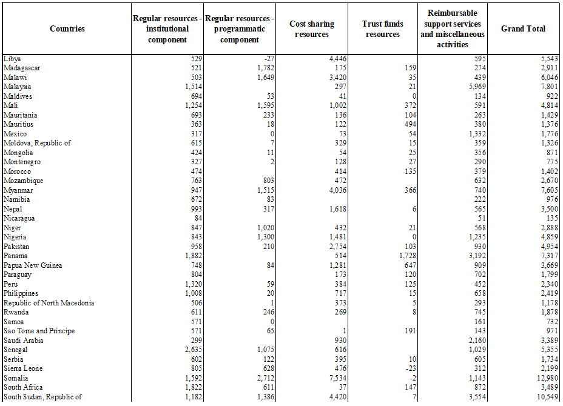

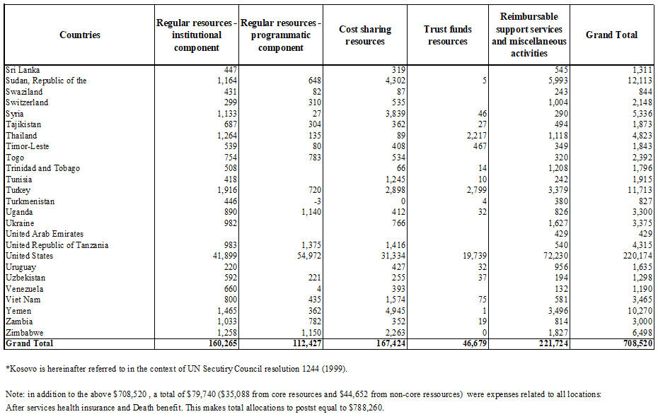

Appendix IV.

Regular resources – annual contributions from top 10 donors, 2018-2019
(in millions of United States dollars)
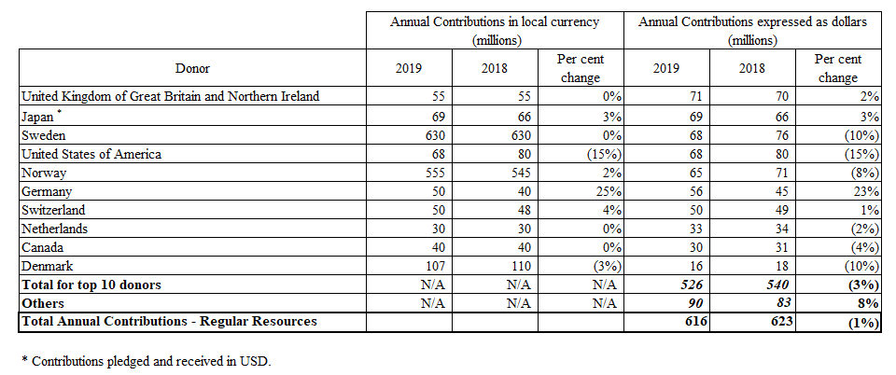

Appendix V.

Explanations of terms used in Annex I to DP/2020/20
- Accumulated surplus: Formerly referred to as ‘unexpended resources or unspent balance’. It represents accumulated funds at the end of the reporting period.
- Bilateral governments: Governments of the Member States that contribute to UNDP regular resources and other resources, comprising the Development Assistance Committee of the Organisation for Economic Co-operation and Development (OECD/DAC) members, and non-members of OECD/DAC including programme countries.
- Certified Emission Reductions (CER)s: Under the Kyoto Protocol industrialized countries are offered the opportunity to offset greenhouse gas (GHG) emissions by procuring credits from Clean Development Mechanism (CDM) projects located in developing countries. A CER basically allows an entity to pay for the reduction of GHG emissions elsewhere and is often more cost-effective than reducing the GHG emissions from their own operations or is used where GHG emissions cannot be avoided. UNDP is committed to buying only very credible, UNFCCC-issued credits (“Gold Standard”) which also deliver tangible sustainable development benefits. For details please refer to the EG-approved HQ Emission Reduction Strategy (https://undp.unteamworks.org/node/369936).
- Cost classification: Set of criteria and the process of determining programme implementation vs. administration costs, and clarifying distinctions between those.
- Development activities: Activities associated with ‘programmes’ and ‘development effectiveness,’ activities essential for achieving development results.
- Programmes: Activities traced to specific programme components or projects, which contribute to delivering development results contained in country/regional/global programme documents or other programming arrangements.
- Development effectiveness activities: Activities of a policy-advisory, technical and implementation nature needed to achieve the objectives of programmes and projects in UNDP’s areas of focus. While essential to the delivery of development results, they are not included in specific programme components or projects in country, regional, or global programme documents.
- Elimination: Represents the accounting adjustment to remove the effect of internal UNDP cost-recovery revenue and general management support expense from total UNDP amounts.
- Expenditure: Utilization of available financial resources, across harmonized cost classification categories
- Expenses: Expenses include disbursements and accruals for goods received and services rendered, and the use or impairment of assets, dependent on the implementation arrangement.
- Government contributions towards local office costs (GLOC): Contributions in the form of cash, or by provision in-kind of specific goods, services and facilities that a host Government makes towards meeting the expenses of maintaining a UNDP country office.
- Institutional budget: The institutional component of the integrated budget covering activities over a period based on a set of defined results from the strategic plan.
- IPSAS: International Public Sector Accounting Standards: Independently developed accounting standards which have been considered the best accounting practice by public sector organisations.
- Joint programmes: Collective efforts through which United Nations organisations and national partners work together to prepare, implement, monitor and evaluate the activities aimed at effectively and efficiently achieving the Millennium Development Goals and other international commitments arising from United Nations conferences, summits, conventions and human rights instruments.
- Low-income countries (LICs), Middle-income countries (MICs): On the basis of their GNI per capita, countries are grouped into the following categories: low income countries (LICs), middle income countries (MICs), transitional net-contributing countries and net-contributing countries (NCCs).
(a) LICs are defined as countries with 2012-2015 an average GNI per capita of less than $1,280.
(b) MICs are defined as countries with 2012-2015 an average GNI per capita of between $1,281 and $12,475. There are two groups of MICs:
  - MICs with levels of GNI per capita of between $1,281 and $6,660.
  - MICs with high levels of GNI per capita of between $6,660 and $12,475 per capita;
(c) Transitional NCCs are defined as countries with 2012-2015 average GNI per capita greater than $12,475 for the first time in 2018-2019 (as compared to the previous biennial budget period 2016-2017).
(d) NCCs are defined as countries with 2012-2015 average GNI per capita greater than $12,475 for the second consecutive Integrated Budget period (i.e. in 2018-2019 as well as 2016-17).
The Executive Board decided in decision 2012/28 that there would be a system of biennial updates. In this regard, a four-year approach for GNI per capita averaging are applied, with the average GNI per capita of the years 2012-2015 applied to the first two years of the Integrated Budget, 2018-2019, and the average GNI per capita of the years 2014-2017 will be applied to the last two years of the Integrated Budget, 2020-2021.
- Management activities: Activities whose primary function is the promotion of the identity, direction and well-being of an organisation. These include executive direction, representation, external relations and partnerships, corporate communications, legal, oversight, audit, corporate evaluation, information technology, finance, administration, security and human resources.
- Management service agreements (MSAs): Management service agreement (MSA) signed with a donor to prepare for receiving contributions to deliver management and other support services to recipient governments under a specific programme or project.
- Multilateral sources: Multilateral partners, such as regional development banks, international financial institutions, United Nations organisations, foundations and the private sector, which contribute to other resources.
- Other expenses: Expenses on activities other than those covered under the four broad cost classifications (i.e., development, management, United Nations development coordination and special purpose).
- Other resources: Resources of a voluntarily funded organisation that are received for a specific theme, programme purpose and for the provision of specific services to third parties. Resources that fall under this category are: cost-sharing, trust funds established by the Administrator, reimbursable support services and miscellaneous activities.
- Overall UNDP contributions: Contributions to UNDP regular resources and other resources.
- Operational reserve: A reserve established in 1979 by the Governing Council (now the Executive Board) of UNDP to ensure adequate liquidity of UNDP by funding such reserve through a defined formula that is calculated yearly.
- Regular resources: Resources of UNDP which are commingled and untied. They include voluntary contributions, contributions from governmental, intergovernmental or non-governmental sources, and related interest earnings and miscellaneous income.
- Reimbursable support services and miscellaneous activities: Resources of UNDP other resources (other than cost-sharing and trust funds). Such funds are received for the provision of management and other support services to third parties. It comprises the following activities: management services agreements; the Junior Professional Officer programme, reimbursable support services; the United Nations Volunteers programme, programme support to Resident Coordinators, and special purpose activities.
- Revenue: Consists of: (a) voluntary contributions; (b) investment revenue; and (c) other revenue (see below).
- Voluntary Contributions: In 2019, UNDP refined its accounting policy for recognizing revenue from voluntary contributions (non-exchange transactions); and as a result of the change, the full value of the contributions agreements signed (including multi-year agreements) is recognized as revenue in the year an agreement is signed. The amounts shown include returns to donors, and transfers to other funds of unused contributions. Contributions may also include in-kind contributions and GLOC cash contributions provided by programme country governments.
  - Annual Contributions: Annual Contributions are calculated to provide additional information in order to align with previous revenue recognition policies for contributions (i.e., cash received in a reporting year, plus receivables due in a reporting year).
  - Future Due Contributions: Future Due Contributions are calculated to show the cash to be received after the reporting year based on the multi-year agreement signed in a reporting year.
  - IPSAS 23 Adjustments: Based on the change in revenue recognition policy, this adjustment was made for agreements signed prior to 2019 for all contributions not received by the end of 2018.
- Voluntary Contributions, net: Net Contributions after returns of unused contributions to donors, and transfers of funds have been deducted.
- Investment revenue: Interest inflows from UNDP investments
- Other revenue: Revenue from sources other than contributions and investments, for example, revenue from sale of goods and provision of services, such as procurement, training, and other services to governments, UN agencies and other parties, foreign exchange gains, common services and miscellaneous revenue, and cost recovery revenue.
- Special purpose activities: Activities and associated costs of (a) capital investments; and (b) non-UNDP operations administered by UNDP.
- United Nations development coordination activities: Activities and associated costs supporting the coordination of development activities of the United Nations system.

_____________

