July 10, 2018

Annex. Lessons Learned from Implementation of UNDP Gender Equality Strategy 2014-2017

Programmatic Lessons Learned

- The implementation of the UNDP Gender Equality Strategy 2014-2017 revealed key lessons learned that informed the development of the Gender Equality Strategy 2018-2021. Those lessons learned include the findings, conclusions and recommendations of the 2017 independent evaluation of the UNDP Strategic Plan and global and regional programmes (2014-2017) and the 2015 independent evaluation of UNDP contribution to gender equality and women’s empowerment.

- Over the Strategic Plan period 2014-2017, the majority of UNDP’s gender equality results were reported under Strategic Plan outcomes 1 (Growth and development are inclusive and sustainable, incorporating productive capacities that create employment and livelihoods for the poor and excluded) and 2 (Citizens’ expectations for voice, development, the rule of law and accountability are met by stronger systems of democratic governance).

- Many of the results reported under Outcome 1 related to efforts to promote women’s economic empowerment through livelihood programming. Overall, during 2014-2017, women accounted for 51 percent of 37.3 million people who benefited from improved livelihoods initiatives in 120 countries. Of nearly 3 million new jobs created in 101 countries, 41 per cent went to women. For example, in India, UNDP’s skills and entrepreneurship support to women and girls under a public-private partnership model led to over 200,000 women and girls becoming equipped for accessing the labour market and contributed to reducing structural barriers that they face in realizing their full potential. In Somalia, trainings on water harvesting techniques and fodder management for women in rural communities have had multiplier effects. Women farmers are now forming cooperatives, in a context where they did not traditionally take the lead on food production.

- However, many UNDP results under Outcome 1 continued to be limited to small scale projects with narrow reach or transformative impact at a significant national scale. And while some initiatives addressed structural barriers to women’s economic participation – such as the skill and entrepreneurship support to women in India – more emphasis needs to be placed on approaches that transform legal, policy or social norms to create sustaining impact on women’s economic empowerment. The midterm review of the UNDP Regional Programme for Europe and CIS 2014-2017 specifies that going from “counting women” to gender-responsive and gender-transformative results requires adequate programmatic, structural and funding arrangements.

- To address this, UNDP’s Gender Equality Strategy 2018-2021 focuses attention on “removing structural barriers to women’s economic empowerment, including women’s disproportionate burden of unpaid work,” as one of the four priority areas of Signature Solution 6. This means investing more in gender-responsive infrastructure, implementing policies that support a more equal distribution of care and domestic work, promoting policies that ensure equal access to finance, land and assets, changing gender stereotypes, and enhancing national statistical capacities on collecting and analyzing gender-disaggregated data. In addition, UNDP must use its livelihoods interventions not only to ensure that women have access to decent jobs, but that gaps in labor market participation are closed, and that gender equality in the workplace is promoted at all levels.

- Under outcome 2, strong results were reported with regard to women’s political empowerment through support for women’s participation in parliaments, elections, and in constitutional and legal reforms to advance gender equality. Between 2014 and 2017, UNDP support led to the registration of approximately 166 million electors and the participation of 304,442 women candidates in national elections. For example, in 2017 UNDP supported the Election Commission of Nepal to reach out to 52,268 potential female candidates, of whom 4,000 were nominated for elections and 1,011 were elected in the local elections. In Montenegro, UNDP’s longstanding efforts to empower women in political parties resulted in the establishment of the cross-party Women’s Political Network, which leads advocacy on women’s political participation, and contributed to an increase of the representation of women in the National Parliament from 17 percent to 24 percent.While UNDP’s contribution to the increased number of women candidates is evident through its work to strengthen women’s capacities, equally important has been work to address structural barriers to women’s political leadership, such as through support for gender equality laws and quotas. UNDP has been a significant provider of support for women in politics globally, with expansive partnerships across the UN, particularly with UN Women, but also with global organizations such as the Inter-Parliamentary Union and regional organizations such as the African Union.

- During implementation of the last gender equality strategy, UNDP expanded its work to support women’s participation and leadership in a broad range of institutions, including public administration, the judiciary and the private sector. Over the course of the 2014-2017 Strategic Plan, UNDP’s Global Initiative on Gender Equality in Public Administration (GEPA) has worked with partners – such as OECD, UN Women and the Wilson Center – to develop tracking systems to monitor and advocate for more women in leadership within the public administration. Likewise, over the strategic planning period, UNDP began promoting women’s empowerment and leadership in the private sector through the Gender Equality Seal for Private and Public Enterprises, which amongst other things, works to advance women’s leadership and gender equality in companies. This work is reflected in the new gender equality strategy as a priority area in Signature Solution 6, “promoting women’s participation and leadership in all forms of decision-making.”

- Over the Strategic Plan period 2014-2017, UNDP saw a surge in requests for support from governments to address gender-based violence as this issue is increasingly recognized as a major impediment to both gender equality and sustainable development. In particular, UNDP has supported efforts to ensure justice for victims of sexual and gender-based violence in crisis and non-crisis contexts by enhancing the capacities of police officers, judges, prosecutors, court administrators, and military and religious leaders. For example, in the Democratic Republic of Congo, UNDP, UNFPA and UNESCO supported work to prevent sexual and gender-based violence (SGBV) cases. An evaluation conducted in 2017 revealed an 88 percent decrease in SGBV cases from 15,532 in 2013 to 1,734 in 2017. It also showed that women’s access to justice improved by 33 percent in 2017 compared to 2016. In Kosovo, with support from UNDP and other UN agencies, a new National Strategy on Protection from Domestic Violence and Action Plan 2016-2020 has been put in place, providing a framework for prevention and response as well as the reintegration of SGBV survivors. In the new gender equality strategy, “preventing and responding to gender-based violence” is a Signature Solution 6 priority area. It underscores the need to ensure access to justice and protection for women and girls, especially those facing multiple and intersecting forms of discriminations, such as women and girls with disabilities.

- UNDP worked over the course of the Strategic Plan period 2014-2018 to improve the integration of gender issues in conflict prevention, disaster preparedness and crisis response, and advance the women, peace and security agenda. Furthermore, UNDP placed gender experts in some critical crises countries – including Central African Republic, South Sudan, Syria and others. For example, in Central African Republic, a gender adviser was instrumental in advising the Government on the draft gender parity law that was subsequently adopted and requires all public institutions to have at least 35 percent women’s representation. In Colombia, UNDP jointly with national partners has helped survivors of sexual violence to rebuild their lives with dignity by providing access to health, protection, and psychosocial and legal care, documenting over 1,600 cases, and promoting reparations for nearly 1,000 survivors. In recent years, the regional programme SEESAC (South Eastern and Eastern Europe Clearing house for the Control of Small Arms and Light Weapons) has been successfully advancing gender equality in security sector reforms in the Western Balkans. It helped establish the Women Police Officers Network in South Eastern Europe, a regional advocacy mechanism which brings together high-ranking women from police services for information exchange and provides trainings for women police officers. SEESAC also helped institutionalize Ministry of Defense Gender Focal Points, who advanced policy reforms to improve the recruitment and retention of women in the armed forces and to make them more responsive towards gender issues.

- However, given the scope of UNDP’s work in crises contexts, initiatives need to move from gender targeted approaches where women are beneficiaries of programmes to the adoption of programmes that aim to empower women as agents of change. The 2017 evaluation of the UNDP Strategic Plan and global and regional programmes (2014-2017) recommended that gender expertise be present in large programmes, not just in gender teams. This approach calling for “strengthening gender-responsive strategies in crisis (conflict and disaster) prevention, preparedness and recovery” is designated as priority area under Signature Solution 6. It calls for ensuring that gender equality and women’s participation are integrated into crisis prevention, preparedness and recovery from the earliest stages. This entails sex-disaggregated gender analysis, the meaningful participation of women and women’s organizations in decision-making, and creating opportunities for women to contribute to and participate in sustainable livelihoods and improve their socioeconomic status.

Leadership, Accountability and Capacities

- UNDP’s report of the Administrator on results for 2017 and progress on the Strategic Plan 2014–2017 shows that while targets were met or exceeded for 20 out of 38 development outputs, UNDP gender performance was lower for 10 out of 21 outputs with sex-disaggregated or gender sensitive indicators. This, along with the uneven distribution of UNDP’s gender equality results across the respective outcomes, underscores the need to strengthen the commitment and accountability for gender mainstreaming across the spectrum of UNDP’s development portfolio. This confirms the findings of the 2015 evaluation of UNDP’s contribution to gender equality and women’s empowerment which argued that “UNDP should better align its programming with its corporate messaging on the centrality of gender equality and women’s empowerment to the achievement of sustainable development, including through senior leadership commitment to and championing of gender equality…”For this reason, the Gender Equality Strategy 2018-2021 focuses on enhancing accountability through the performance management of senior managers; creating focal teams led by senior management at the country level; strengthening the ‘Gender Steering and Implementation Committee’ chaired by the Administrator; and promoting more visible leadership for gender equality. Stronger senior management oversight was also recommended by the 2017 End-Term Gender Review of the RBAP Regional Programme 2014-2017, suggesting that senior management conduct annual meetings to review progress toward gender equality and women’s empowerment within the regional programme. There is also a particular need to incentivize better application of gender analysis tools and to take measures to ensure adequate funding to mainstream gender across all programming areas especially in large programmes as was recommended by the Strategic Plan evaluation in 2017.

- The 2015 evaluation of UNDP contribution to gender equality and women’s empowerment noted that UNDP should build upon institutional mechanisms for gender mainstreaming, such as the Gender Equality Seal and the gender marker, both of which have proven to drive results toward gender equality through achievable, concrete and measurable standards. Positive incentives for good performance such as the Gender Equality Seal are transforming behavior, creating a new cadre of leadership for gender equality across the organization, and connecting organizational structure with impact and results. Since 2011, more than 50 country offices have been awarded a Gender Equality Seal this will be expanded to another 50 offices over the Strategic Plan period 2018-2021. While there is both high demand and high commitment by Country Offices, the Gender Equality Seal has demonstrated that deep changes are gradual and require time.

- Over the implementation of UNDP’s last gender equality strategy, increasing recognition was given to women facing multiple and intersecting forms of discrimination, such as disability and indigenous identity, that increase their vulnerability to violence, poverty and disempowerment. The new gender equality strategy recognizes that addressing these intersecting forms of discrimination is an essential component of the SDG agenda and its focus on leaving no one behind.

Partnerships to Promote Gender Equality

- Throughout the period of 2014-2017, UNDP engaged in a broad range of inter-agency partnerships to promote gender equality and women’s empowerment, most notably with its largest programme partner, UN Women, but also with NFPA, UNICEF, DPA, ILO and others. This included leveraging one another’s strengths and co-creating towards a shared goal.

- Apart from UNDP partnership within the UN System, consolidating, expanding and strengthening the partnership with other relevant stakeholders, including the private sector and civil society organizations, have been critical for achieving transformative results. For example, through the Gender Equality Seal for Public and Private Enterprises, UNDP has been engaging companies in Latin America and Africa to change their business practices to advance gender equality in the workplace. UNDP’s new gender equality strategy recognizes the importance of working as partners with both the private sector and civil society organizations.

Resources for Gender Equality

- The amount of resources UNDP devoted to mainstreaming gender equality across the organization’s portfolio of work is significant and makes a vital contribution to advancing gender equality. Following the recommendation of the 2017 evaluation of UNDP’s Strategic Plan, UNDP is increasingly strengthening implementation of its gender policies and dedicating resources and capacities to advancing gender equality in large programmes such as the Nationally Determined Contributions Support Programme which are serving as models and flagships for the organization. The Gender Strategy has also focused increased attention on benchmarking financial commitments for gender equality and strengthening monitoring of compliance with the benchmark.

Gender Marker

- UNDP progressively mainstreamed gender equality and women’s empowerment as evidenced by the gender marker ratings. In 2017, 44 per cent of programme expenditure had significant contributions to gender equality (GEN2), an increase from 29 per cent in 2014. Interventions in which gender equality is a principle objective (GEN3), however, have remained static and more work is required. UNDP will strengthen its implementation of gender policies and gender mainstreaming in all programmatic areas through the gender equality signature solution in the Strategic Plan 2018-2021 as explained above. One of the key lessons learned for improving financial allocations for gender equality is the need to share accountability and oversight for gender marker scores, and ensure resources are allocated for gender equality. This requires more systematic monitoring of gender marker results and strengthened accountability for individual performance, which has been adopted in the new Gender Equality Strategy. Additionally, strengthened Gender Marker quality assurance mechanisms will allow the positive trend in GEN2 expenditures to be sustained, and will increase the reliability of the gender marker data.

GEN2 and GEN3 trends, 2014-2017

Gender Parity

- UNDP has been successful in attaining and maintaining gender parity among its staff. As of the beginning of 2018, 51% of all UNDP staff were women and 49% were men. Due to dedicated efforts over the life of the Gender Equality Strategy 2014-2017, UNDP has managed to approach parity among senior managers in the field. The share of women among UNDP Resident Representatives has increased from 42% in 2013 to 47% in 2017, and among Deputy Resident Representatives/Deputy Country Directors – from 42% to 49%. Some of the reasons for the success include robust policy frameworks aimed to support parity, including a recruitment and selection policy aimed to reduce biases, a comprehensive flexible working arrangements policy, and a set of leave policies to support staff in balancing their multiple responsibilities at work and personal lives; and building a stronger pipeline of female candidates for senior country leadership roles and development programmes for women.

Percentage of women in leadership positions in the field (2013-2018)

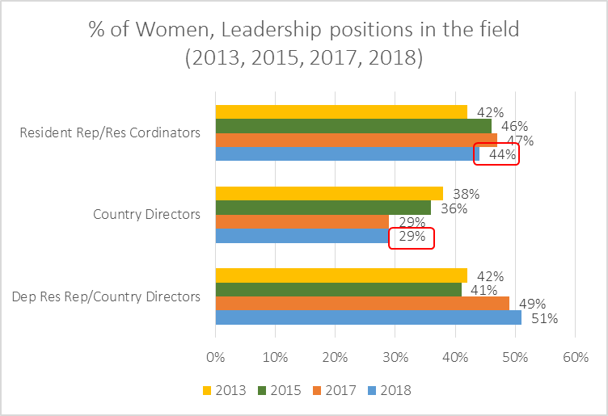

- Despite progress, challenges persist with regard to women’s representation in senior positions as well as their experiences as employees. The share of women declines from close-to-parity at the P3 level to 35 percent at the D2 level. This trend is mirrored by national staff, particularly at NOD and NOC levels. Some reasons for this include inconsistency in the implementation of policies and work practices, unconscious bias in recruitment practices, an imbalance in the number of women applying for senior posts, as well as dispersed accountability for reaching gender parity. The new Gender Parity Strategy calls for strengthening a gender-inclusive culture, enhanced efforts to attract and recruit more qualified women to posts where they are under-represented, improving retention and advancement of qualified personnel and strengthening accountability for gender parity results across the organization. Recent appointments by the Administrator at Assistant Secretary General level now mean his senior leadership team of Directors is 50:50 gender balanced as at July 2018.

Percentage of women and men, total UNDP staff, by grade (March 2018)
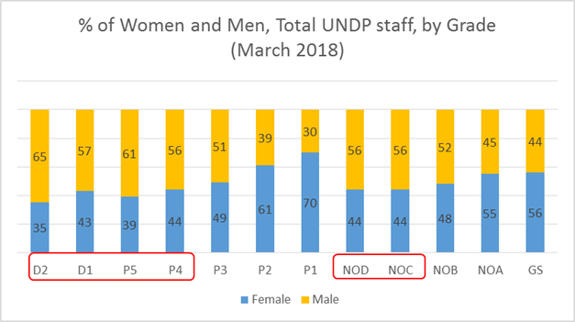

Report of the Administrator on results for 2017 and progress on the Strategic Plan, 2018-2021.
Ibid.
UNDP Results-Oriented Annual Reporting (ROAR) 2017
Ibid.
Report of the Administrator on results for 2017 and progress on the Strategic Plan, 2018-2021.
UNDP ROAR 2017
UNDP ROAR 2017
Report of the Administrator on results for 2017 and progress on the Strategic Plan, 2018-2021.
References to Kosovo shall be understood to be in the context of Security Council Resolution 1244 (1999).
UNDP ROAR 2017
Ibid
https://stories.undp.org/breaking-the-silence
http://www.seesac.org/Gender-in-Security-Sector-Reform/

