ionb

Annex I to DP/2020/20
Detailed annual review of the financial situation, 2019

Contents
I. Introduction 2
II. Overview 2
III. Financial highlights for 2019 5
A. Summary of UNDP financial situation 5
B. Revenue 6
C. Expenses 10
IV. Financial position 16
A. Assets 16
B. Liabilities 17
C. Accumulated Surplus 18
V. Others 20
VI. United Nations reform and support to United Nations organizations 21
A. UNDP administrative agent function 21
B. Support to United Nations organizations 22
C. United Nations development coordination activities 22
D. United Nations-mandated security costs 22
VII. ‘Greening’ UNDP 23
VIII. Appendices 23

- Introduction
- This Annex provides an overview of the financial position of UNDP – including the United Nations Volunteers (UNV) and the United Nations Office for South-South Cooperation (UNOSSC) at the end of 2019.
- Appendices I-V are available on the Executive Board web page. Tables 1-10, in Appendix VI, provide further details of the activities undertaken by UNDP.
- In accordance with Executive Board decision 2013/28, this report includes a comparative overview of actual 2019 utilization compared to the resource planning figures in the UNDP Integrated resources plan, 2018-2021 (DP/2017/39), and the corresponding appendix II. It includes appendices III.A and III.B in the format of the UNDP integrated resources plan. Appendix III.C provides the resources allocated to posts, by location.
- In 2019, UNDP refined its accounting policy on IPSAS 23 (non-exchange) revenues. UNDP now records the full value of funding agreements when signed, even when cash has not been received for majority of the amounts of the contribution agreements. Any uncollected cash associated with funding agreements is held as a receivable. All comparatives for 2018 have been restated on the same basis as 2019.
- Under UNDP’s new voluntary contributions policies established in 2019, the full amount of the contributions will be recorded as revenue upon signing of contribution agreements, irrespective of which future period the contributions will be received. This applies to revenue received through all contribution agreements, including core (with donors who sign agreements) but excluding Programme Government Cost Sharing and GLOC contributions, which will continue to be recognized upon receipt of funds.
- The change in accounting policy has had the following impact on UNDP’s 2019 Financial Statements and therefore the information presented in this paper:
  - Increase in voluntary contributions revenue (which also impacts the accumulated reserve through an increase in contributions receivable).
  - Increase in Outstanding Contributions Receivable.
  - No Change in Cash Received: The revised policy does not impact the amount of cash received which will continue to determine the spending ability by UNDP offices.
  - Restatement of Prior Period Financial Statements.
- In line with UNDP’s Financial Regulations and Rules (FRRs), funds will continue to be programmed only when funding partners transfer cash resources. Thus, the ability of offices to spend or enter into commitments is unchanged and continues to be dependent on funds received.
- Overview
- Financial stability remained a top corporate priority in 2019 for UNDP. UNDP continued to maintain a positive net asset position on its balance sheet. During 2019, net assets/equity increased by $66 million, and UNDP achieved the year-end core liquidity position above the minimum threshold requested by the Executive Board.
- Total revenue, including voluntary contributions in 2019 was $4.8 billion, a decrease of $863 million (or 15 per cent) from $5.7 billion in 2018. This includes voluntary contributions of $4.5 billion, a decrease of $887 million (or 17 per cent) from $5.4 billion) in 2018. Of this decrease, $559 million is due to lower multi-year funding agreements signed in 2019 compared to 2018, and $161 million can be attributed to exchange rate fluctuations.
- Total expenses in 2019, that includes programme delivery, was $4.9 billion, a decrease of $173 million (3 per cent) from $ 5.1 billion in 2018. Total expenses remained above the level of total revenue by drawing upon the accumulated positive balance. Programme expense (i.e., delivery) was $4.3 billion a decrease of $86 million (or 2 per cent) from $4.4 billion in 2018.
- Compared to the previous year, the proportion of regular resources allocated to development programmes increased to 65.9 per cent from 62.6 per cent, while the proportion of regular resources used for institutional budget activities decreased from 37.4 per cent to 34.1 per cent. The latter was below the planned allocation of regular resources to institutional activities of 35.9 per cent in the Executive Board-approved integrated budget.
- Total cash and investments, including the After-Service Health Insurance (ASHI) portfolio increased by $543 million to $7.1 billion (2018: $6.5 billion) at 31 December 2019. This was due to an increase in investments of $753 million which was offset by a $210 million decrease in cash and cash equivalents.
- The liability for ASHI increased by $10 million (or 1 per cent) compared to 2018, while investments and cash balances (arising from ASHI investments) increased by 24 per cent to $775 million. This resulted in a funding position of 74 per cent up from 60 per cent in 2018 which is based on a 15-year ASHI funding strategy.
- UNDP continued to reverse the institutional budget deficit and balanced its institutional budget for the third consecutive year. Institutional expenditure remained below the level of the institutional revenue, and there was a small net institutional balance of $58.4 million.
- Total accumulated resource balances were $9.4 billion (in 2018 (restated): $9.3 billion), of which, non-core programme resources balances were $8.7 billion, a slight decrease of 1 per cent from 2018 (restated, $8.8 billion). UNDP is systemically reviewing these balances. UNDP continues to seek opportunities to accelerate the delivery of development results and further draw down its accumulated surplus, taking into account the revenue increase and the late receipt of funds. Available accumulated regular resource balances (core) increased by $187 million, mainly due to a small surplus of $58 million in 2019, along with an increase in the fair value of ASHI investments and an actuarial gain. The fair value change in ASHI investments and the actuarial gains are unrealized and therefore non-programmable.

- Figure I (a)-I (c) illustrates the trend of total revenue and total expenses.
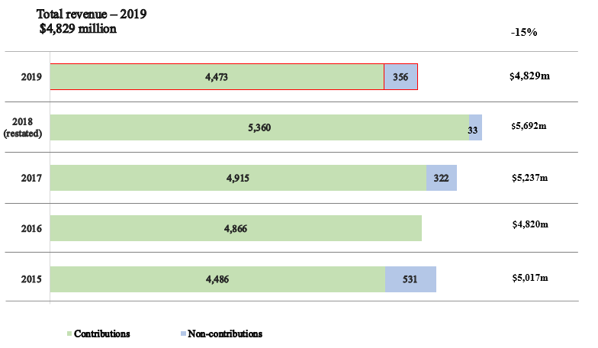
Figure I (a). UNDP total revenue trend

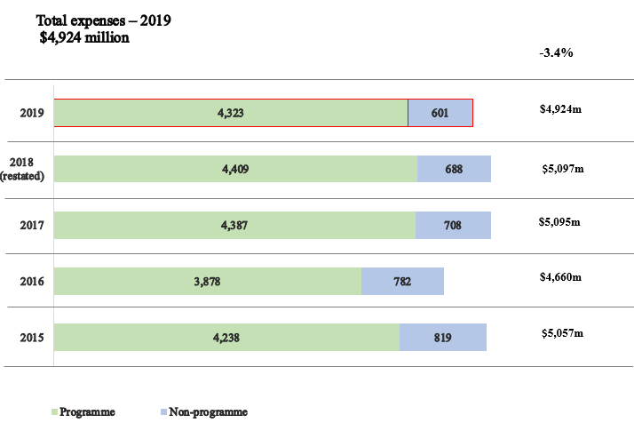
Figure I (b). UNDP total expenses trend
Note: Non-program Note: Non-programme expenses consist of development effectiveness, United Nations development coordination, management and special purpose classifications.

Figure I (c). Total revenue and expenses trend, 2009-2019
(in millions of United States dollars)
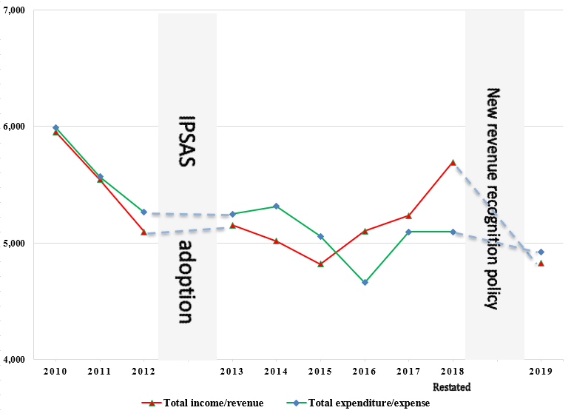

Note: IPSAS=International Public Sector Accounting Standards
- Financial highlights for 2019
  - Summary of UNDP financial situation
Table 1. UNDP financial situation, 2018-2019
(Millions of United States dollars) | 2019 | 2018  (restated) | Increase/  (decrease) | Percentage change
Revenue ª | 4,829 | 5,692 | (863) | (15%)
Expenses ª | 4,924 | 5,097 | (173) | (3%)
Net revenue | (95) | 595 | (690) | (116%)
Assets | 12,485 | 12,204 | 281 | 2%
Liabilities | 2,790 | 2,575 | 215 | 8%
Net assets | 9,695 | 9,629 | 66 | 1%
Composed of:
Accumulated balance | 9,409 | 9,337 | 72 | 1%
Reserves | 286 | 292 | (6) | (2%)
 | 9,695 | 9,629 | 66 | 1%
ª Revenue and expense amounts are after elimination of $256 million in 2019 and $258 million in 2018.
Before elimination: Total revenue - $5,085 million in 2019; $5,950 million in 2018;
Total expense - $5,180 million in 2019; $5,355 million in 2018;.
  - Revenue
- Total revenue (including contributions, investment revenue, exchange revenues, etc.) in 2019 was $4.8 billion, a decrease of $863 million or 15 per cent over 2018 revenue of $5.7 billion (restated).

Voluntary Contributions
- Voluntary Contributions reported in the financial statements in 2019 totalled $4.5 billion, a decrease of $887 million (16.6 per cent) from the 2018 restated amount of $5.4 billion. Of the $4.5 billion, $694 million were contributions to regular (core) resources and $3.8 billion were contributions to other (non-core) resources. The decrease in other resources was primarily due to a 62 per cent decrease in the value of new agreements signed with the Global Environment Facility, the Green Climate Fund and the Global Fund to Fight AIDS, Tuberculosis and Malaria. In 2019, fewer new multi-year regular resource agreements were signed compared to 2018. Decreases were also reported in key funding partners for other resources.
- Voluntary Contributions represent 93 per cent (2018 restated: 94 per cent) of the total revenue, with the remaining 7 per cent largely consisting of other revenue and investment revenue, as set out in table 2a below.
- As set out in paragraph 4 above, UNDP refined its accounting policy for recognizing revenue from voluntary contributions, which results in the full value of the contributions agreements signed (including multi-year agreements) being recognized as revenue in the year an agreement is signed. Under UNDP’s Financial Regulations and Rules, UNDP is only permitted to spend up to the amount of cash received; hence, in the following section of this document, where applicable, ‘Annual Contributions’ are presented to align with the past revenue recognition policies for contributions (i.e., cash received in a reporting year, plus receivables due in a reporting year), and the comparative figures of 2018 audited Financial Statements will also be presented where applicable.
Table 2a. UNDP revenue, 2019
(in millions of United States dollars)

Resources | 2019 | 2018  (restated) | Increase/ (decrease) | Percentage change
REVENUE
Voluntary Contributions
Annual Contributions | 4,796 | 5,173 | (377) | (7%)
Future Due Contributions | 3,947 | 4,280 | (333) | (8%)
IPSAS 23 Adjustments | (4,251) | (4,076) | (175) | 4%
Subtotal: Voluntary Contributions | 4,492 | 5,377 | (885) | (16%)
GLOC | 18 | 24 | (6) | (25%)
Net contributor countries (NCC) contributions | 8 | 8 | - | -
Upper middle income countries (MIC) contributions | 9 | 9 | - | -
Contributions in-kind | 15 | 16 | (1) | (6%)
Transfer of funds and refunds to donors | (69) | (74) | 5 | 7%
Voluntary Contributions, net | 4,473 | 5,360 | (887) | (17%)
Investment revenue | 167 | 134 | 33 | 25%
Other revenue | 445 | 456 | (11) | (2%)
Total revenue before elimination | 5,085 | 5,950 | (865) | (15%)
Elimination – internal UNDP cost recovery | (256) | (258) | 2 | 1%
Total revenue after elimination | 4,829 | 5,692 | (863) | (15%)

- During 2019, UNDP’s annual contributions were $4.8 billion, a decrease of $377 million or 7.3 per cent from the 2018 (restated) amount of $5.2 billion. Figure II sets out the level of annual contributions of regular (core) resources in comparison to other (non-core) resources in 2019. In 2019, the ratio between regular and other resources marginally moved to 13 per cent and 87 per cent from 12 per cent and 88 percent respectively in 2018.
Figure II. Annual regular and other resources ratio, 2019
(in millions of United States dollars)
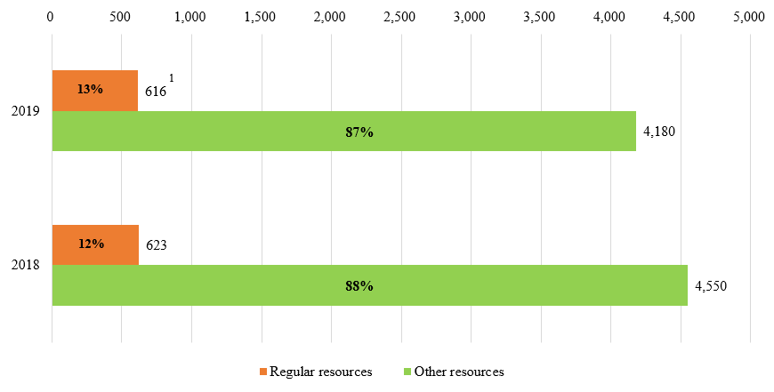
- Regular resources annual contributions received increased to $629 million from $624 million in 2018, including a $23 million loss applicable to exchange rate fluctuations. Multi-year commitments to regular (core) resources annual contributions increased by 14 per cent from $271 million in 2018 to $363 million in 2019. Government contributions to local office costs (GLOC) were $26 million (2018: $33 million).
- Total other resources annual contributions decreased by 8.1 per cent, to $4.2 billion (2018: $4.6 billion (restated)), including a $0.14 billion loss applicable to exchange rate fluctuations and $104 million in past due receivables. Other resources are ‘earmarked’ for individual programmes or projects and are important complements to the ‘un-earmarked’ regular resources base. It consists of cost-sharing, trust funds and reimbursable support services and miscellaneous activities. UNDP is committed to working with Member States to improve the flexibility of this funding.
- Annual Contributions are provided by the funding partners per table 2b and Figure III (a) below.
Table 2b. UNDP annual contributions by funding partners, 2018-2019
(in millions of United States dollars)
 | 2019 |  |  | 2018 |  |  | Total Increase | Percentage Change
 | Regular  Resources | Other  Resources | Total | Regular  Resources | Other  Resources | Total
Donor Country Governments | 594 | 1,463 | 2,057 | 610 | 1,517 | 2,127 | (70) | (3%)
Programme Country Governments | 22 | 845 | 867 | 13 | 1,071 | 1,084 | (217) | (20%)
Multilateral Partners | - | 1,872 | 1,872 | - | 1,962 | 1,962 | (90) | (5%)
Total | 616 | 4,180 | 4,796 | 623 | 4,550 | 5,173 | (377) | (7%)

Figure III (a). Annual contributions by funding partners, 2019
(in millions of United States dollars)
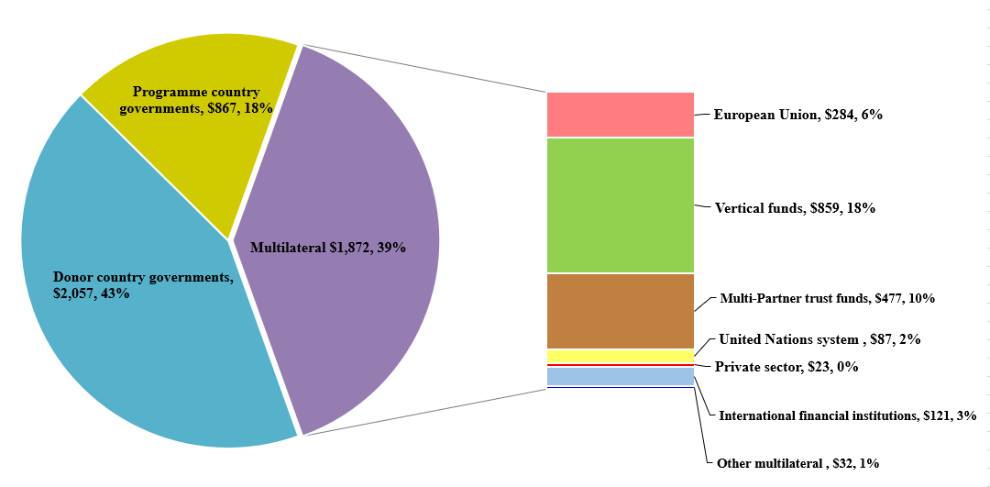

Government contributions to local office costs
- Annual government contributions to local office costs (GLOC) are an important source of revenue and can take the form of in-kind or cash contributions by host governments. In the low and middle-income countries categories, $26 million was received in 2019 (2018: 33 million), consisting of cash contributions of $18 million ($13 million for 2019 targets and $5 million against arrears) and in-kind contributions of $8 million for premises and utilities. The top 10 contributors are shown in figure III (b).
Figure III (b). Annual GLOC contributions by top 10 host governments, 2019
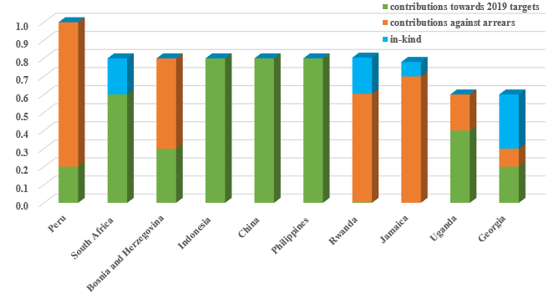
(in millions of dollars)
- Tables 8(a), 8(b) and 8(c) in appendix VI provide information on 2019 government cash contributions to local office costs in regular resources by countries in low and middle-income categories, cumulative arrears, and contributions towards arrears.

Net contributor country contributions
- Net contributor programme country governments contributed $8 million, the same level as 2018. (See details in appendix VI).

Upper-middle income country contributions
- Contributions from Upper-middle income programme countries with GNI per capita above $6,660 contributed $9 million, also at the same level as 2018. (See details provided in appendix VI).

Investment revenue
- Total investment revenue rose in 2019 to $167 million (2018 (restated): $134 million). This increase of $33 million (25 per cent) was a result of increasing interest rates and UNDP’s ability to re-invest maturing investments at higher rates.
- Hedging programme - UNDP’s hedging strategy resulted in a foreign exchange gain of $1 million (2018: $18 million loss). Enhanced programme budgeting and strengthened multi-year partnership frameworks will continue to help align inflows and outflows in foreign currencies and contribute to the reduction of currency risk exposure.

Other revenue
- Other revenue totalled $445 million (2018 (restated): $456 million), mainly consisting of: cost recovery revenue of $354 million; for instance, $58 million revenue for providing services to the United Nations system; and miscellaneous revenue, such as foreign exchange gains.

Cost-recovery
- UNDP made every effort to recover the general management support and implementation costs associated with the delivery of other resources-funded programmes and projects and with United Nations entities.
- UNDP recovered $240 million through general management support service fees, $1 million higher than in 2018, suggesting that incentives to help country offices improve revenue management were effective. Total cost recovery revenue decreased by 3 per cent to $354 million, (2018: $365 million), reflecting a change in mix of resources. Table 3 shows the breakdown of these revenues.
Table 3. Cost recovery, 2019
(in millions of United States dollars)

 | Programme and project delivery | Reimbursable support services | Total
Revenue
General management support services | 240 | - | 240
United Nations organizations – reimbursable services | 30 | 28 | 58
Administrative agent fees | 8 | - | 8
NCC contributions | 8 | - | 8
Upper MIC contributions | 9 | - | 9
Interest | 11 | - | 11
Other | 20 | - | 20
Total revenue | 326 | 28 | 354
Expenditure
Total expenditure | 256 | 52 | 309

- UNDP made every effort to attain full compliance with the cost recovery rate and seeks to further reduce the number of waivers. While infrequent, general management support waivers continue to be requested by funding partners. During 2019, no new waiver on the general management support fee was granted for new projects, but three waivers were renewed at previously approved reduced GMS rates. (DP/2020/9, annex III). The financial impact of these three waivers was estimated at $5.5 million in total.
  - Expenses
- In 2019, total expenses, after elimination, decreased by 3 per cent or 173 million, to $4.9 billion (2018 (restated): $5.1 billion).
- Out of this total of $4.9 billion, $4.3 billion was for programme expenses, which represents 88 per cent of total expenses. The amount of $5.2 billion, before elimination, is composed of $716 million for regular resources and $4.5 billion for other resources.
Table 4. UNDP overall expenses, 2019
(in millions of United States dollars)
Resources | 2019 | 2018  (restated) | increase/ (decrease) | Percentage change
Expenses
Development activities
Programme | 4,323 | 4,409 | (86) | (2%)
Development effectiveness | 176 | 167 | 9 | 5%
Subtotal – development activities | 4,499 | 4,576 | (77) | (2%)
United Nations development coordination activities | 22 | 125 | (103) | (82%)
Management activities | 392 | 368 | 24 | 7%
Special purpose activities | 79 | 57 | 22 | 38%
Other activities | 188 | 229 | (41) | (18%)
Total expenses before elimination | 5,180 | 5,355 | (175) | (3%)
Elimination | (256) | (258)
Total expenses | 4,924 | 5,097 | (173) | (3%)

- Pursuant to Board decision 2010/32, expenditures are reported in four harmonized cost-classification categories: (a) development; (b) United Nations development coordination; (c) management; and (d) special purpose. Expenditures outside those classifications are reported under ‘other activities’ and are included as part of overall expenditure.
- The composition of total expenses and harmonized cost classification activities is shown in figure IV (a); comparison of programme expenses by region between 2018 and 2019 is shown in figure IV (b).
Figure IV (a). Total expenses by cost classification and programme expenses by region, 2019
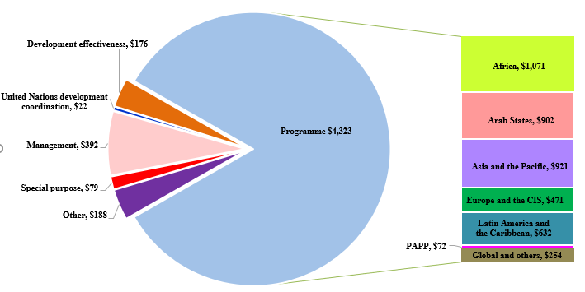
(in millions of United States dollars)

Development expenses
- Development expenses consist of programme expenses of $4.3 billion and development effectiveness of $176 million.

Programme expenses
- Total programme expense decreased by 2 per cent, to $4.3 billion from $4.4 billion in 2018. This decrease was due to a number of factors, including local circumstances, as well as UN development system reform, which resulted in field-level leadership positions being temporarily vacant.
- UNDP took measures to curtail expenses, reflecting its focus on efficiency while shielding programme components, such as target for resource assignment from the core TRAC-1, TRAC-2, TRAC-3, South-South cooperation, and the Human Development Report Office, including multi-year allocations from TRAC-2 issued largely in 2019.
- The $4.3 billion programme expenses include $2.0 billion related to donor cost-sharing, $833 million related to government cost-sharing, $797 million related to the following vertical funds (the Global Fund to Fight AIDS, Tuberculosis and Malaria ($306 million), the Global Environment Facility ($403 million), the Green Climate Fund ($56 million) and the Montreal Protocol ($32 million)), and $185 million relating to the Law and Order Trust Fund for Afghanistan. Of the 10 largest UNDP programmes, nine are in fragile or crisis-affected countries, accounting for 40 percent of total programme delivery.
Figure IV (b). Programme expenses by region, 2018-2019
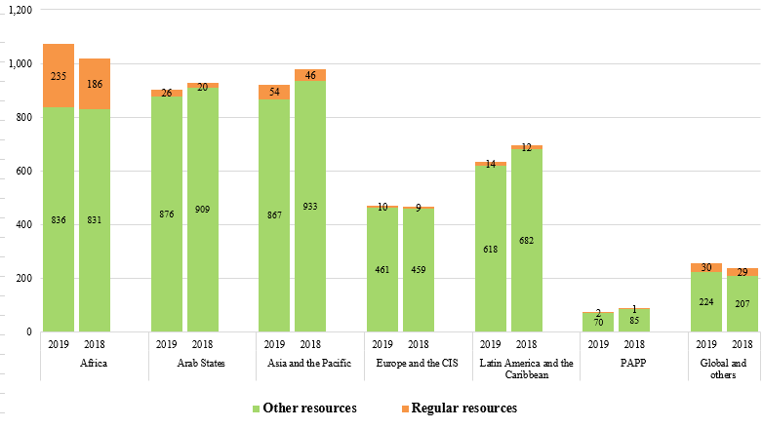
(in millions of United States dollars)

Comparison of programme expenses by region, 2018-2019
- Overall programme delivery in the Africa region increased by 5.3 per cent. The top three countries with the largest programme delivery in 2019 were Zimbabwe ($176 million), the Democratic Republic of the Congo ($108 million) and South Sudan ($100 million). The delivery in Zimbabwe increased by 5 per cent to $176 million, of which $148 million (84 per cent) was funded by the Global Fund. The Democratic Republic of the Congo, South Sudan, Burundi, Central African Republic, and Chad have increased their delivery, each within a range of $4 million to $11 million.
- Overall programme delivery in the Arab States region decreased by 2.9 per cent. Iraq has the second largest programme delivery in UNDP. Iraq delivered a total of $323 million, an increase of 11 per cent from the 2018 delivery of $291 million. Of that amount, 85 per cent was funded by donor country governments under third-party cost-sharing arrangements. Yemen was also one of the top ten countries, with total programme delivery of $110 million (2018: $199 million), of which 53 per cent were funded by the World Bank Group.
- In the Asia and the Pacific region, Afghanistan delivered the highest level of programme expenses in UNDP at $439 million (2018: $473 million), including $185 million (2018: $217 million) for the Law and Order Trust Fund for Afghanistan, and $241 million (2018: $245 million) under cost-sharing agreements. Of the seven Country Offices with more than $30 million delivery; Bangladesh, India, and Fiji had an increase in delivery of 42 per cent to $57 million, 9 per cent to $37 million, and 50 per cent to $34 million, respectively.
- Overall programme delivery in the Europe and the Commonwealth of Independent States (CIS) region slightly increased by 0.7 per cent. Ukraine has the highest programme delivery at $154 million, and the highest increase in programme delivery was in Turkey, which increased to $46 million from $34 million in 2018, funded by government cost-sharing for the procurement of health products.
- In the Latin America and the Caribbean region, overall programme delivery decreased by 8.9 per cent, mainly due to the currency depreciation in Argentina, the shifting of national priorities to address natural disaster, and the political situation in certain countries. Argentina has the highest programme delivery, at $125 million. Brazil, Dominican Republic, and Paraguay increased their programme delivery, each within the range of 3 million to 6 million.

United Nations development coordination expenses
- UNDP effectively supported the rapid transition of the United Nations development system, following General Assembly resolution 72/279 on United Nations repositioning. In 2019, UNDP’s support to the resident coordinator system was $22.4 million, 0.4 per cent of UNDP total expenses. This amount includes UNDP’s contribution of $10.3 million to the cost-sharing arrangement among United Nations development system entities, double that of 2018, and an additional $12.1 million of legacy coordination support activities continued on a transitionary basis at the request of UN Development Coordination Office and its funding partners.

Management expenses
- Management expenses rose by 7 per cent, to $392 million (2018: $368 million), remaining within the parameters of the integrated resources plan, 2018-2021, and included increased spending for the Independent Evaluation Office and the Office of Audit and Investigations, and non-discretionary inflationary increases on staff costs.
- It should be noted that, as a result of the delinking of the resident coordinator system from UNDP, many new UNDP leadership positions at the country level were filled in 2019. In 2018 and prior years, these positions were part of the “backbone” services provided by the resident coordinator/UNDP resident representative and UNDP country office to the United Nations system coordination and representation functions. From 2019 onwards, these positions were reported under management activities.

Special purpose expenses
- Special purpose expenses totalled $79 million (2018: $57 million). This amount includes expenses of $63 million for reimbursable support services, $4 million related to capital investments, $9 million related to UNV and $2 million related to UNCDF.

Other expenses
- Other expenses totalled $188 million (2018: $229 million), of which $37 million (2018: $46 million) related to after-service health insurance, $34 million (2018: $35 million) to common services, $34 million (2018: $62 million) to security-related activities, $19 million (2018: $17 million) to the junior professional office programme, and $13 million (2018: $33 million) to currency revaluation and exchange rate fluctuations to voluntary contributions.

Regular resources and integrated budget expenditure
- For activities reported in 2019, UNDP operates within the integrated budget, 2018-2021, as approved by the Executive Board in decision 2017/31, for regular resources-financed activities: (a) programmatic components; and (b) institutional components.
- Appendix II and figure V below compare the final approved budget, covering both programmatic and institutional components, with the actual expenditure amounts, calculated on the same basis as the corresponding budget for regular resources (modified accruals basis).
Figure V. Regular resources, comparison of budget to actual expenditure, 2019
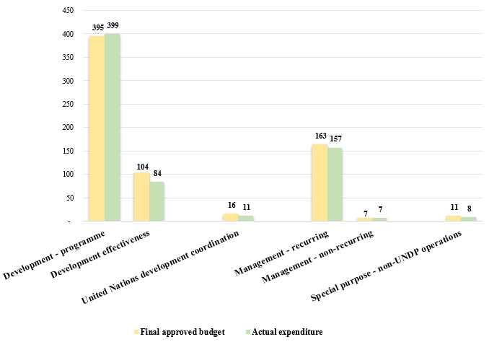
(in millions of United States dollars)
- UNDP’s performance in 2019 should be considered against the backdrop of two contexts:
- The overarching objective of the UNDP budget was to ensure financial sustainability with respect to the institutional and programmatic components, achieve a better equilibrium between regular and other resources, and increase productivity over time; and
- General Assembly resolution 72/279 of 31 May 2018 on the repositioning of the United Nations development system. UNDP continued to support the functioning of the independent and reinvigorated resident coordinator system, helping to ensure that Resident Coordinators and their offices are able to carry out their critical coordination functions seamlessly. At the same time, UNDP maintained its business continuity and continued successfully to drive forward the Strategic Plan, 2018-2021.
- Table 5 below compares actual expenditures for 2018 and 2019. In 2019, the share of regular resources spent for institutional activities was $227 million, which was $11 million or 5 per cent more, compared to $216 million in 2018. The share of regular resources spent for programmatic activities was $440 million, which was $96 million or 28 per cent more, compared to $344 million in 2018.
Table 5. Integrated budget expenditure, by cost classification category, 2018-2019
(in millions of United States dollars)

Regular resources | 2019 actual  expenditures | 2018 actual expenditures
Programmatic component | 440 | 344
Institutional component | 227 | 216
Total | 667 | 560
Cost classification category | 2019 actual  expenditures | 2018 actual expenditures
Development activities | 484 | 372
United Nations coordination activities | 11 | 88
Management activities | 164 | 91
Special purpose activities | 8 | 9
Total | 667 | 560
- Appendix III.A presents the integrated resources plan that covers regular and other resources for 2018-2019 and compares the plan with 2018-2019 actuals. This comparison shows that:
    - activities reported in 2019 remain within the integrated resources plan;
    - at the end of 2019, the expenditure ratio for management activities (regular (core) and other (non-core)) to total activities (i.e., management efficiency ratio) was 7.5 per cent (2018: 6.7 per cent);
    - the overall expenditure level of programmatic activities at the end of 2019 reached 90.7 per cent (2018: 90.6 per cent).
- Appendix III.B presents 2018-2019 actuals versus estimates of the institutional components of the integrated resources plan by category of expenditures, while appendix III.C presents information on resources allocated to posts by location.
- Financial position
  - Assets
- Total assets registered $12.5 billion (2018 restated: $12.2 billion), representing an increase of 2 per cent. UNDP assets consist mainly of investments to fund known liabilities, as well as contributions receivable, as set out below.
Figure VI. UNDP assets, 2018-2019
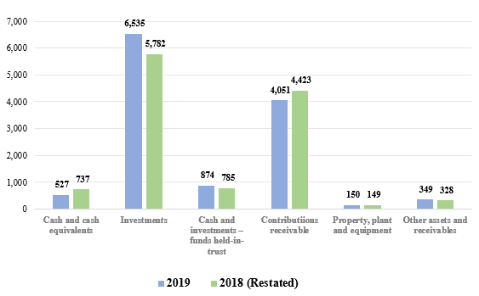
(in millions of United States dollars)

Cash and investments
- Total cash and cash equivalents and investments amounted to $527 million and $6.5 billion, respectively.
- The majority of investments and cash and cash equivalents in other resources are earmarked for programme activities funded through cost-sharing and trust fund agreements with donors. The investments and cash equivalents in regular resources and other resources also includes $775 million for after-service health insurance (ASHI) and the amount invested for the Executive Board mandated operational reserves of $283 million and the Programme of Assistance to the Palestinian People (PAPP) Endowment Fund of $3 million.
- The total cash and investments for Multi-Partner Trust Fund Office of $874 million (cash and cash equivalents of $286 million and investments of $588 million) represent funds provided to UNDP by funding partners to be held on their behalf for future disbursement to organizations of the United Nations system and to national governments.

Contributions receivable
- Contributions receivable from funding partners registered $4.1 billion, a decrease of $372 million (8 per cent) from the 2018 restated amount of $4.4 billion.
- Contributions receivable amounts are recognized in full, including for multi-year contributions, at the time the agreement is signed, except for programme government contribution agreements and agreements that have performance conditions beyond the control of UNDP. As these funds are not yet received, they are not available for utilization.
- Contributions receivable of $4.1 billion include $3.9 billion committed to UNDP by donors in future years, as set out in the payment schedule in signed agreements. This amount is programmed accordingly for delivery in future years and consists of $358 million receivable for regular resources and $3.6 billion for other resources.
- Of the of $358 million regular resources contributions receivable, $260 million is due in 2020 and the balance of $98 million is due in future years. Of the $3.7 billion other resources contributions receivable, $104 million is past due, $2.1 billion is due in 2020, and the balance of $1.5 billion is due in future years. Three donors (Global Environment Fund, Green Climate Fund, and European Union) account for 49 per cent (2018: 50 per cent) of total other (non-core) outstanding receivables. This provides visibility of future year funding available for programme pipeline.
Table 6. Contributions receivable, 2018-2019
(in millions of United States dollars)
Contributions receivable | 2019 | 2018  (restated) | increase/ (decrease)
Contributions past due | 104 | 143 | (39)
Contributions due in future periods | 3,947 | 4,280 | (333)
Total contributions receivables | 4,051 | 4,423 | (372)
  - Liabilities
- Total liabilities amounted to $2.8 billion, an increase of 8 per cent over the 2018 restated amount of $2.6 billion. The change is mainly attributable to Payables for the Multi-Partner Trust Fund Office, which increased by $150 million.
- Funds received in advance and deferred revenue of $29 million comprises of $7 million funds received in advance for future periods specified in donor contribution agreements, and $22 million deferred revenue for contributions.
Figure VII. UNDP liabilities, 2018-2019
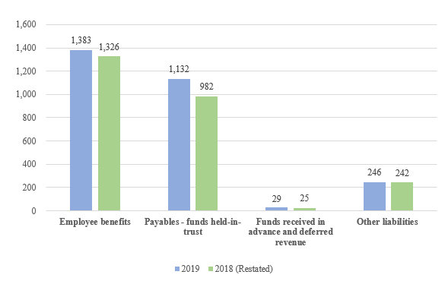
(in millions of United States dollars)

- UNDP liabilities also include $1.4 billion (2018: $1.3 billion) in liabilities for employee benefits, of which $1.0 billion is for after-service health insurance (ASHI). In 2019, ASHI liabilities increased by $10 million (1 per cent) from $1.0 billion, resulting in an increase in the proportion of the liability funded fully by UNDP from 63 per cent in 2018 to 74 per cent in 2019. UNDP participates in the United Nations system-wide valuation of post-retirement benefits, performed by an independent actuary. The latest valuation was carried out as at 31 December 2019 and the $10 million increase (1 per cent) in the liability was largely due to the decrease in valuation discount rates as a result of improved market yields during the year and a change in actuarial assumptions.
- UNDP continued to have a 15-year plan to fund its ASHI liability, which is assessed periodically. Of the $1.0 billion, $775 million had been funded as of 31 December 2019. The investment management of this portfolio is fully outsourced to external managers to ensure an adequate level of investment return given the longer-term nature of the liabilities. UNDP, UNFPA, UNCDF, the United Nations Children’s Fund (UNICEF) and the United Nations Entity for Gender Equality and the Empowerment of Women (UN-Women) collaborate in this arrangement.
- Payables (funds held in trust) represent funds provided by donors to UNDP to be held on their behalf for future disbursement to organizations of the United Nations system and to national governments. The amount of $1.1 billion in figure VII includes $872 million for multi-partner trust funds that UNDP administers, $168 million for clearing accounts with United Nations entities, and $91 million for common services to United Nations entities.
  - Accumulated Surplus
- The financial regulations and rules of UNDP require it to operate on a fully funded basis for activities funded by other resources. In accordance with partnership agreements, all project balances are segregated for accounting and reporting purposes, with no commingling of balances between projects. Appropriate cash balances are held for settling liabilities.
- UNDP receives programmatic resources for multi-year programmes linked to individual programmes or projects. Hence, in any given year, there is an excess of resources over expenditure. This excess of resources is referred to as the accumulated surplus, which consists mainly of resources committed for future programme delivery.
- At 31 December 2019, the accumulated balance, excluding reserves, increased by 0.8 per cent, to $9.4 billion (2018 (restated): $9.3 billion). The increase in accumulated balance from 2017 is mostly attributed to the increase in receivables as a result of the change in the revenue recognition policy due to International Public Sector Accounting Standards. Accordingly, the accumulated surplus now includes receivables from non-exchange transactions (net of past due) of $3.9 billion at 31 December 2019 (2018 (restated): $4.3 billion). Under UNDP’s Financial Regulations and Rules, the organization is only permitted to spend when the cash is received. i.e., the organization is not permitted to spend the $3.9 billion stated above. Figure VIII (a) below illustrates the trend in the accumulated balances, and the impact of changes in the receivables of non-exchange transactions.
Figure VIII (a). Accumulated balance, regular resources and other resources
(in millions of United States dollars)
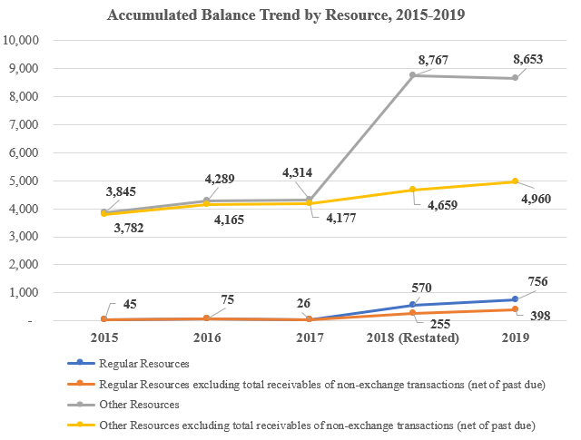
- Available accumulated regular resources (core) increased by $187 million mainly due to a small surplus balance of $58 million in 2019, along with an increase in the fair value of ASHI investments and an actuarial gain. The fair value change in ASHI investments and the actuarial gains are unrealized and therefore non-programmable. In addition, in line with Board decision 1999/9, a prudent level of liquidity for regular resources is equivalent to three to six months’ expenditures. UNDP maintained the year-end core liquidity position at 6.61 months of working capital, above the minimum threshold (2018: 7.61 months).
- Total accumulated other resources (non-core) programme balances remained fairly flat in 2019 compared to 2018.UNDP continued to seek opportunities to accelerate the delivery of development results and further draw down its accumulated balance, taking into account the late receipt of funds in 2019. Contributions received in the last quarter at 37 per cent (2018: 38 per cent) of total contributions in 2019 were too late for delivery in the same year and will have to be budgeted in the following year. Early payments of contributions by funding partners aid the timely delivery of development results.
- In 2019, $6 million (2018: $10 million) was released to the accumulated surpluses from the operational reserve, in accordance with the operational reserve formula approved by the Executive Board in decision 1999/9.
- The attribution of the accumulated balance to the various funding sources for future delivery is set out in figure VIII (b) below. This comprised of donor cost-sharing balance of $4.3 billion (2018 (restated): $3.9 billion), vertical funds balance of $2.5 billion (2018 (restated): $3.0 billion), programme cost-sharing balance of $821 million (2018 (restated): $853 million), regular resources balance of $757 million (2018 (restated): $570 million), reimbursable support services balance of $548 million (2018 (restated): $502 million), and trust funds balance of $421 million (2018 (restated): $453 million).
Figure VIII (b). Accumulated balance by funding source, 2018-2019
(in millions of United States dollars)
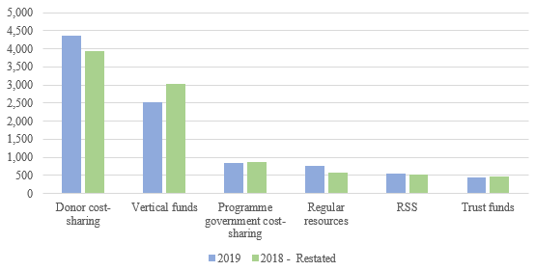

- Accumulated resources of donor cost-sharing increased by $404 million, of which, $183 million is due to the resources transferred by the Multi-Partner Trust Fund Office and $65 million is due to resources from UN agencies. Accumulated resources of vertical funds decreased by $500 million, of which $296 million is due to reduction of the balance from the Global Fund to Fight AIDS, Tuberculosis and Malaria.
- Others

Management service agreements
- Management service agreement contributions totalled $3 million (2018: $7 million), total expenses registered $6 million (2018: $6 million), and the accumulated balance increased to $48 million (2018: $39 million). Details are provided in document DP/2020/20/Add.1.

United Nations Volunteers
- In 2019, the second year of the implementation of the UNV Strategic Framework, 2018-2021, the total financial volume amounted to $221.3 million, a $21.3 million increase from $200 million in 2018, of which $211.8 million consisted of programme resources. Of this, programme regular resources expenses made directly by UNV through the Special Voluntary Fund, cost sharing, trust funds and full funding arrangements totalled $23.7 million (11 per cent). The remaining financial value was attributable to direct charges to United Nations organizations. The total financial volume in 2019 increased by US $21.3 million from US $200 million in 2018.
- In 2019, the Special Voluntary Fund received contributions (including multi-year) amounting to $4.5 million, a 14 per cent increase compared to $5.2 million in 2018. At the same time, contributions (including multi-year contributions) received for fully funded UN-Volunteers, including contributions for United Nations Youth Volunteers and United Nations University Volunteers, increased to $22 million in 2019 inclusive of interest and multi-year contributions. This is notably higher than $15.6 million of full funding contributions received in 2018, mainly due to a new revenue recognition policy which accounts for total agreement amounts, effective 2019.
- UNV received funding for institutional activities through UNDP regular resources amounting to $8.6 million, a slight decrease compared to $8.8 million in 2018. UNV notes that it needs a stable and predictable level of UNDP regular resources to fulfil its mandate and provide high quality volunteers and innovative, cost-effective solutions to UNDP and other United Nations entities.

United Nations Office of South-South Cooperation
- The overarching goal of the United Nations Office of South-South Cooperation (UNOSSC) Strategic Framework, 2018-2021, is to support of the efforts of Member States to eradicate poverty in all its forms and to promote gender equality and women’s empowerment so as to achieve the 2030 Agenda through enhanced South-South cooperation, including triangular cooperation.
- UNOSSC benefitted from a UNDP-provided institutional budget of $2.3 million and a core programme budget of $3.4 million. Non-core mobilized contributions amounted to $14.1 million for the United Nations Fund for South-South Cooperation, $2 million for the India, Brazil and South Africa Facility for Poverty and Hunger Alleviation (India and South Africa: $1 million each), and various modest contributions under the Perez-Guerrero Trust Fund. The $14.1 million contributions for the United Nations Fund for South-South Cooperation include $9 million from India for the India-United Nations Development Partnership Fund (a dedicated facility therein), $1.5 million from China, $0.7 million from the Republic of Korea, $0.5 million from the World Green Economy Organization in Dubai, United Arab Emirates. Although in historical terms this resource mobilization figure is among the highest volumes UNOSSC has raised, it represents a 20 per cent decrease in non-core contributions compared to 2018, owing mostly to multi-year variations in the funding provided by the Government of India to the India-UN Development Partnership Fund, which are computed in the calendar year in which they are received. Non-core expenditures amounted to $11.4 million, representing a 14 per cent increase from 2018, as the India-UN Fund gained maturity in the implementation of its portfolio.
- United Nations reform and support to United Nations organizations
- UNDP undertakes many activities in partnership with and support to the United Nations system at large.
  - UNDP administrative agent function
UNDP supports joint programming, including through its role in fund design and administration of joint programmes and multi-donor trust funds on behalf of the United Nations system and national governments, and through its programme implementation role as a participating United Nations organization. Details are set out in DP/2020/20, Section VI.
  - Support to United Nations organizations
- UNDP provides services, on a cost-recovery basis, to United Nations organizations, including peacekeeping missions.
  - United Nations development coordination activities
- In 2019, the UNDP role ended to coordinate support to the United Nations development system and country-level coordination in support of national development, as UNDP effectively supported the repositioning of the United Nations development system. Combined expenses totalled $22.4 million ($10.3 million to the cost-sharing arrangement among United Nations development system entities, double that of 2018, and an additional $12.1 million of legacy coordination support activities continued on a transitionary basis at the request of UN Development Coordination Office and its funding partners).
- In support of the repositioning of the United Nations development system from 1 January 2019, the following was requested by the GA resolution 72/279:
    - A one per cent coordination levy on tightly earmarked third-party non-core contributions to United Nations development-related activities, to be paid at source. UNDP established internal guidance, processes and communication channels to manage the levy collection and its transfer. UNDP monitors the process of levy collection and continuously engaged with Development Coordination Office and Resident Coordinator Offices on levy matters. For UNDP the aggregated amount of all levies received and transferred to the United Nations Secretariat was $2.6 million for 2019. It is noted that for the same year UNDP estimated cost for administering the levy at $0.4 million, representing a substantial additional administrative cost that UNDP had to spend to able the levy collection in 2019.
    - Doubling the current United Nations Sustainable Development Group cost-sharing arrangement among United Nations development system entities, amounting to an annual contribution of $10.3 million for UNDP. The payment for 2019 was made by UNDP early, in December 2018.
  - United Nations-mandated security costs
- In its decision 2017/31, the Executive Board approved the UNDP integrated budget, 2018-2021. In document DP/2017/39 on the UNDP integrated budget, 2018-2021, and following prior practice, UNDP sought exceptional authority during 2018-2021 to disburse up to $30 million in regular resources for security measures, in addition to the approved appropriation from regular resources for the institutional component of the integrated budget of $1.1 billion, the use of which would be limited to new and emerging security mandates as defined in United Nations Department of Safety and Security directives. UNDP will report on these as and when they may occur. During 2019, no amount was drawn down from the $30 million.
- UNDP spent $30.2 million (2018: $31.2 million), of which $21.2 million (2018: $21.2 million) was associated with the UNDP share of the United Nations field security coordination programme; and $9.0 million (2018: $10.0 million) with security advisory services and security investments to ensure the compliance with minimum operating security standards. The latter included security assessments, compliance, and improvement of premises security, blast and seismic assessments, and security included office relocations; security communication and transportation equipment; as well as security trainings.
- ‘Greening’ UNDP
- In 2019, UNDP launched the ‘Greening UNDP Moonshot’, significantly accelerating UNDP’s ‘greening’ ambitions committing to reduce Greenhouse Gas (GHG) emissions from global operations by 25 per cent by 2025 and 50 per cent by 2030. Building on and scaling up innovative ‘greening approaches’ already adopted throughout the organization, the ‘Greening Moonshot Facility’ was launched in November 2019 incentivizing contributions by UNDP facilities to the Moonshot targets via competitive calls for proposals.
UNDP also banned single-use plastic from cafeterias, canteens and events and build a comprehensive staff greening engagement platform. Environmental Reporting via UNDP’s Environmental Management Tool increased significantly with 65 offices reporting their 2018 carbon footprint (during 2019). The organization-wide 2018 carbon footprint of 76,599 tons CO2e was offset with Certified Emission Reductions (CERs) from the Adaptation Fund established under the Kyoto Protocol of the United Nations Framework Convention on Climate Change. Similarly, 2019 GHG emission data are collected during 2020 and UNDP’s 2019 Carbon Footprint is expected to be offset by end of 2020. As such, UNDP continues to be climate neutral in its global operations.
- Appendices (available on the UNDP Executive Board web page)
Contents
- UNDP overview
  - Statement of financial performance for the year ended 31 December 2019
  - Statement of financial position as at 31 December 2019
- Regular resources – comparison of budget to actual, 2019
- A. Integrated resources plan, 2018-2021 estimates compared to 2018-2019 actuals
B. Summary of institutional component of the integrated budget by category of expenditures: 2018-2019 annualized estimates versus 2018-2019 actual expenditures
C. Resources allocated to posts by location, 2019
- Regular resources – annual contributions from top 10 donors, 2018-2019
- Explanation of terms used in Annex I to DP/2020/20
- Supporting information relating to the detailed annual review of the financial situation, 2019.

Amounts exclude a $12 million contribution for 2019 from the United States which was received in 2020.
Taking into account a $12 million contribution for 2019 from the United States which was received in 2020
See footnote 1.
As evidenced in the IRRF, the UNDP management efficiency ratio continues to improve and remains below the level of the corresponding annual milestone. UNDP continues to outperform its annual milestone. During 2018-2019, UNDP exceeded its targeted levels, moving to a management efficiency ratio of 6.7 per cent (actual) versus 6.9 per cent (milestone), and 7.5 per cent (actual) versus 7.7 per cent (milestone) for 2018 and 2019 respectively. The figures for 2019 reflect the impact of General Assembly resolution 72/279 on delinking the resident coordinator system from UNDP.

